FAIR FIELD NEWS
Summer Term Issue 1
Dear Parents and Carers,

Welcome Back and a warm welcome to our first Fair Field News of the year. It has been beyond pleasurable to welcome back children, parents, carers, grandparents and staff this week. It is especially lovely to see those who were unable to return last term. We enjoyed meeting and getting to know our new Year 3 children, who have settled fantastically well over the last two days. We have had the opportunity to meet “virtually” for two assemblies, which has certainly been a new experience for us all! You will, I am sure, have noticed that we have needed to make some changes to the beginning and end of the school day and we appreciate your patience and co-operation as we adapt into new ways. The children have been so brilliant in school at following our new rules and systems. Please see below a more comprehensive explanation of our one-way system. More information will be coming out next week for extra-curricular opportunities and how we will be setting homework. Homework will be issued on Thursdays and should be completed by the following Tuesday. It will be set on a variety of online platforms including Google Classroom, Purple Mash and TT Rockstars. In the meantime, please encourage your child to access TT Rockstars and read. The children are very welcome to wear their lanyards and continue to earn new badges this term. Year 3 will receive their lanyards next week. Finally, every year group has two PE days. They should come to school wearing their PE kit on these days. Our PE kit is a plain or logoed white t-shirt accompanied with either a plain black or bottle greet tracksuit. Thank you for all your support.
Take Care

Mrs Aharon & Mrs Goodwin

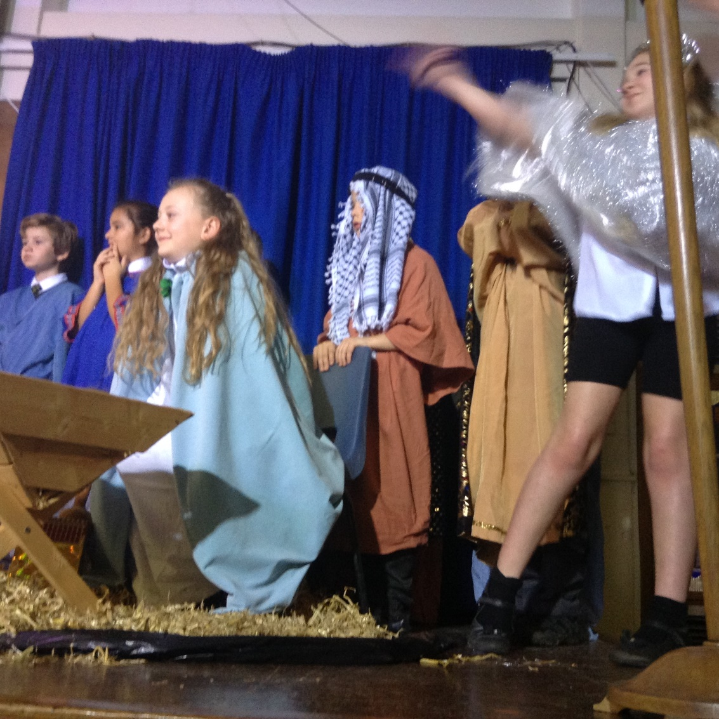
F Factor
3 Walliams | 3  Blyton | 4 Morpurgo | 4 Rowling | 5  Ridley | 5  Pullman | 6  Rosen | 6  Blackman
Sasha | Willow | Joseph | Ben | Jayden | Reuben | Ryan | Mimi
Jia | James | Mimi | Olivia | Georgie | Sophia | Brooke | Luca
Diamond Book
6 Rosen | Nancy, Penny, Harry, Sofia and Ray | 5 Ridley | Ellie, Martha & Leonie
6 Blackman | Zoe, George, Harrison, Izak, Liam, Pratham, Miley | 5 Pullman | Maria, Louise, Harry, Nico, Frankie, Ruby, Konstantin and Rory
4 Morpurgo | Marat & Sienna | 3 Walliams | Amarah & Robin
4 Rowling | Olivia & Vinnie | 3 Blyton | Ella – May & Albei J

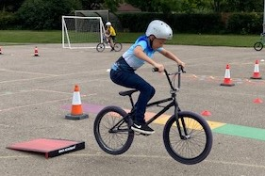



PE Days are as follows

 | Day 1 | Day 2
Year 3 | Monday | Tuesday
Year 4 | Wednesday | Thursday
Year 5 | Wednesday | Thursday
Year 6 | Tuesday | Friday

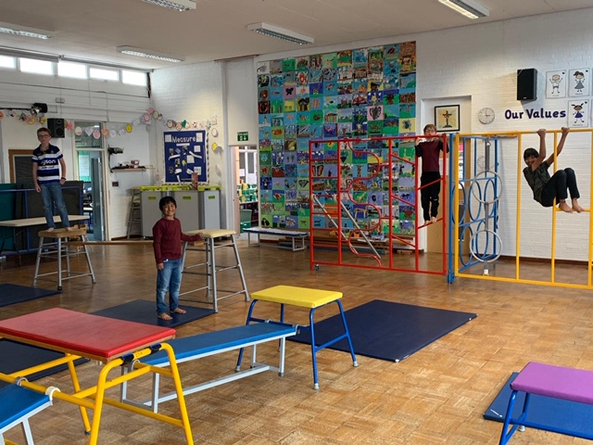



Our PTA Need you!

If you are interested in joining the PTA please email the office and we will be in contact. We are really keen to put
on some socially distanced and virtual events this term.


Keep In Touch
Email: admin@fairfield.herts.sch.uk
Tel: 01923 856 341
Fair Field Junior School
Watford Road,
Radlett, Hertfordshire, WD7 8LU

INBOUND MESSAGES from GATEWAY: 01923 750 087

Follow us @FairFieldJrSch


Lateness

The one-way system at Fair Field Junior School
Mornings (Surnames A-L 8:30 – 8:45am and Surnames M-Z 8:45 - 9:00am)
There are 3 points of entry in the morning
- Back gate (ENTRY ONLY)
People walk through the alleyway and down the side of the playground. If they are going into a Year 5 or 6 classroom, they go straight to their classroom. If they are going (which includes taking a sibling) to a Year 3 or Year 4 classroom, they continue through the playground into the staff car park. They walk on the pathway behind the stationary vehicles and the kitchen, and around the building past the office and Mrs Aharon’s office. This takes them into the lower school playground.

- Vehicle gate
Children are dropped from 8:30am or from 8:45am on the turning circle, they walk through the lower school playground and onto the upper school if appropriate.

- Front gate
Only Y3 parents/children* will use this gate in the mornings, unless prior agreement. This gate is next to the vehicle gate so please be careful if crossing. It is much safer to arrive through the back gate in the mornings. If you need to use this gate the adult and child walk up the path into the playground. The adult then continues walking around the one-way system past upper school, through the staff car park and out the side front gate on Watford Road.

*Please note that Year 3 parents/carers should be encouraging their children to walk by themselves by the end of September, if not before.

Afternoons (Surnames A-L 2:45 – 3:00pm and Surnames M-Z 3:00 – 3:15pm)

There is 1 point of entry in the afternoon
- Front gate
Parents/Carers should park at the back of school, walk around school
and through the front gate, next to the vehicle entrance. They then
follow the one-way system into the lower school playground, upper
school playground collecting children as appropriate and then exit
either through the back gate (EXIT ONLY) or the side front gate on
Watford Road.
- If Y6 children are collecting siblings, they walk round the one-way system on the pathway in the staff car park and round the office, past Mrs Aharon’s office into the lower school playground.
- Y6 children can only exit through the back gate independently – not the front side gate.

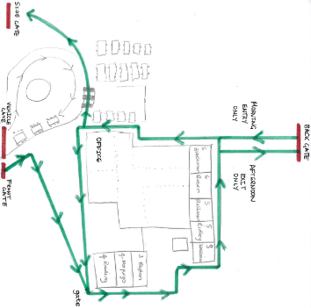

Respect Honesty Perseverance Kindness Forgiveness Inclusion

Our very own Fair Field choir will be singing at 2.50pm. Come and support them before the switching on of the lights at 4.30pm by Sophie Perry.

