FAIR FIELD NEWS
Autumn Term Issue 10
Dear Parents and Carers,

There are lots of things to fill you in on this week! You will have noticed that we have sent out a letter reminding everyone of drop-off and pick up routines and etiquette. Please read it carefully and help us in maintaining good relationships with the local residents and our community. We ask that you do not park inconsiderately at the back gate or bump up onto the curb at the front gate, even if you have someone else with you who is collecting or you are waiting for a Year 6 child. Thank you in advance.
On Wednesday we held a PTA AGM and I wish to thank Angela Stephenson for agreeing to take on the role of Vice Chair. Equally I wish to thank Julie Kranz and Madalyn Biefield who will remain treasurer and secretary respectively. They have been the driving force of us gathering back up momentum to raise money and hopefully you will have seen their letter highlighting two events we are launching this term. Thank you in advance for any support you can give us.
On Thursday more of our Nature Nurturers and Eco Warriors visited the Recreation Ground and were able to spot the bird boxes which were erected last week. Next week another group will go to plant bulbs and monitor the bat boxes. This is an ongoing project with Radlett Parish Council, which will involve lots of children at Fair Field over the year.
Each week the children have been working hard towards whole school, class and personal goals and the winning class will receive a new piece of PE equipment each week. This week’s winners were 4 Rowling.Thank you to everyone who supported Children In Need in style – the school was adorned with some fabulous spotty creations and lots of Pudsey merchandise. We raised a fantastic £213.60. This week we were kindly donated a drum kit by Aldenham School and Ollie Stephenson played us out of assembly with a lively rendition of We Will Rock You.
On Monday we launch Anti-Bullying week with odd sock day. The day is an opportunity for children to express themselves and appreciate individuality. They should wear their uniform as usual, but accompanied by a pair of odd socks - the brighter the better! ICT Club have also been working hard on a presentation on keeping safe online. The children will have the chance to earn a new badge throughout the week too designed by Tiaan in Year 4. Nature Nurturers
Lastly, we are excited to say we have entered the world of Instagram to keep you updated with all the exciting things going on around school and upcoming events. Please follow us @ffjsradlett. We will not be posting images of the children; it will be used to promote
events, connect with people and organisations and showcase children’s learning.

Have a good weekend and dig out those odd socks!
Mrs Goodwin and all the Fair Field staff

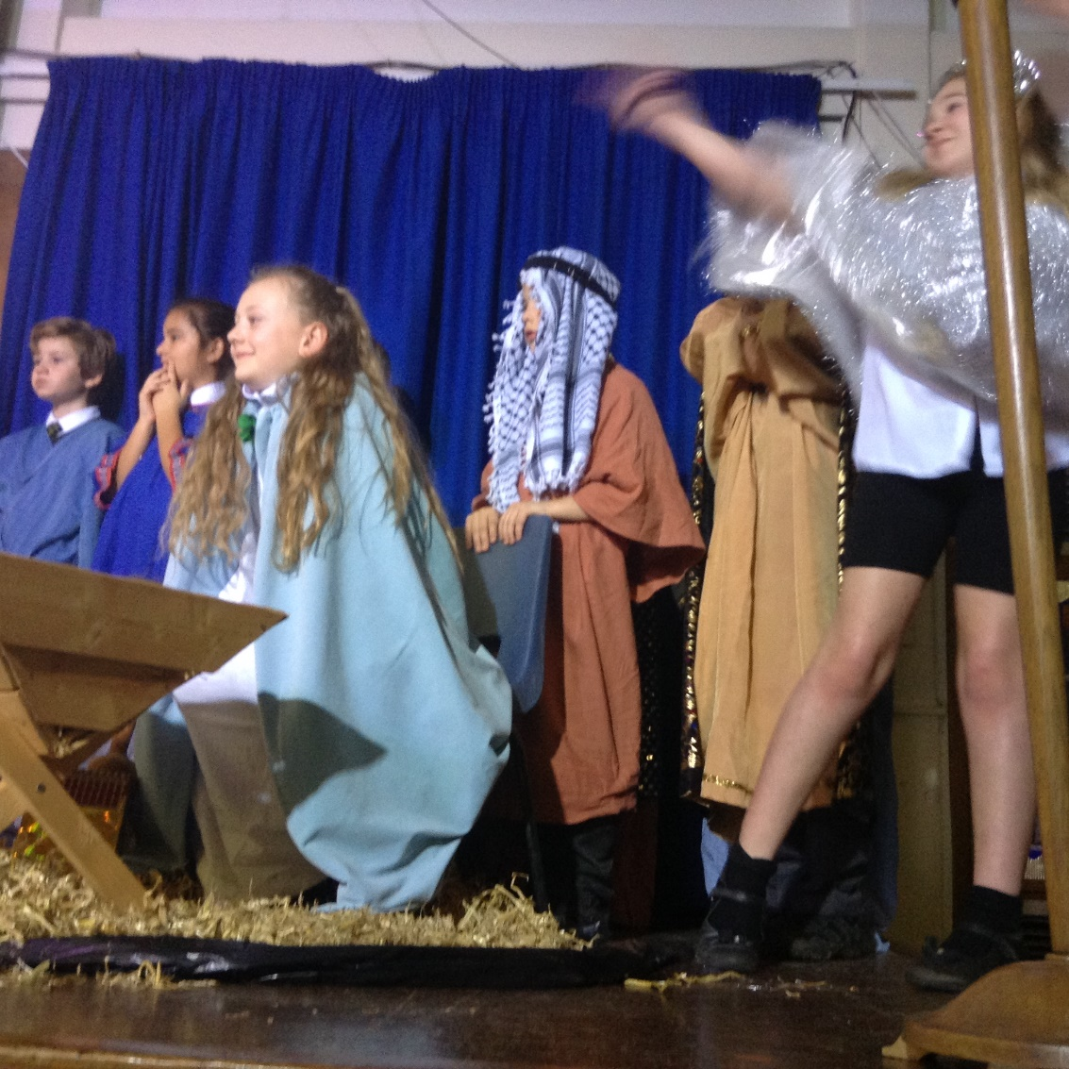



Dates for the Diary

Date | Time | Event | Year Group(s)
16th – 20th November | All week | Anti-bullying week | All
16th November | All day | Odd sock day | All
10th December | PM | Virtual Production | Year 4
11th December | 2.00pm | Reverend Fletcher’s virtual assembly | All
14th December | 1.30pm | Virtual Carol Service | Year 3
14th December | 2.15pm | Virtual Carol Service | Year 4
15th December | 1.30pm | Virtual Carol Service | Year 5
15th December | 2.15pm | Virtual Carol Service | Year 6
16th December | 12,00pm | Christmas lunch | All
17th December | 1.30pm | Last day of term | All

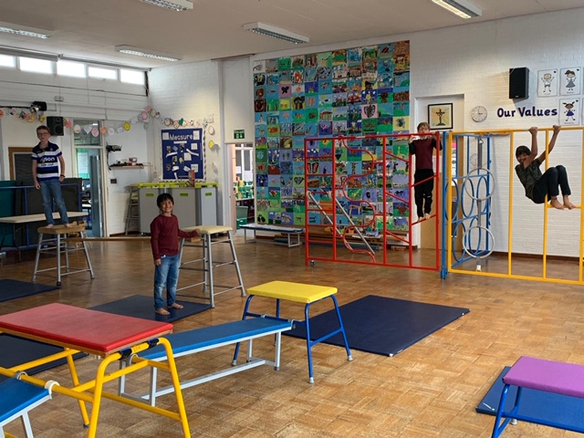

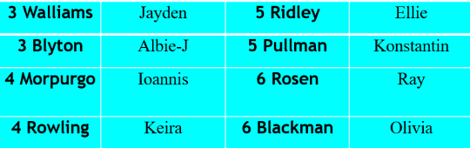


This week’s TT Winners

F Factor Superstars
.

Diamond Book Times Table Rock Stars

T

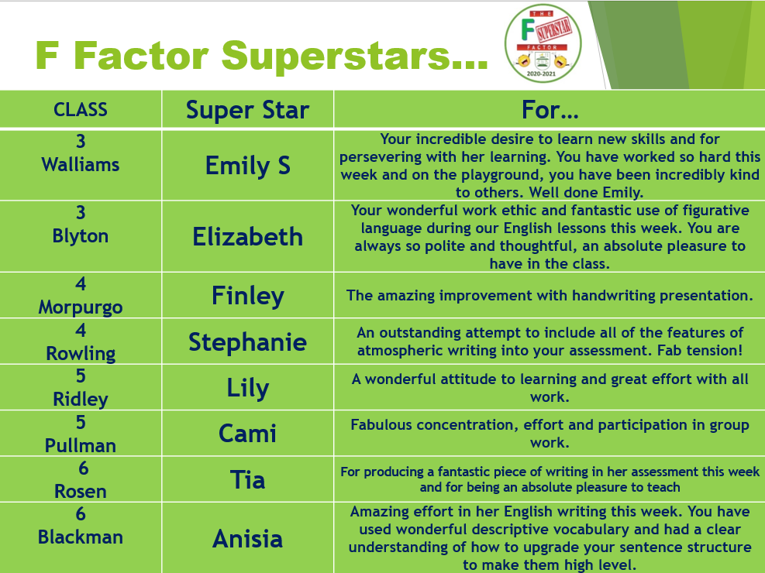
Lateness
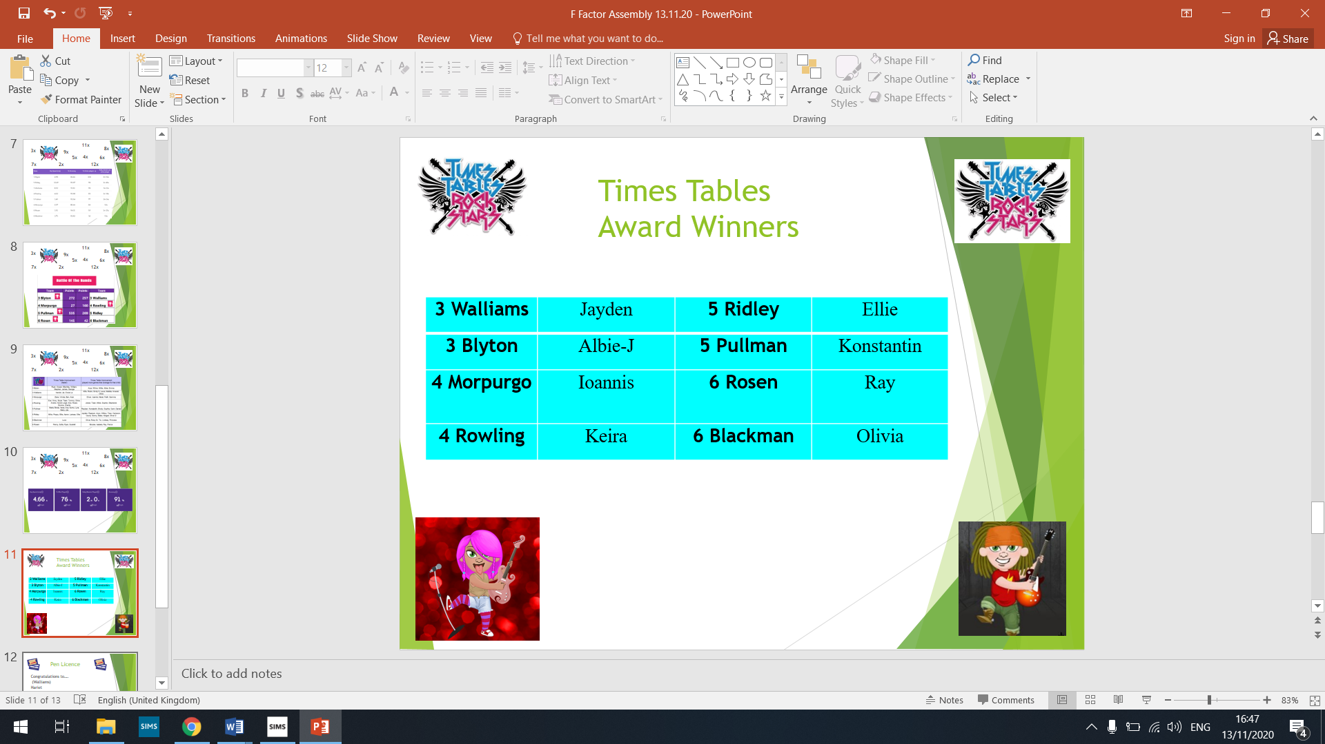



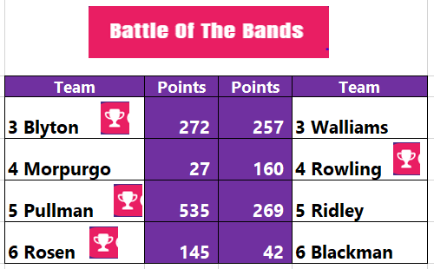
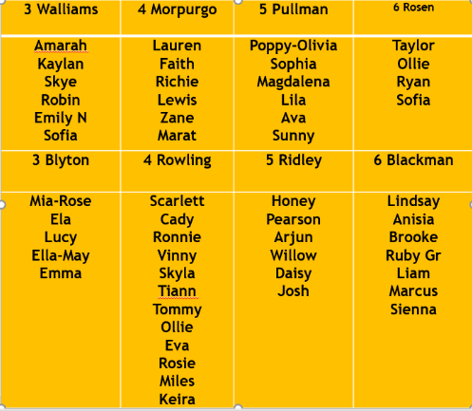

This week’s SUCCESS code winners were 4 Rowling, who have won a new basketball for their playground box!
Attendance
Well done! to 5 Pullman again and 6 Rosen!
3 Walliams | 98% | 5 Ridley | 93%
3 Blyton | 98% | 5 Pullman | 100%
4 Morpurgo | 99% | 6 Rosen | 100%
4 Rowling | 97% | 6 Blackman | 98%

Gallery
Some of this week’s
highlights!
.

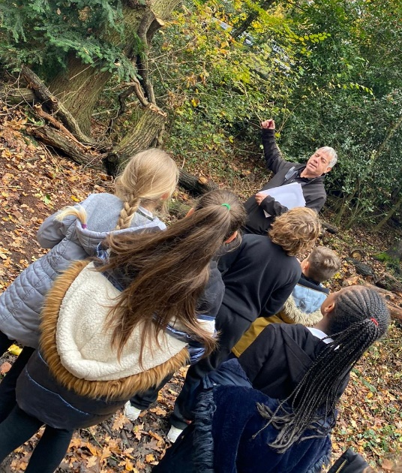


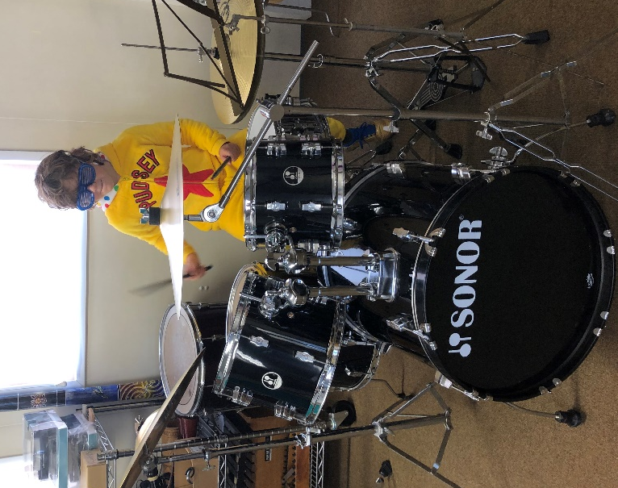

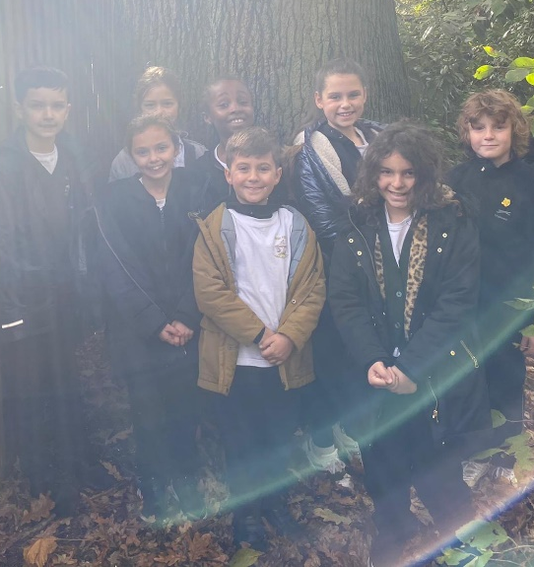

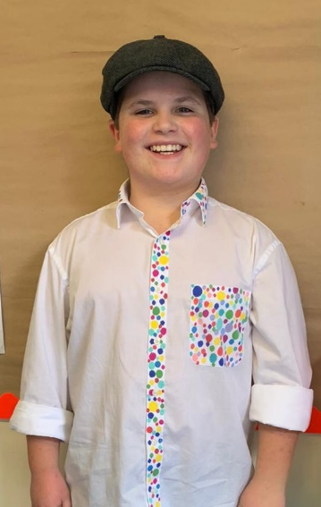
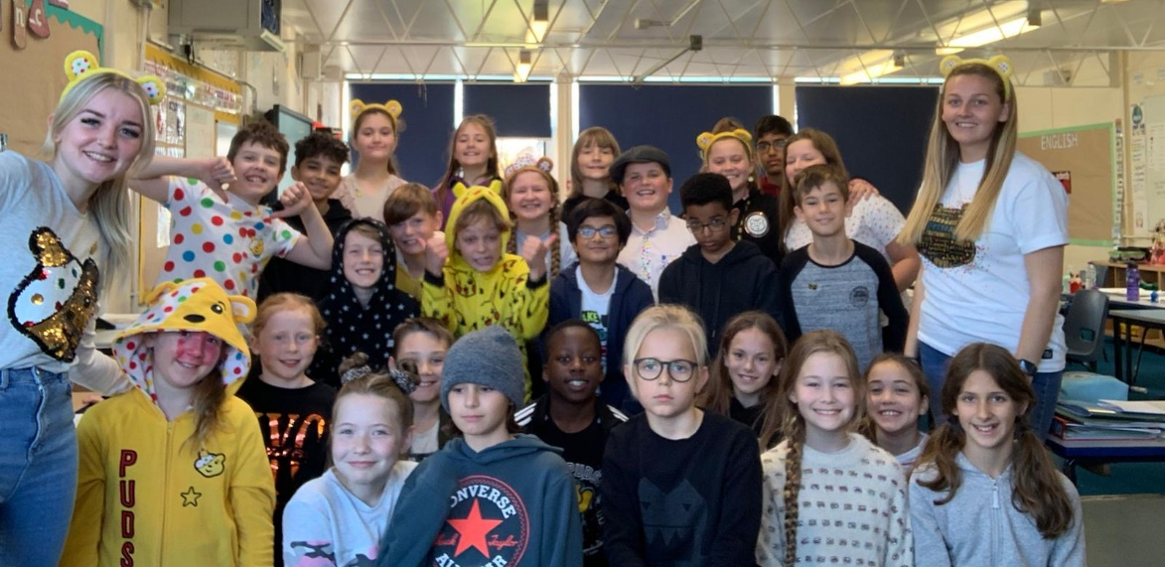
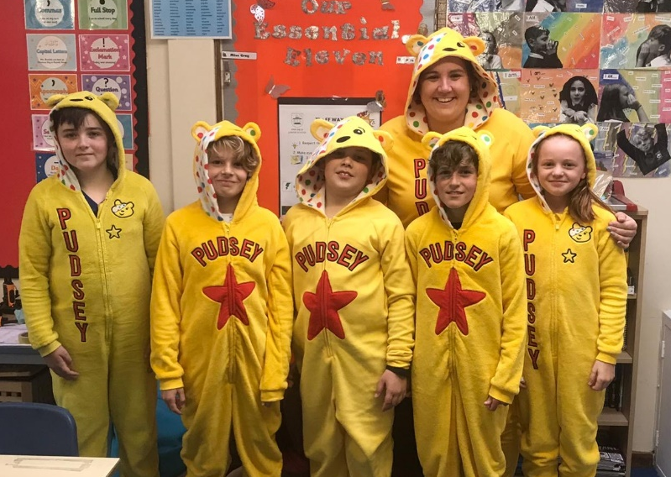

Keep In Touch
Email: admin@fairfield.herts.sch.uk
Tel: 01923 856 341
Fair Field Junior School
Watford Road,
Radlett, Hertfordshire, WD7 8LU

INBOUND MESSAGES from GATEWAY: 01923 750 087

Follow us!




@ffjsradlett

@FairFieldJrSch

Respect Honesty Perseverance Kindness Forgiveness Inclusion

Our very own Fair Field choir will be singing at 2.50pm. Come and support them before the switching on of the lights at 4.30pm by Sophie Perry.

