FAIR FIELD NEWS
Autumn Term Issue 11
Dear Parents and Carers,

I want to start by thanking Mrs Lakhani for our Diwali assembly last week. It was so great for the children to have a virtual visitor run an assembly that was so packed with information. Following on from the assembly, the children were able to learn more about the festival of Diwali through our whole school goals. This week’s whole school goals focused around anti-bullying week and keeping safe online. The children watched a superb video on E Safety compiled by our ICT club and had the chance to earn a badge designed by Tiaan. I hope they are proud of the badge they have earnt and the learning that we have done has embedded a subconscious understanding of feeling safe. The week begun with filming for our virtual open days. Thank you to all involved. We are looking forward to seeing the finished product. On Thursday, the founders of the Nature Nurturers visited the Recreation Ground to plant bulbs, which we are excited to watch bloom in the Spring. They also spotted the remaining bird and bat boxes. The winners of last term’s house points, Kendals, enjoyed their ice-cream factory and Disney reward this afternoon.

Thank you to those who have already supported the PTA, which helps to raise vital money to support the school. We have asked the PTA for support to buy, amongst other things, new dictionaries, new I pads and support classroom funds. The first 100 Club and Success draws will take place next Friday at 2pm. Be sure to get your tickets on Gateway!

Don’t forget this Sunday you are invited to switch on the winter lights from the comfort of your own home from 4.30pm. Get your snacks and drinks ready....let’s all do the countdown together. Visit www.aldenham-pc.gov.uk for login details

Mrs Goodwin and all the Fair Field staff

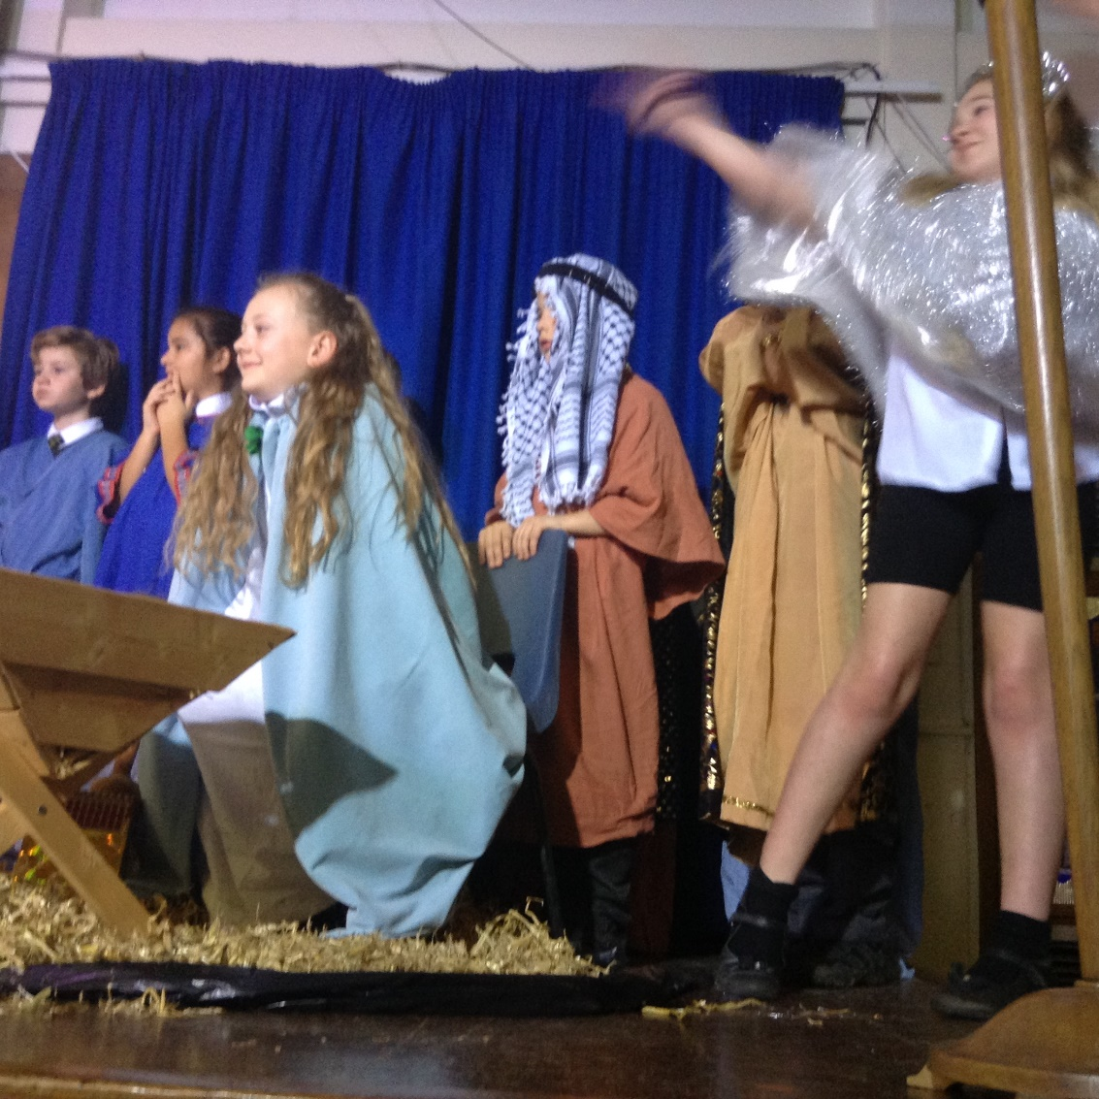

Dates for the Diary

Date | Time | Event | Year Group(s)
7th – 9th December | PM | PTA Discos | All
10th December | PM | Virtual Production | Year 4
11th December | 2.00pm | Reverend Fletcher’s virtual assembly | All
14th December | 1.30pm | Virtual Carol Service | Year 3
14th December | 2.15pm | Virtual Carol Service | Year 4
15th December | 1.30pm | Virtual Carol Service | Year 5
15th December | 2.15pm | Virtual Carol Service | Year 6
16th December | 12.00pm | Christmas lunch & jumper day! | All
16th December | 1.30pm | Virtual pantomime | All
18th December | 1.30pm | Last day of term | All
5th January | 8.50am | First day of Spring Term | All

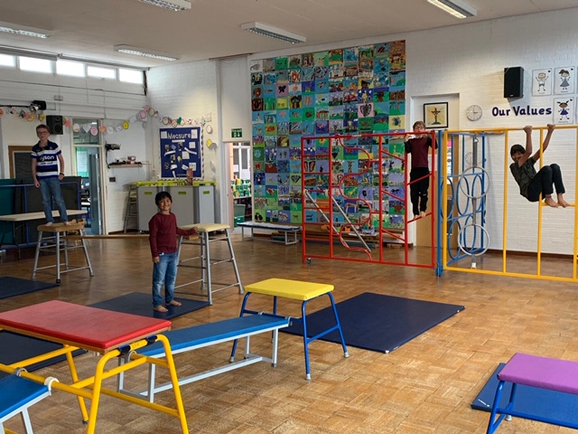

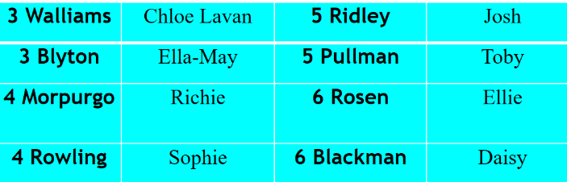


This week’s TT Winners

F Factor Superstars
.

Diamond Book Times Table Rock Stars

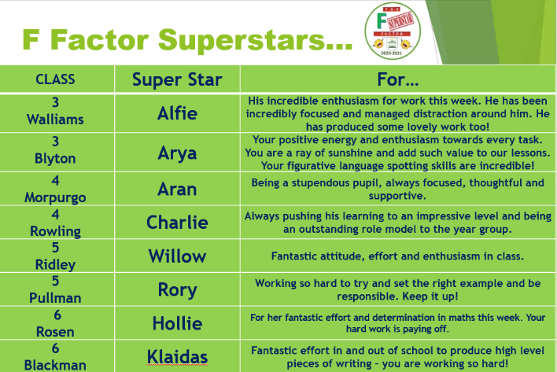
Lateness
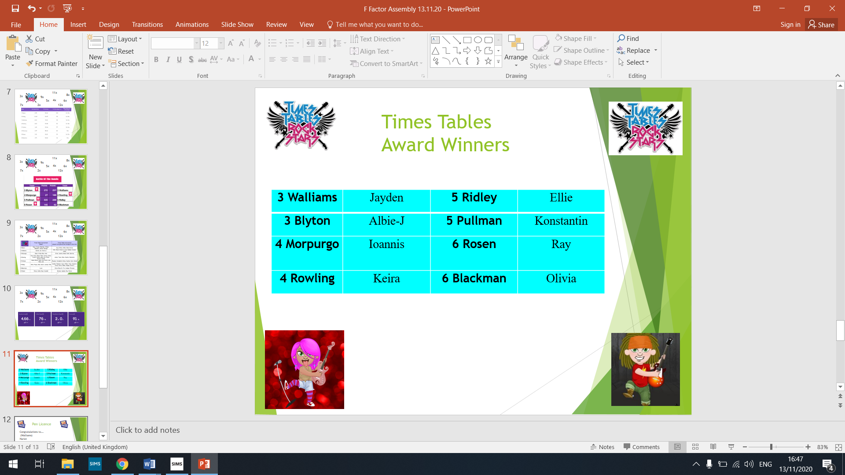



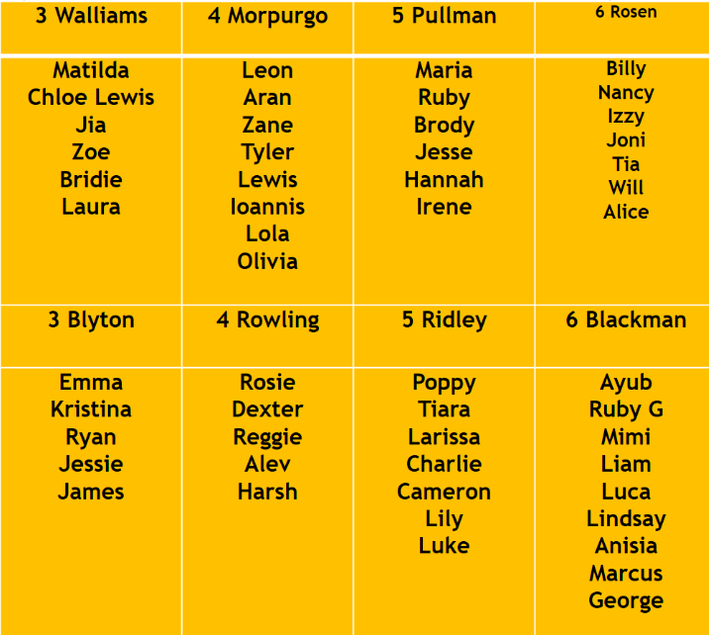
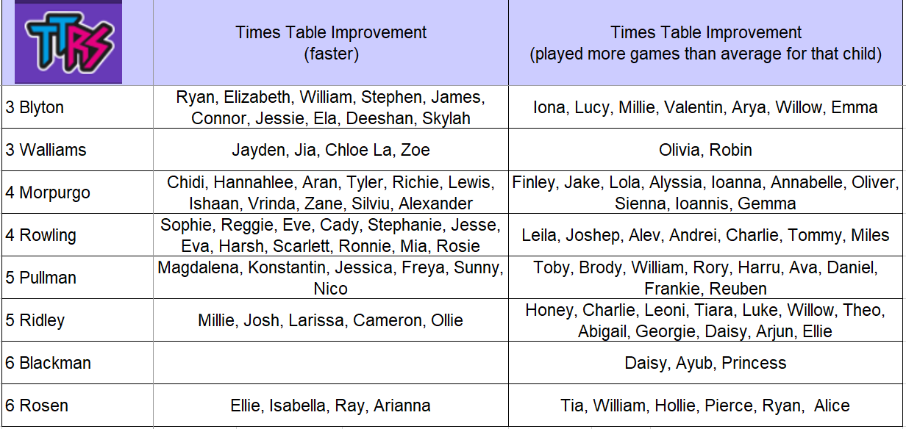

This week’s SUCCESS code winners were both Year 6 classes, who have won a new football for their playground boxes!
Attendance

Well done everyone! Our whole school attendance was
98% this week!
3 Walliams | 98% | 5 Ridley | 94%
3 Blyton | 98% | 5 Pullman | 99%
4 Morpurgo | 99% | 6 Rosen | 97%
4 Rowling | 98% | 6 Blackman | 98%

Blue Peter
.

We would like to inform you that Blue Peter on YouTube has been launched by CBBC. Blue Peter is the longest running kids TV show in the world and we are uploading videos to it that are suitable for 5-11 year olds. We have world record breaking challenges, arts and crafts, environmental videos, cooking and baking how tos, inspirational films, gaming, celebrity appearances, dance routines and music performances. They also feature ways of getting a Blue Peter badge, behind the scenes footage and extra content about our incredible presenters Adam, Lindsey, Mwaksy, Richie and Henry the Blue Peter dog.
If you think you would be interested in this, please subscribe to https://www.youtube.com/bluepeter - (it’s obviously completely free to subscribe!) and don’t forget to watch the live programme on CBBC at 5.30pm every week, or on BBC iPlayer.



PTA Update
Our PTA have launched the 100 Club for the adults and Success Raffle for the children. Please support our school in any way you can and you never know – you may win! The first draw is next Friday!!

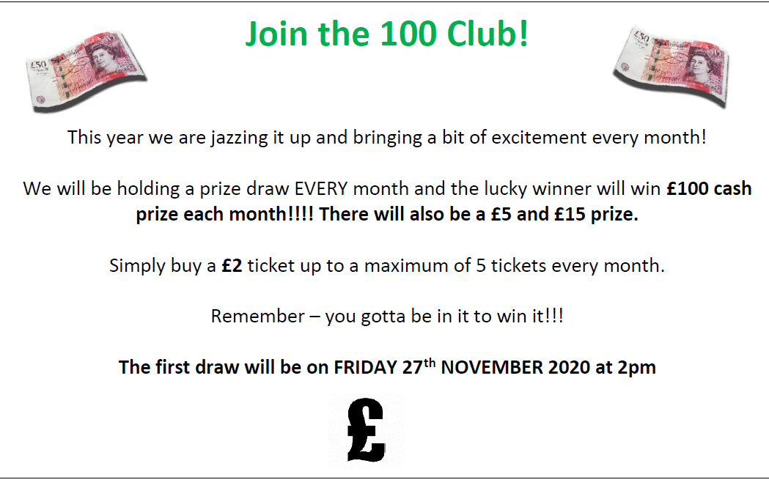

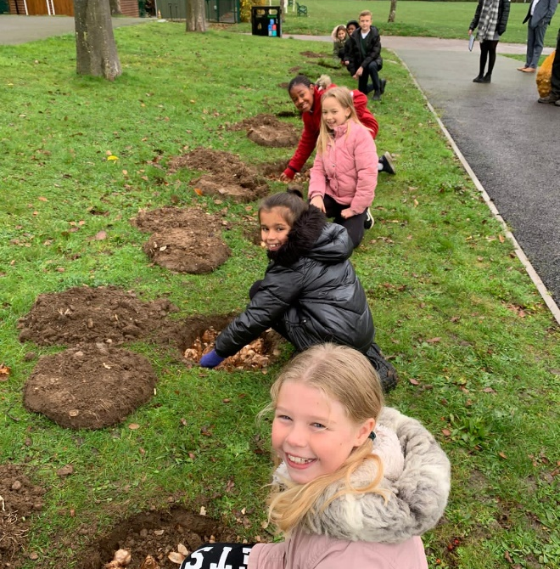
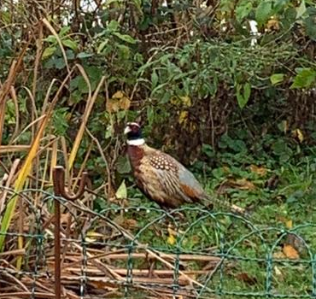
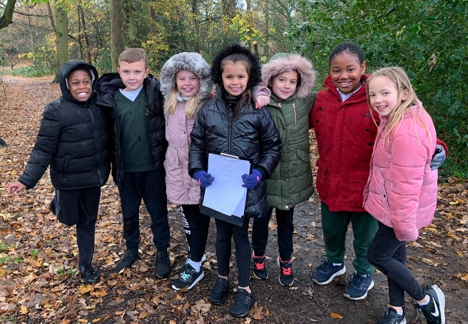
Gallery

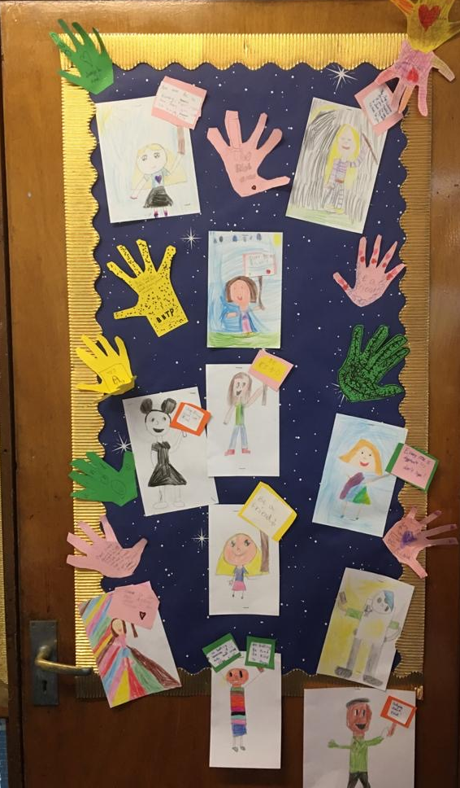
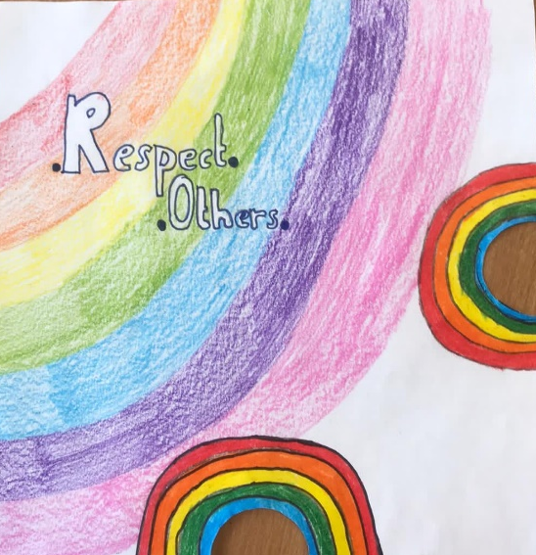

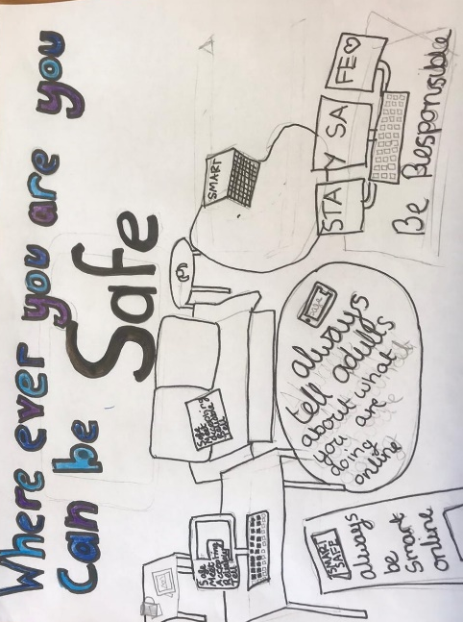



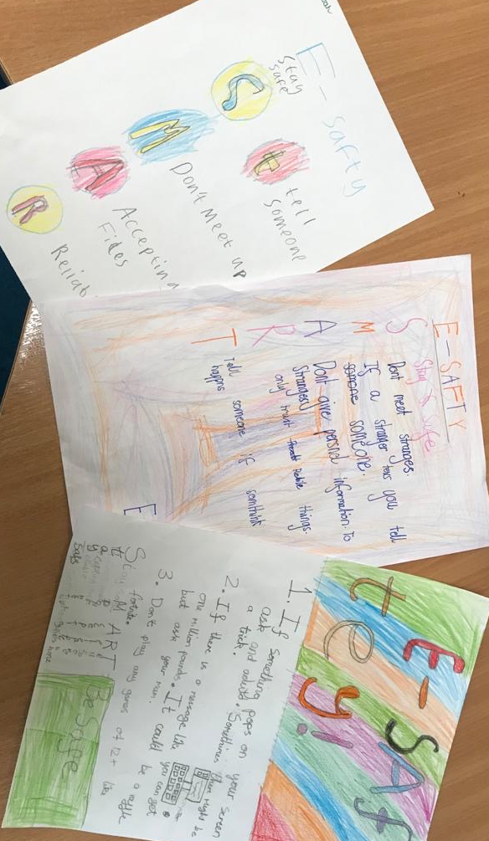



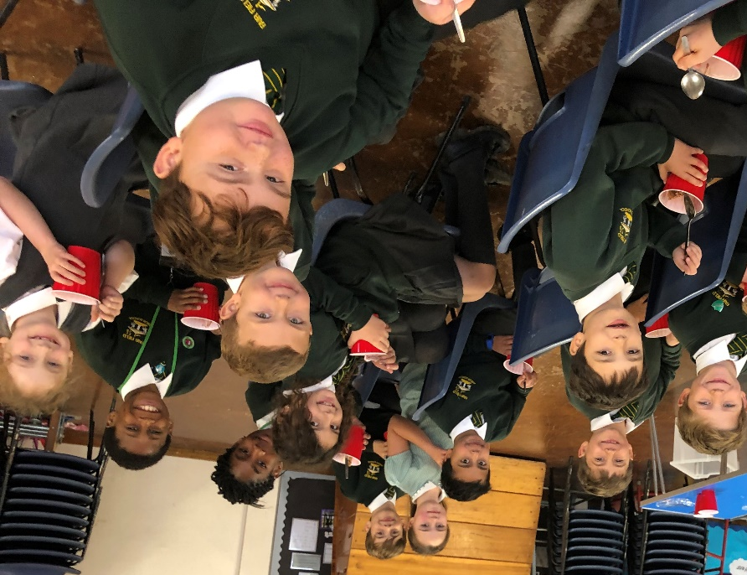

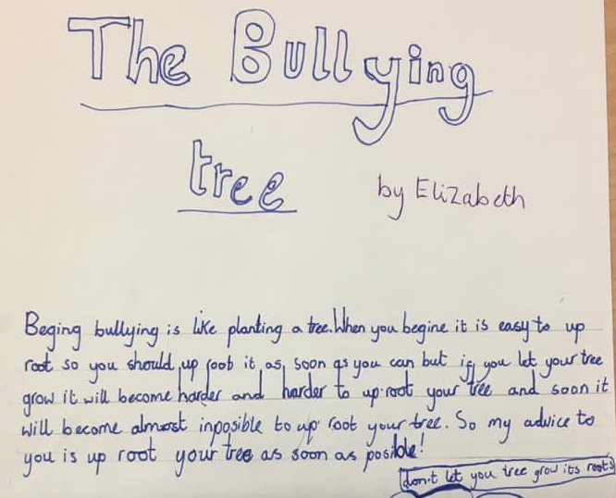

Keep In Touch
Email: admin@fairfield.herts.sch.uk
Tel: 01923 856 341
Fair Field Junior School
Watford Road,
Radlett, Hertfordshire, WD7 8LU

INBOUND MESSAGES from GATEWAY: 01923 750 087

Follow us!




@ffjsradlett

@FairFieldJrSch

Respect Honesty Perseverance Kindness Forgiveness Inclusion

Our very own Fair Field choir will be singing at 2.50pm. Come and support them before the switching on of the lights at 4.30pm by Sophie Perry.

