FAIR FIELD NEWS
Autumn Term Issue 12
Dear Parents and Carers,

We want to whole-heartedly thank everyone for supporting the PTA events this week. At 2.15pm, during our virtual F Factor Assembly we drew the winners for both the children’s success raffle and the 100 Club. Winners have now been notified and we look forward to announcing December’s winners! Thank you to the PTA members for all they continue to do to support our school. We also wish to thank the parents of Poppy Olivia, who this week donated a bank of dictionaries this week. The generosity of the community at this difficult time is overwhelming. This week it was the turn of our Year 5 Eco Warriors and Nature Nurturers to visit the Recreational Ground and monitor the bird boxes. They were also introduced to the oldest tree in the wood! Year 4 have been working hard on their production of Cinderella Rockafella and we are very proud of how they have been learning their lines and timetabling in rehearsals around their curriculum subjects. Practise has also begun for the Carol Concert following Government guidelines and it is so wonderful to hear the children singing again.

Throughout the week, Police have visited our site in the mornings to monitor the traffic and we can report that they were pleased with the systems we have in place following their suggestions. Just a reminder, they have asked parents to exit the site by turning left and use the roundabout to return if necessary. In the interests of COVID safety, we would like to thank all parents and carers who are wearing face masks at these times; this precautionary measure is very important when people are passing through our school site at the same time. From Monday the children will see each classroom has a “no no” box where adults outside their bubble may stand for a short period of time whilst wearing a mask. We will be asking the children not to enter the “no no” box to maintain social distancing. Again this is a precautionary measure in the event another adult is required to be present in the class.

Lastly, we are excited to announce that in line with Government guidelines our extra curricular after school clubs with Radlett Gym Club and Mr Flynn will return from Wednesday 2nd December.
Wishing you a restful weekend.

Mrs Goodwin and all the Fair Field staff

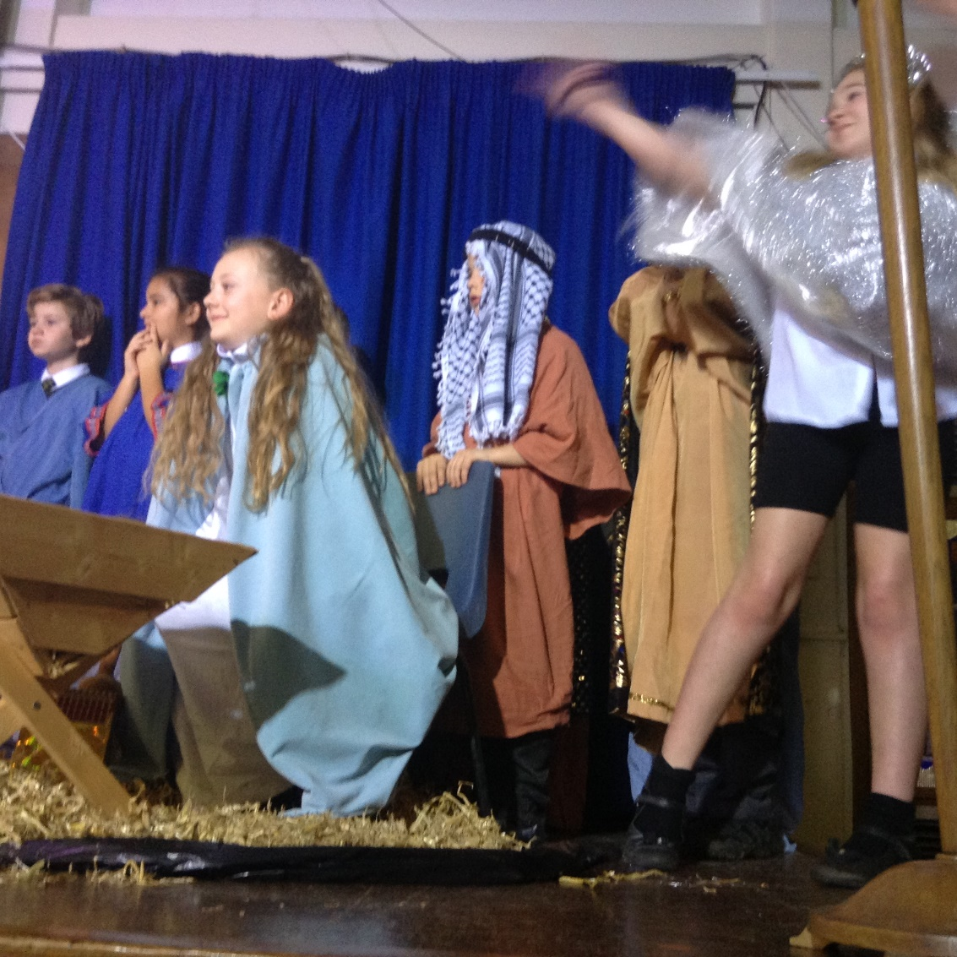

Dates for the Diary

Date | Time | Event | Year Group(s)
7th – 9th December | 1.30pm | PTA Discos | All
10th December | 2.00pm | Virtual Production | Year 4
11th December | 2.00pm | Reverend Fletcher’s virtual assembly | All
14th December | 1.30pm | Virtual Carol Service | Year 3
14th December | 2.15pm | Virtual Carol Service | Year 4
15th December | 1.30pm | Virtual Carol Service | Year 5
15th December | 2.15pm | Virtual Carol Service | Year 6
16th December | 12.00pm | Christmas lunch & jumper day! | All
16th December | 1.30pm | Virtual pantomime | All
17th December | 1.30pm | Chanukah Celebrations | All
18th December | 1.30pm | Last day of term | All
5th January | 8.50am | First day of Spring Term | All

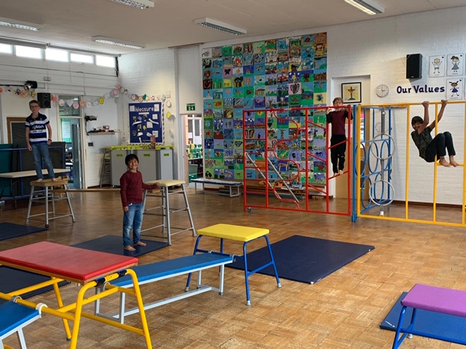

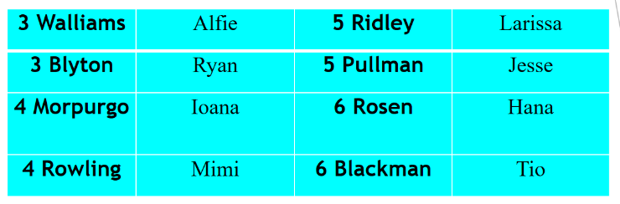


This week’s TT Winners

.

Diamond Book

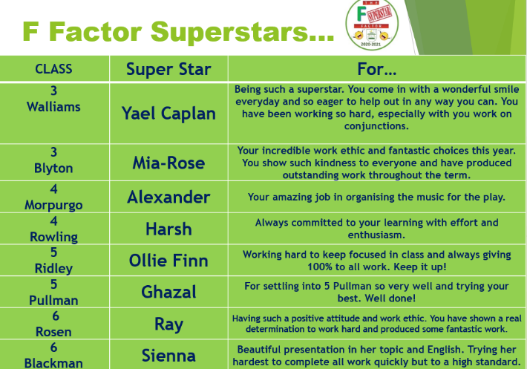
Lateness


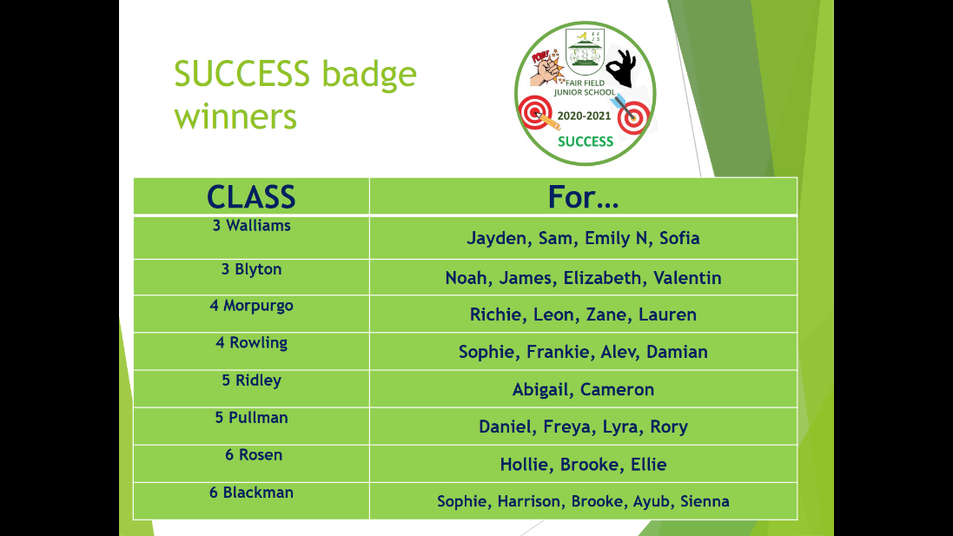

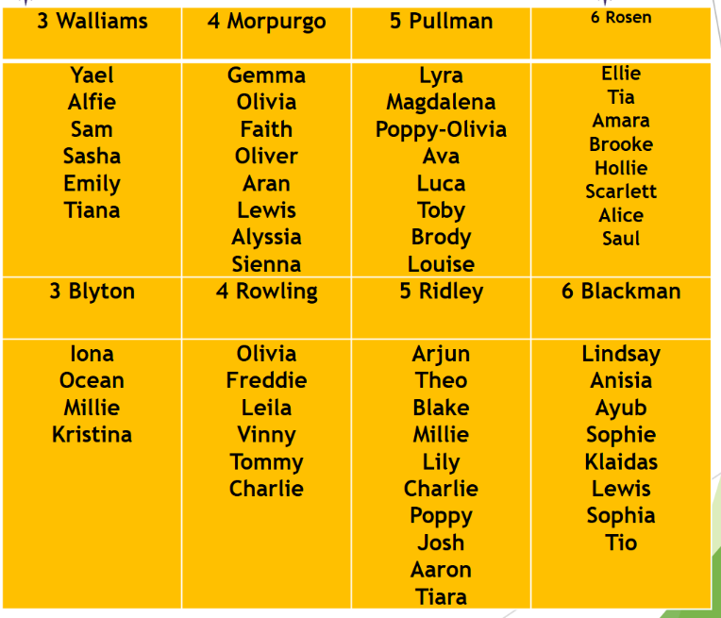

This week’s SUCCESS code winners were 5 Pullman, who have won a new basketball for their playground box!

Attendance

WOW! Every class has attendance above 96%!
3 Walliams | 98% | 5 Ridley | 97%
3 Blyton | 99% | 5 Pullman | 99%
4 Morpurgo | 99% | 6 Rosen | 99%
4 Rowling | 98% | 6 Blackman | 98%

Gallery

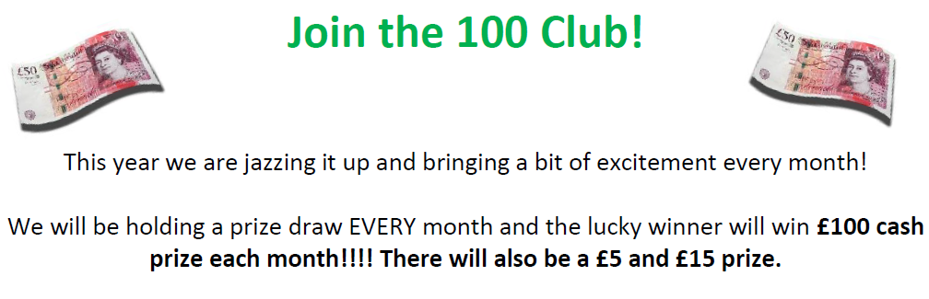
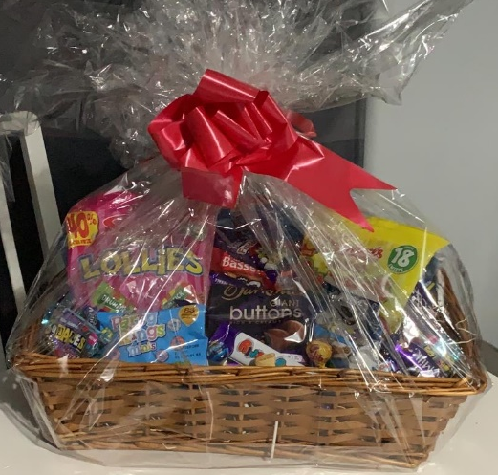

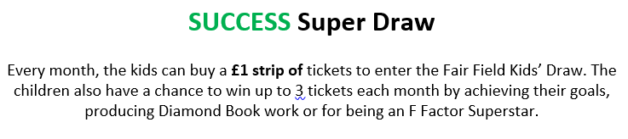

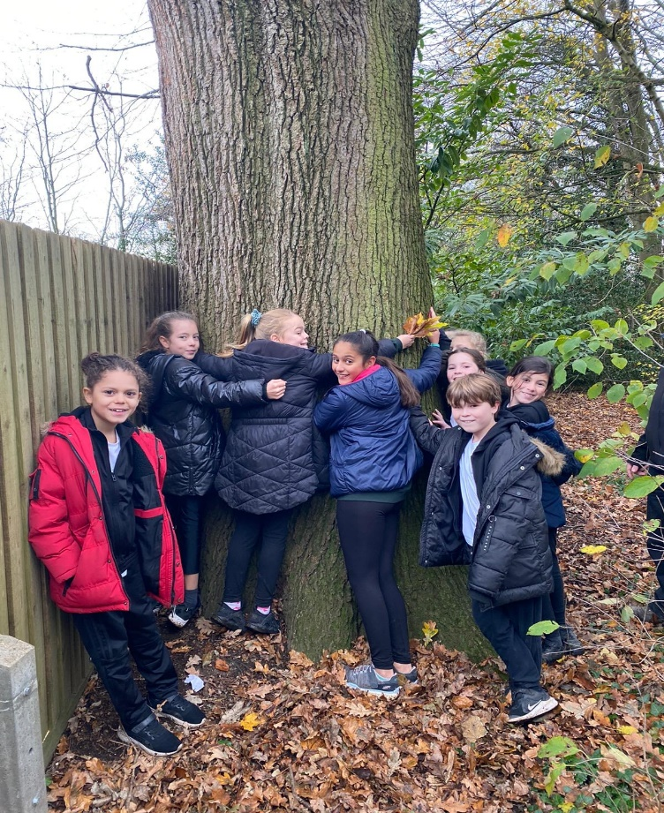
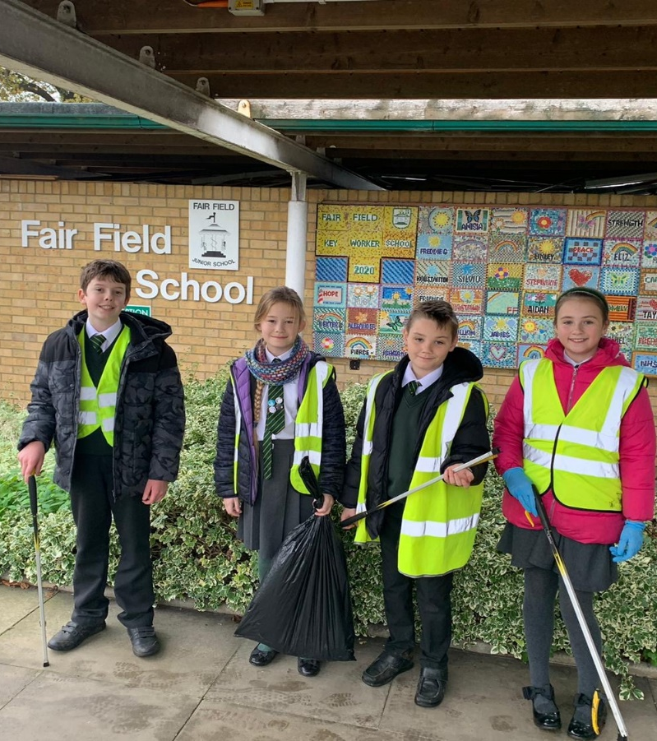

Site force have been on a
litter pick this week!
Y5 hugging the oldest tree in the wood!

Keep In Touch
Email: admin@fairfield.herts.sch.uk
Tel: 01923 856 341
Fair Field Junior School
Watford Road,
Radlett, Hertfordshire, WD7 8LU

INBOUND MESSAGES from GATEWAY: 01923 750 087

Follow us!



@ffjsradlett

@FairFieldJrSch

Respect Honesty Perseverance Kindness Forgiveness Inclusion

Our very own Fair Field choir will be singing at 2.50pm. Come and support them before the switching on of the lights at 4.30pm by Sophie Perry.

