FAIR FIELD NEWS
Summer Term Issue 2
Dear Parents and Carers,

We have successfully completed our first full week back! Staff feel so proud of the resilience and enthusiasm inside your children – who have adapted to our new ways seamlessly. We thank you for your support as we continue to work had to make everything as easy as possible, whilst maintaining necessary systems and processes. If you have any concerns please do not hesitate to get in touch with the school office, by telephone or email. We are starting to bring back the return of extra-curricular activities from next week, including at lunchtime and after school. If you are unsure about the options available, please get in touch.

From next week we will be holding meet the teacher through Google Meets. The dates and times of these meetings are below. There will also be a link sent via text message nearer the time. This link will also be posted onto your child’s Google Classroom. We hope you can join us for this virtual get together!

Please can I remind you to ensure your child has a healthy snack for playtime to keep them going until lunch. Many thanks.

Wishing you a relaxing weekend.

Mrs Aharon & Mrs Goodwin

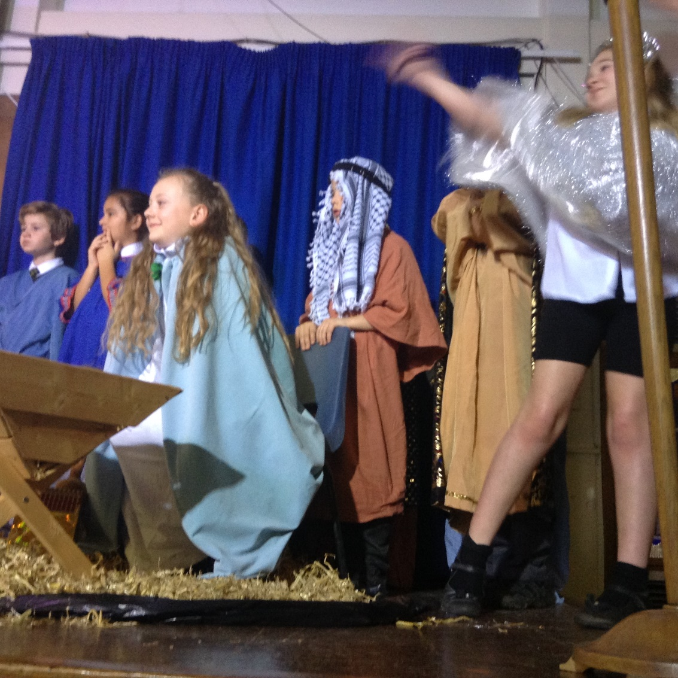
F Factor Superstars
3 Walliams | 3  Blyton | 4 Morpurgo | 4 Rowling | 5  Ridley | 5  Pullman | 6  Rosen | 6  Blackman
Sam | Valentin | Marat | Eve | Luke | Toby | William | Harrison
Tiana | Jessie | Hannahlee | Miles | Tiara | Hannah | Penny | Ruby Ghioc

Diamond Book
6 Rosen | Alice, Finn, Will, Scarlett, Harry, Brooke, Saul & Tia | 5 Ridley | Theo, Georgie, Aaron, Daisy, Milly, Honey
6 Blackman | Tio, Pratham, Vinnie & Izak | 5 Pullman | Brody, William, Daniel, Harry
4 Morpurgo | Oliver, Vrinda, Gemma, Jake, Lewis, Rassim | 3 Walliams | Emily N, Emily S, Bridie, Sofia, Sasha, Chloe Lewis,
4 Rowling | Eve, Scarlett, Vinny, Sophie | 3 Blyton | Mia-Rose, Elizabeth, Lucy

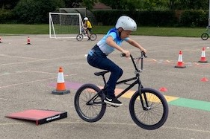

Dates for the Diary

Date | Time | Event | Year Group(s)
Wednesday 16th September | 6.00-6.45pm | Meet the teacher | Year 6
Thursday 17th September | 4.30-5.30pm | Meet the teacher | Year 5
Wednesday 23rd September | 4.30-5.15pm | Meet the teacher | Year 3
Wednesday 23rd September | 5.30-6.15pm | Meet the teacher | Year 4
Friday 13th November | Afternoon | Nasal flu immunisation | All year groups



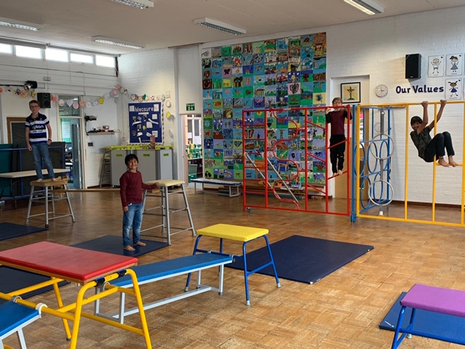



Our PTA Need you!

If you are interested in joining the PTA please email the office and we will be in contact. We are really keen to put
on some socially distanced and virtual events this term.


Keep In Touch
Email: admin@fairfield.herts.sch.uk
Tel: 01923 856 341
Fair Field Junior School
Watford Road,
Radlett, Hertfordshire, WD7 8LU

INBOUND MESSAGES from GATEWAY: 01923 750 087

Follow us @FairFieldJrSch


Lateness

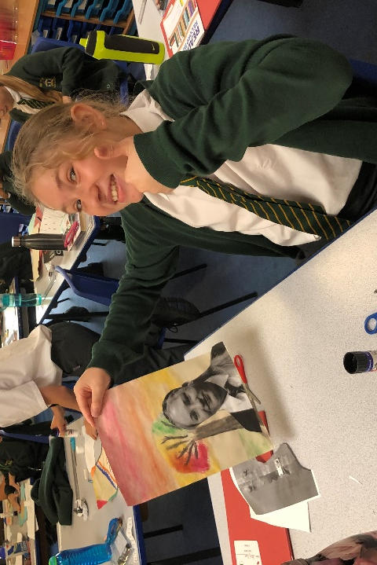
Take a look at some of our amazing learning from this week

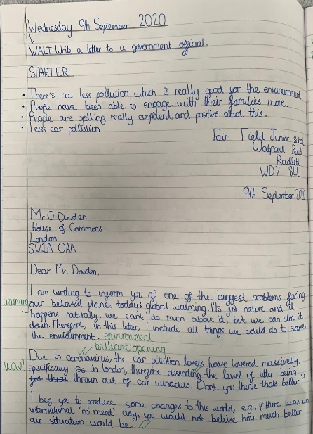

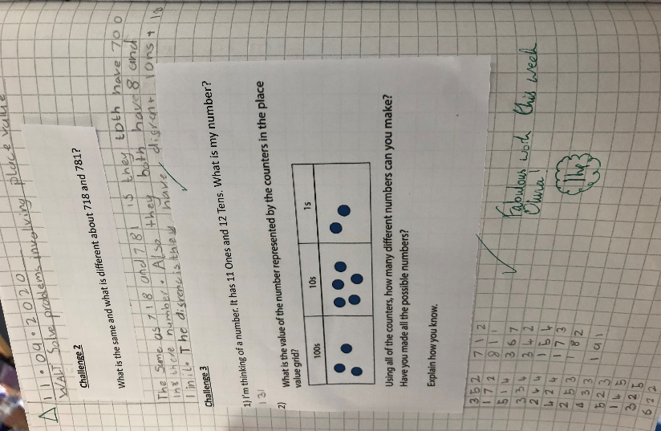

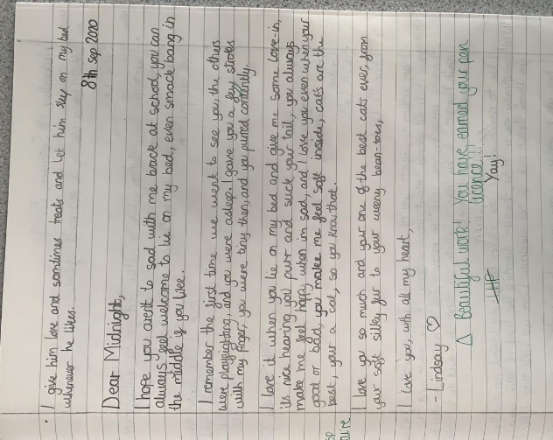
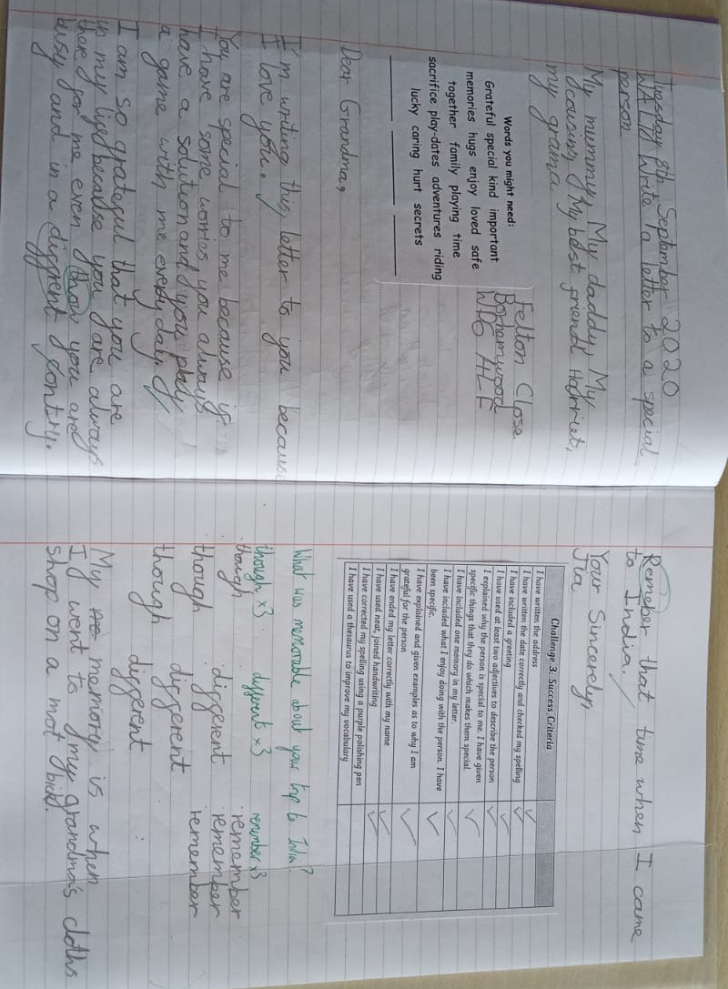

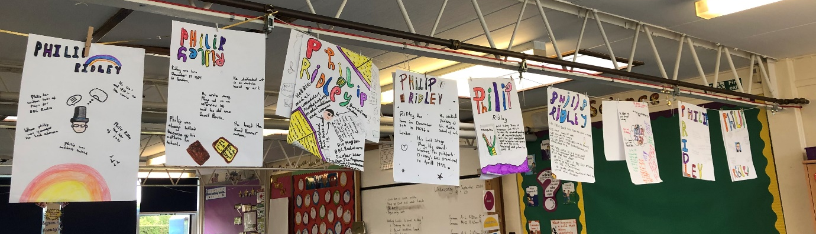

Respect Honesty Perseverance Kindness Forgiveness Inclusion

Our very own Fair Field choir will be singing at 2.50pm. Come and support them before the switching on of the lights at 4.30pm by Sophie Perry.

