FAIR FIELD NEWS
Summer Term Issue 3
Dear Parents and Carers,

We have been enjoying the good weather this week and continuing to immerse ourselves back into school life. The children have been producing some fabulous learning and enjoying happy times with their friends. We have now announced who will take the roles of meet and greeters, school council and sports council and offer our congratulations to the children stepping into these roles. We held the first two of our Welcome Back virtual meetings and thank those, who were able, for attending. We apologise to some Year 6 parents who were unable to get on due to a mix up with codes. All the information will be loaded onto Google Classroom after each meeting if you were unable to attend or wish to revisit.
Thank you for adhering to the one-way system and continuing to respect social distancing. Can we also ask that you do not block any driveways or pavements, allowing our neighbours to access their houses and pedestrians to use the paths safely.
You will see below that we will be holding parent consultations virtually, using Google Meet, next month. Next week you will receive more information on how to book these slots.
Wishing you a relaxing weekend.

Mrs Aharon & Mrs Goodwin

F Factor Superstars Diamond Book

3 Walliams | Laura | Joey
3 Blyton | Ocean | George
4 Morpurgo | Teddy | Ruby
4 Rowling | Ollie | Tommy
5 Ridley | Oliver | Leonie
5 Pullman | Filip | Irene
6 Rosen | Amara | Billy
6 Blackman | Vinnie | Liam

Well done to all of our award
winners this week!

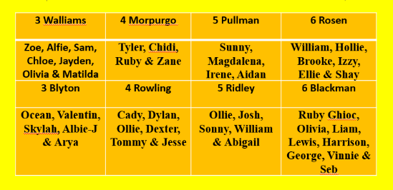
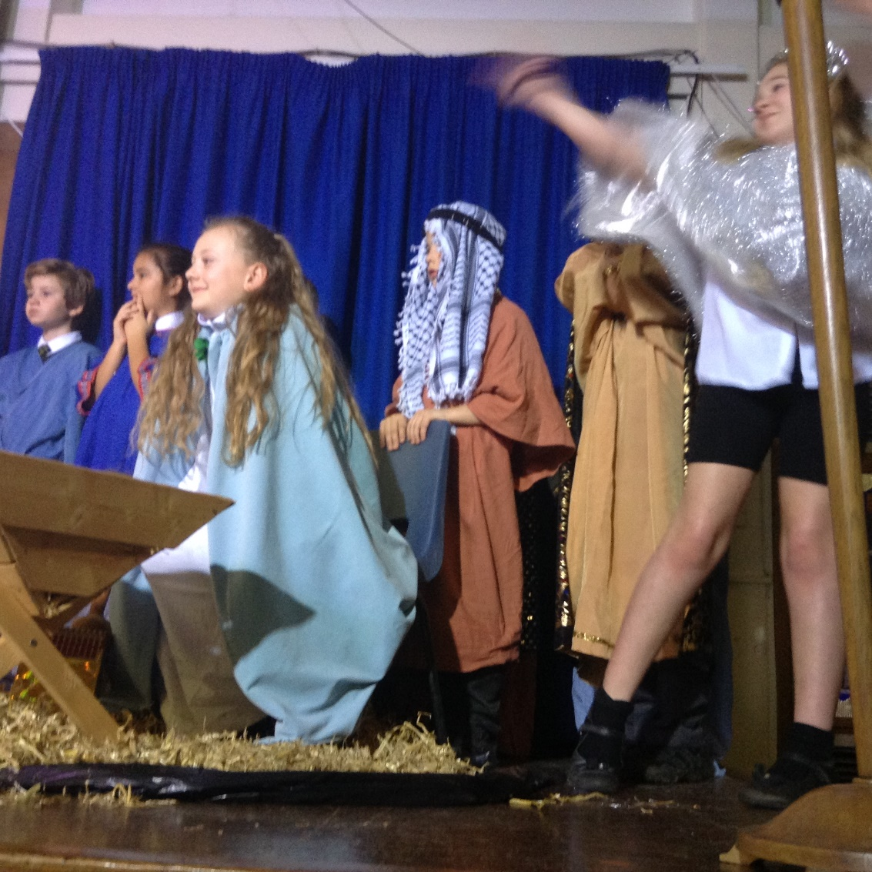

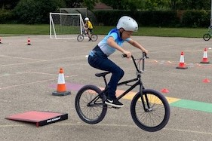
Times Tables Awards
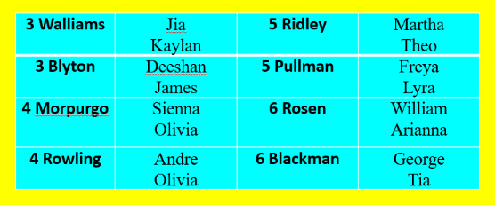

Dates for the Diary

Date | Time | Event | Year Group(s)
Wednesday 23rd September | 4.30-5.15pm | Meet the teacher | Year 3
Wednesday 23rd September | 5.30-6.15pm | Meet the teacher | Year 4
Friday 13th November | Afternoon | Nasal flu immunisation | All year groups
2nd October | 2.00pm | Harvest Celebration | All
Tuesday 13th & Wed 14th October | 3.30-6.00pm | Virtual Parent meetings | All

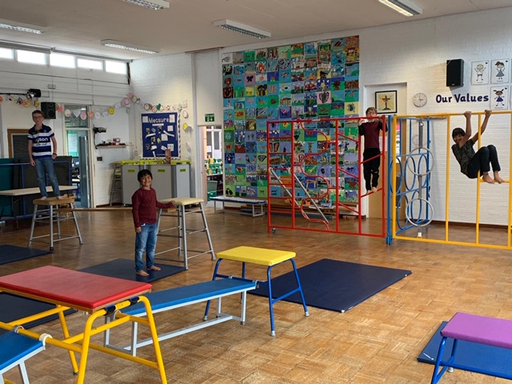

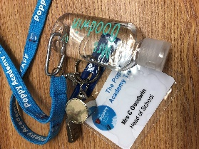
Personalised hand sanitiser

One of our Year 5 parents, Nikki Smith, has kindly made all members of staff a personalised hand sanitiser for our lanyards. Many thanks. If you would like one for your child or anyone you know they are £2.50 each.


Keep In Touch
Email: admin@fairfield.herts.sch.uk
Tel: 01923 856 341
Fair Field Junior School
Watford Road,
Radlett, Hertfordshire, WD7 8LU

INBOUND MESSAGES from GATEWAY: 01923 750 087

Follow us @FairFieldJrSch


Lateness

Recreation area

Aldenham Parish Council has produced a plan for the recreation ground and over the next eighteen months it is looking to invest heavily in facilities and the look of the recreation area. They would like to have some input into our ideas from the pupils and parents of the school and have a closer relationship with us
For example they have the following actions to take place over the winter/spring of 2020/21 and wonder if the pupils/teachers wish to be involved
• Spring time bulbs to be planted near the Multi Use Play Area
• Bird boxes to be installed in the wood, as well as recording use
• 210 trees (whips) to plant
We will be putting a team together to volunteer. If you have any ideas for the area or can offer help you can add them to the stream on the library.

Fair Field Culture Competition
- The competition will be virtual - so judging will be based on the submitted video.
- The performance can be any genre, no longer than 3m30s etc.
- The judging criteria is attached
- Costume is not required - and will not play any role in the judging.
- There will be competitions for KS2 lower and upper
- There is a maximum number of entries from a school of 5. One from each house and one from Mrs Goodwin.
Entry Procedure
- The initial entry must be submitted to a house captain by FRIDAY 9th OCTOBER at 5pm. Let your teacher know
- The video deadline is Friday 6th November. The video needs to be the finished piece. We will add a folder to Google Classroom or we can video for you in school
- Videos should not include graphics, titles or other identifiers with pupil or school name. All we will need is the participant number. This is part of our child protection and GDPR policy.
- The videos will only be seen by us and the judges and not used on any website / social media etc.
- Entries must come via the school. You cannot send an entry direct to the competition.

Prizes
- All participants will get a certificate.
- The winners will get trophies. We will announce the winners in the F Factor on Friday 13th November
- The 5 winners will have their entry sent to the competition.

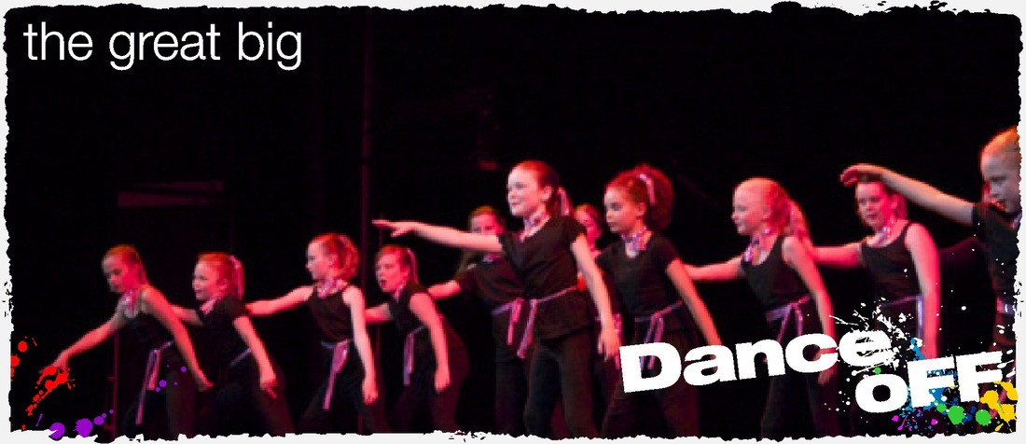
SOLO COMPETITIO
Respect Honesty Perseverance Kindness Forgiveness Inclusion

Our very own Fair Field choir will be singing at 2.50pm. Come and support them before the switching on of the lights at 4.30pm by Sophie Perry.

