FAIR FIELD NEWS
Summer Term Issue 4
Dear Parents and Carers,

This week the children have begun preparing for a pentathlon in their PE lessons, which is very exciting, and immersing themselves in all areas of school life. From Monday we were able to resume extra-curricular activities, both at lunchtime and after school. We welcomed back Radlett Gym Club and we launched some exciting new clubs, including ICT and Art. Mr Flynn also started clubs in football and athletics. Further down this week’s newsletter you will find information for booking onto these. From next week, you will be able to book a slot for a virtual parent consultation using the school website. These will be 10 minute slots and we will provide you with a google meet link to access. We really hope you are able to join us. If you are eligible for Free School meals, please get in touch with us and we can help you to access these. Wishing you a peaceful weekend

Mrs Goodwin

F Factor Superstars Diamond Book

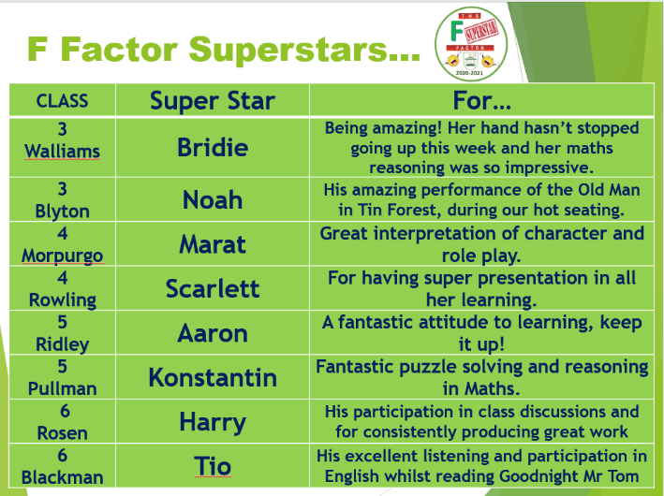


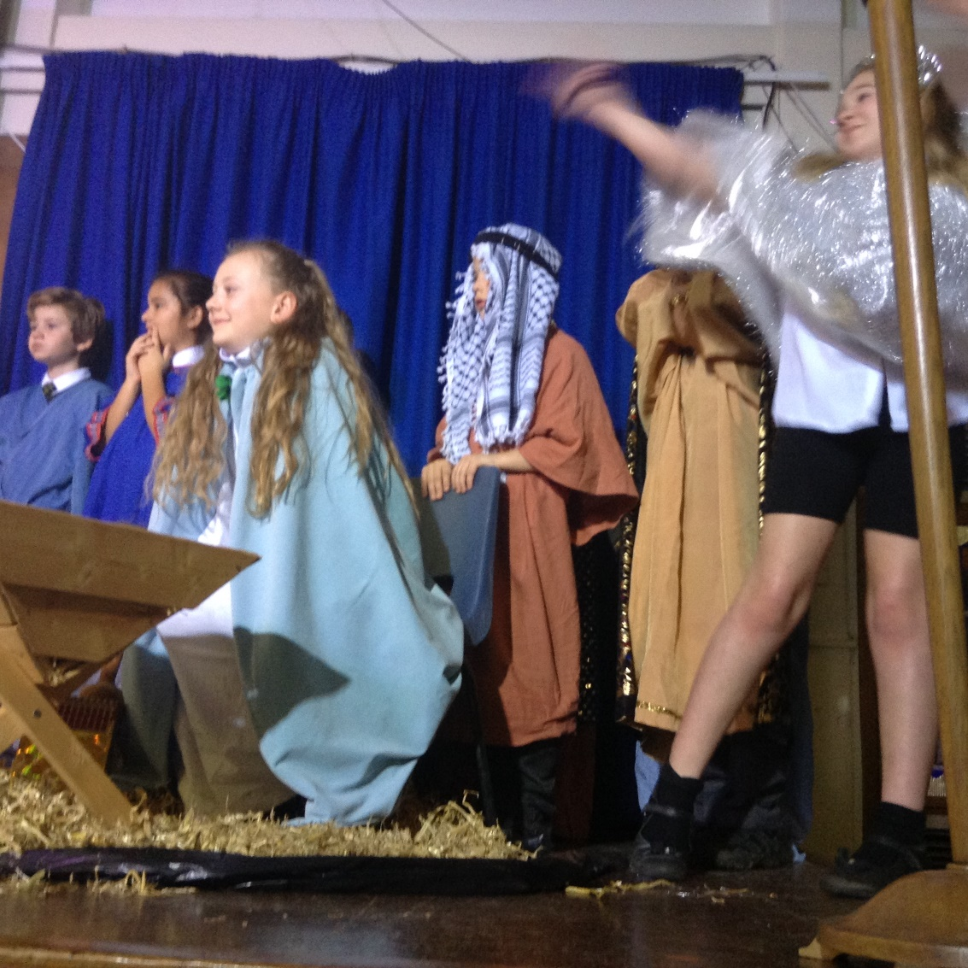

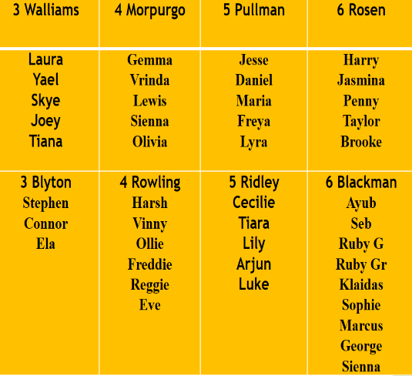

Dates for the Diary

Date | Time | Event | Year Group(s)
Friday 13th November | Afternoon | Nasal flu immunisation | All
Friday 2nd October | 2.00pm | Harvest Celebration | All
Friday 2nd October | All day | Y6 WW2 Immersion day | Year 6
5th October | All month | Black History Celebrations | All
5-9th October | All week | Walk to School week | All
Monday 12th – Friday 16th October | All Week | Black History focus week | All
Tuesday 13th & Wed 14th October | 3.30-6.00pm | Virtual Parent meetings | All

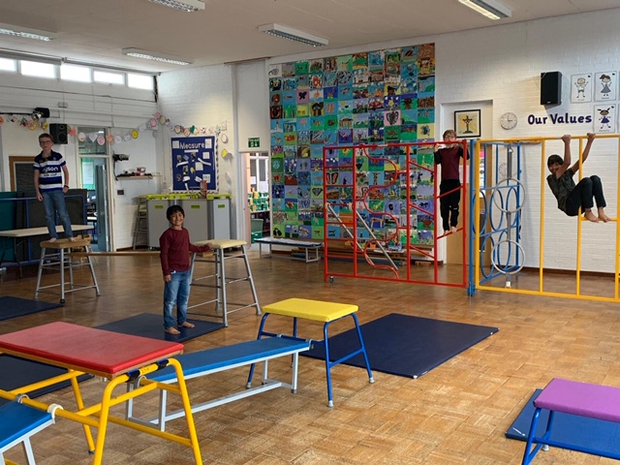

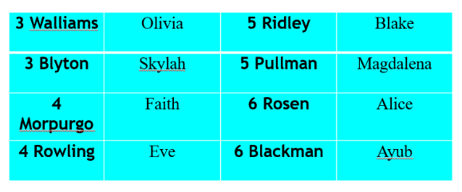


This week’s TT Winners

Extra-Curricular Opportunities

Club | Day | Times | Year Group(s) | Cost | Places available
ICT | Monday | 12.30-1.00pm | Year 3&4 | £15 / ½ term | No
Athletics | Monday | 3.15-4.15pm | Year 5&6 | £60 / term | Yes
Art | Tuesday | 12.30-1.15pm | Year 5&6 | £20 / ½ term | Yes
French | Wednesday | 12.15-12.40pm | Year 3&4 | £30 / term | Yes
French | Wednesday | 12.50-1.15pm | Year 5&6 | £30 / term | Yes
Girls’ football | Wednesday | 3.15-4.15pm | All Years | £60 / term | Yes
Football | Thursday | 3.15-4.15pm | All Years | £60 / term | Yes
Chess | Friday | 12.15-12.40pm | Year 3&4 | £50 / term | Yes
Chess | Friday | 12.50-1.15pm | Year 5&6 | £50 / term | Yes

Art, French & Chess club can be paid for on School Comms

For Football and Athletics please email your child’s details to: m.flynn@fairfield.herts.sch.uk
and pay by bank transfer using the following details:
Account: Mr Matthew A Flynn
Account No: 74734164 Sort Code: 60-03-12 Ref: FFA/Childs Full Name

[Please contact the office before paying as we will pro rata the cost]

Lateness

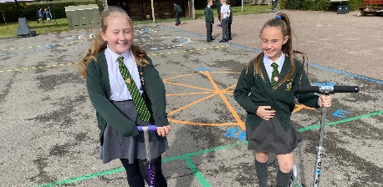
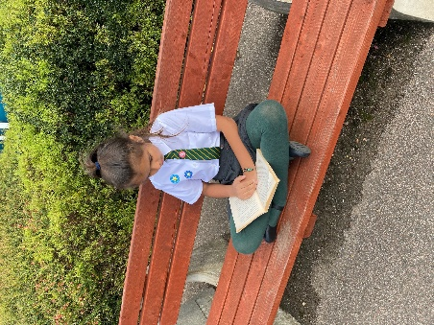
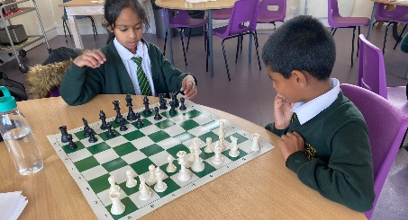




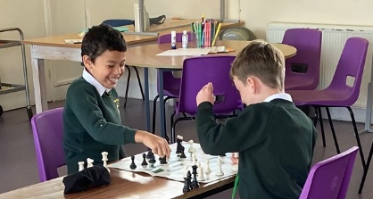
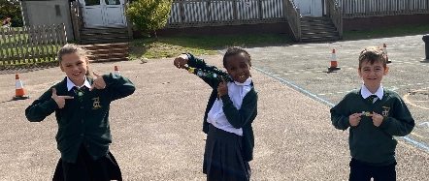
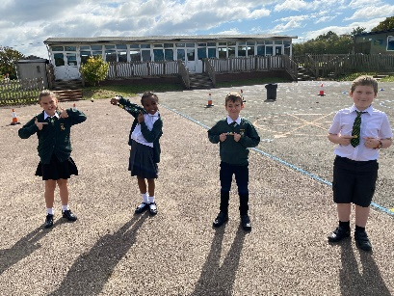
Follow us @FairFieldJrSch
Keep In Touch
Email: admin@fairfield.herts.sch.uk
Tel: 01923 856 341
Fair Field Junior School
Watford Road,
Radlett, Hertfordshire, WD7 8LU

INBOUND MESSAGES from GATEWAY: 01923 750 087

Respect Honesty Perseverance Kindness Forgiveness Inclusion

Our very own Fair Field choir will be singing at 2.50pm. Come and support them before the switching on of the lights at 4.30pm by Sophie Perry.

