FAIR FIELD NEWS
Summer Term Issue 5
Dear Parents and Carers,

Thank you to those who have booked onto the virtual parent consultations. If you are yet to do so there are still slots available. Please call the office if you are having trouble, where someone will be happy to help you. This week we asked the children to complete some assessments. The children were fabulous and we were so impressed at their retention of knowledge, not only over the summer (which is challenging in itself!) but through lockdown. These assessments were to inform the teachers’ planning, to ensure any knowledge gaps from last year are closed and we maximise our curriculum time. Today Year 6 travelled back to the 1940s with a WW2 topic day. In their brilliant outfits, they spent some time sampling rationed food and hiding out in an air raid shelter! We are excited to launch Black History Month next week, where children will be immersing themselves in texts and discussion around a variety of subject relevant topics. We will also be celebrating the Harvest and ask for a small donation towards the food bank.
Take Care
Mrs Goodwin

Mrs Goodwin

F Factor Superstars Diamond Book




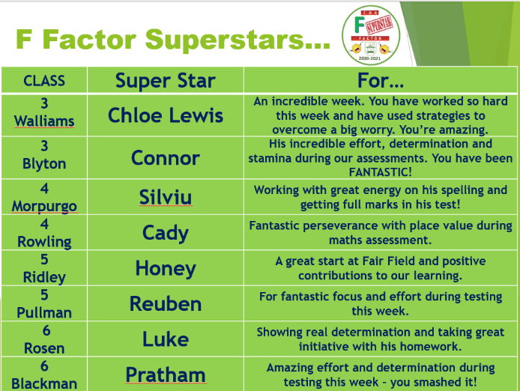
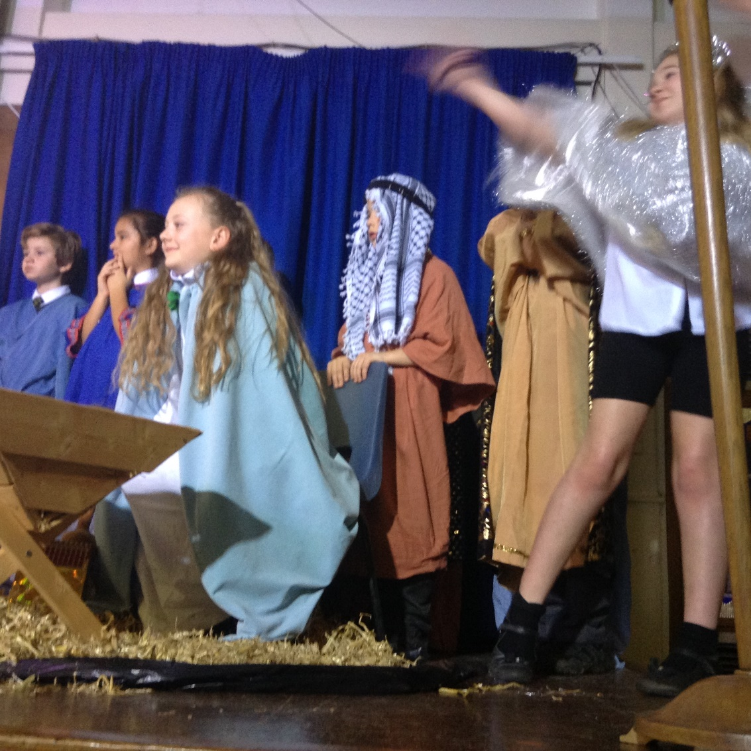

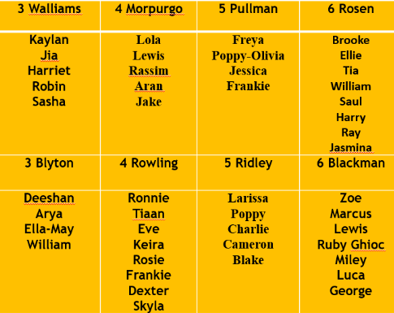

Dates for the Diary

Date | Time | Event | Year Group(s)
Monday 5th October | All day | School Photos | All
5th October | All month | Black History Celebrations | All
5-9th October | All week | Walk to School week | All
9th October | 2.15pm | Harvest Celebration | All
Monday 12th – Friday 16th October | All Week | Black History focus week | All
Tuesday 13th & Wed 14th October | 3.30-6.00pm | Virtual Parent meetings | All
Friday 13th November | Afternoon | Nasal flu immunisation | All

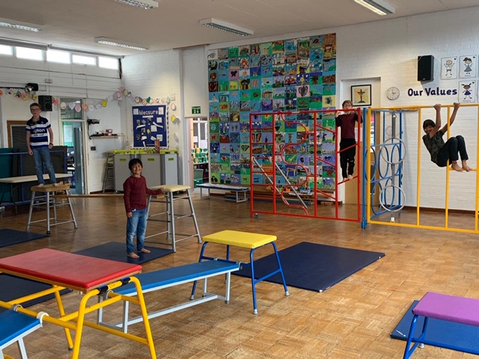

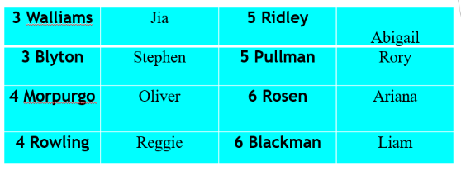


This week’s TT Winners

Gallery
Our circle of friends - connecting us all together, sketching techniques in Year 3 and WW2 immersion day in Year 6.

Lateness
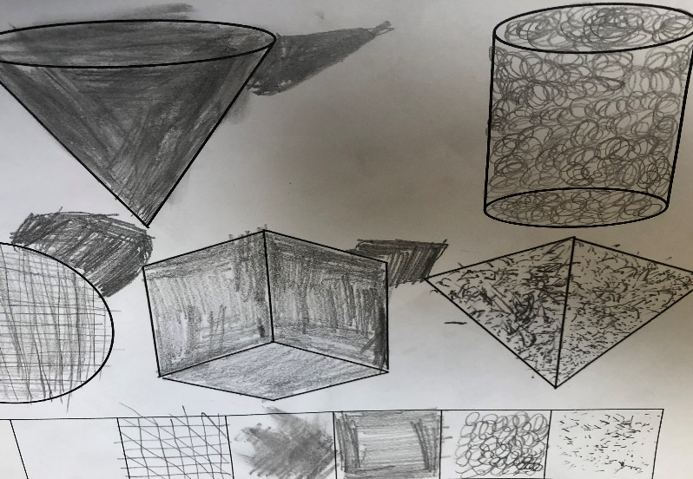
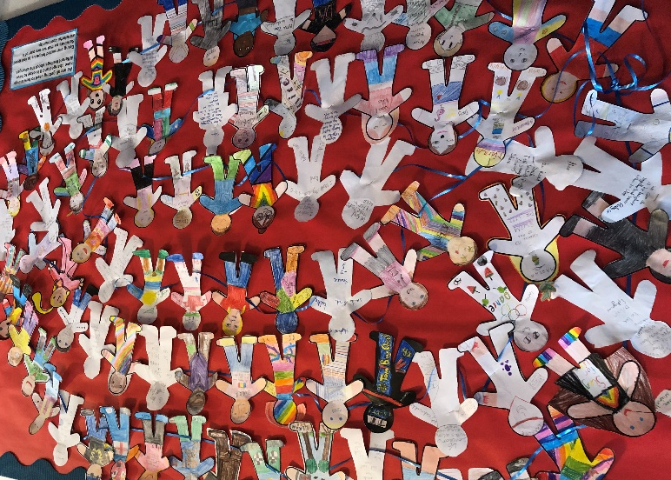


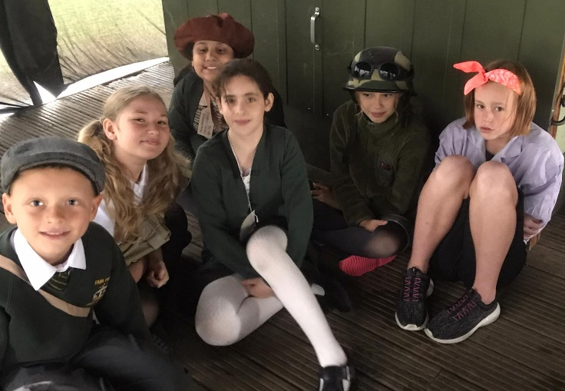
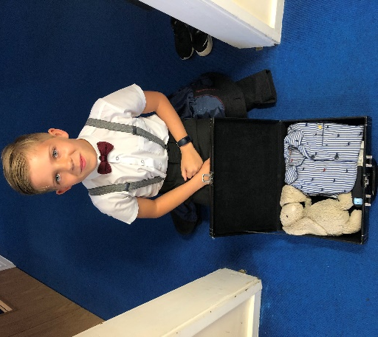




Harvest Celebration

We will be hosting a Harvest celebration next week. If you are able, please
donate one cupboard staple of non-food item for our donation to the food bank.

Follow us @FairFieldJrSch
Keep In Touch
Email: admin@fairfield.herts.sch.uk
Tel: 01923 856 341
Fair Field Junior School
Watford Road,
Radlett, Hertfordshire, WD7 8LU

INBOUND MESSAGES from GATEWAY: 01923 750 087

Respect Honesty Perseverance Kindness Forgiveness Inclusion

Our very own Fair Field choir will be singing at 2.50pm. Come and support them before the switching on of the lights at 4.30pm by Sophie Perry.

