FAIR FIELD NEWS
Summer Term Issue 6
Dear Parents and Carers,

Take Care
Mrs Goodwin






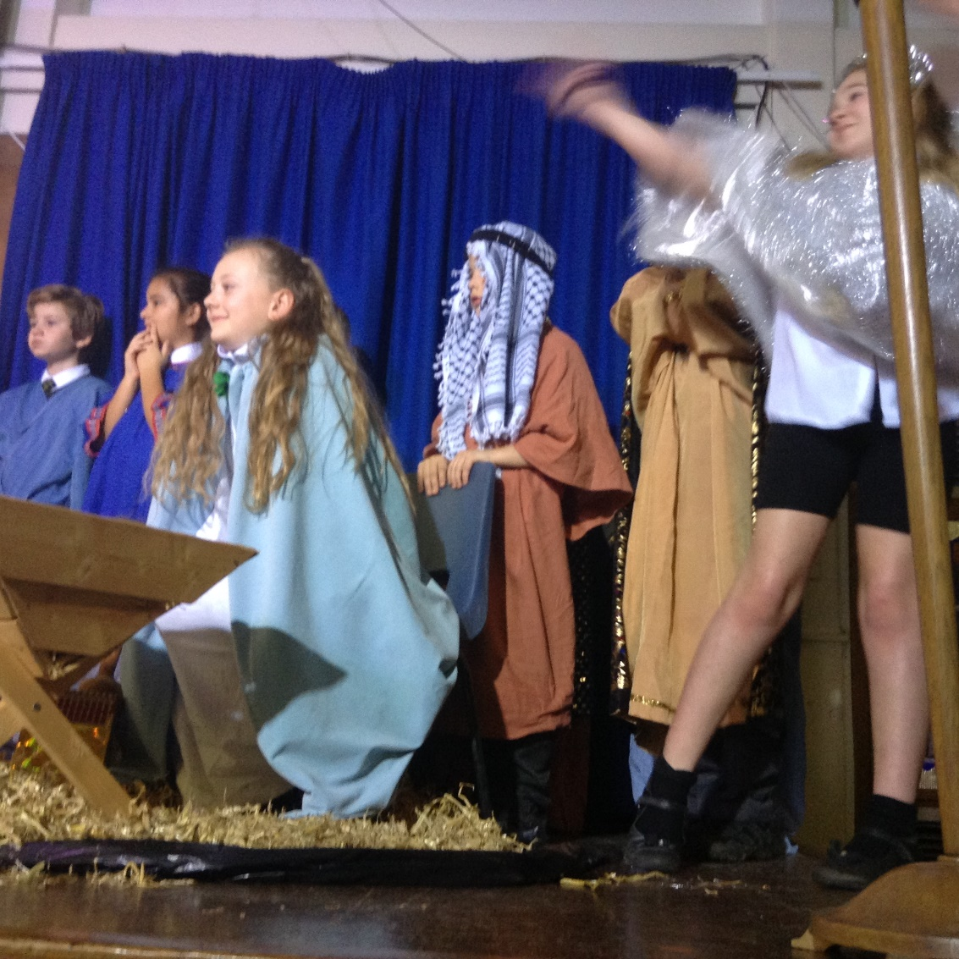
F Factor Superstars Diamond Book



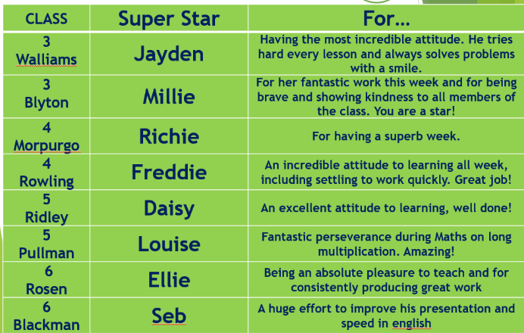
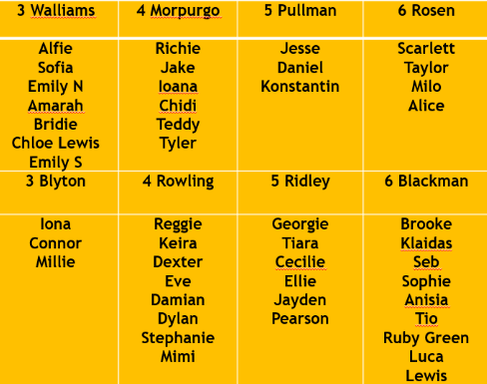

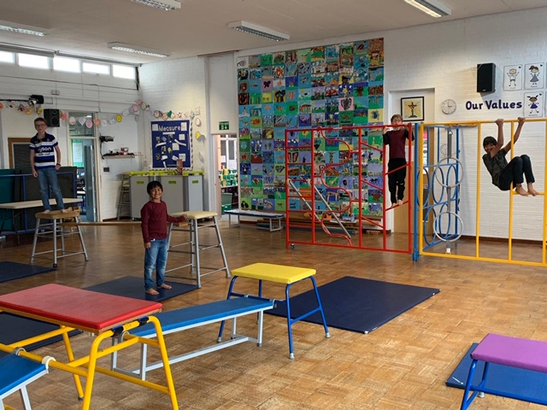

Dates for the Diary

Date | Time | Event | Year Group(s)
5th October | All month | Black History Celebrations | All
Monday 12th – Friday 16th October | All Week | Black History focus week | All
Tuesday 13th & Wed 14th October | 3.30-6.00pm | Virtual Parent meetings | All
Friday 13th November | Afternoon | Nasal flu immunisation | All

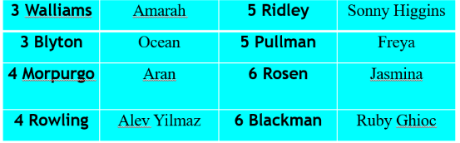


This week’s TT Winners

Gallery
We played, we laughed, we smiled.

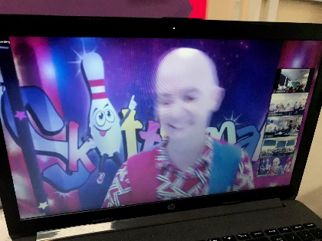
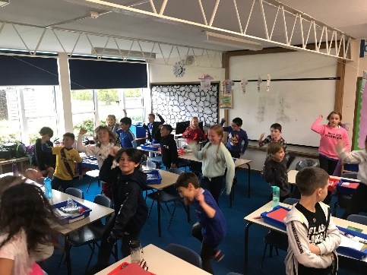
Lateness



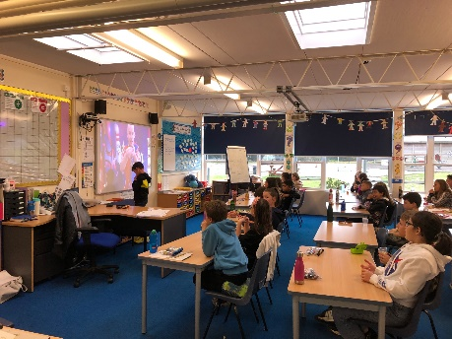
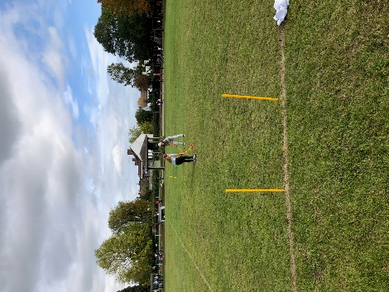
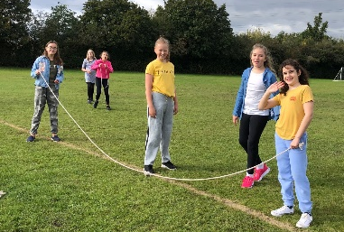
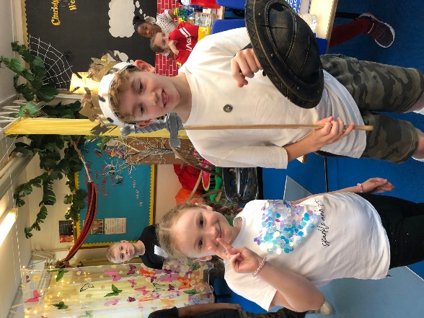






Harvest Celebration

Thank you for all your kind donations
for our Harvest Celebration. We will be
donating to the trussell trust, who
support many families in the community.
Thank you to Miss Hyde and Miss
Foster for the lovely display.

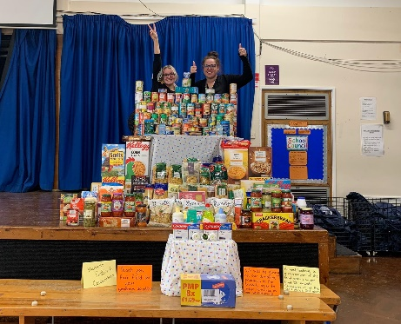



Respect Honesty Perseverance Kindness Forgiveness Inclusion

Our very own Fair Field choir will be singing at 2.50pm. Come and support them before the switching on of the lights at 4.30pm by Sophie Perry.
Follow us @FairFieldJrSch
Keep In Touch
Email: admin@fairfield.herts.sch.uk
Tel: 01923 856 341
Fair Field Junior School
Watford Road,
Radlett, Hertfordshire, WD7 8LU

INBOUND MESSAGES from GATEWAY: 01923 750 087

