FAIR FIELD NEWS
Summer Term Issue 7
Dear Parents and Carers,

This week we held our Black History Focus Week. In Monday’s assembly we continued with our mission to Dig Deeper, Look Closer and Think Bigger. We listened to Newsround presenters De'Graft and Shanequa, Blue Peter Presenter Mwaksy and Rhys from CBBC HQ to find out what their lives were like growing up black and what they'd tell their younger selves about racism here in the UK. We also learnt more about Reggae music and the origins and traditions of Nottin Hill Carnival. Each year group have continued to explore Black History through other areas of the curriculum including English and Art.
The school photo proofs have now been sent home and we ask that they are returned to us by Thursday 22nd October if you wish to buy them as the company will be coming in to collect them. We handed over an overwhelmingly large donation to the food bank on behalf of Fair Field, that had been received. Thank you to those who supported the cause for Harvest Celebrations. Lastly, we are back reporting on house points now that our House Captains have collated the running total. The winning house will, after half term, be treated to an ice cream factory so next week is their last chance to boost their house’s score. Finally, we would like to wish all our Year 6s who are sitting the 11+ this weekend the best of luck.

Take Care
Mrs Goodwin

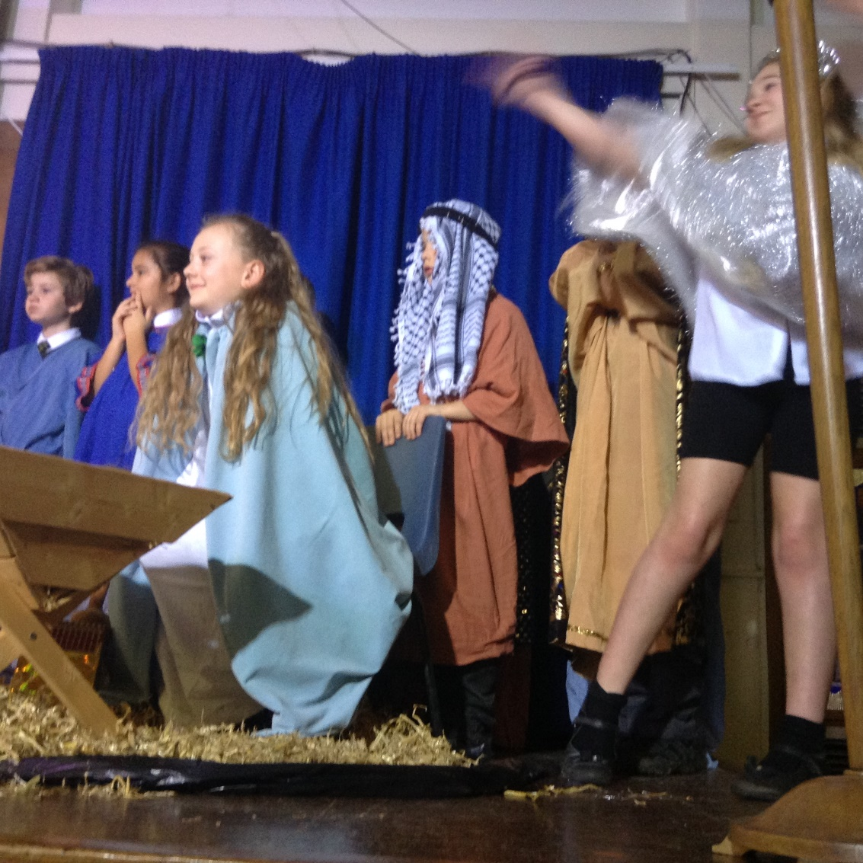
F Factor Superstars Diamond Book



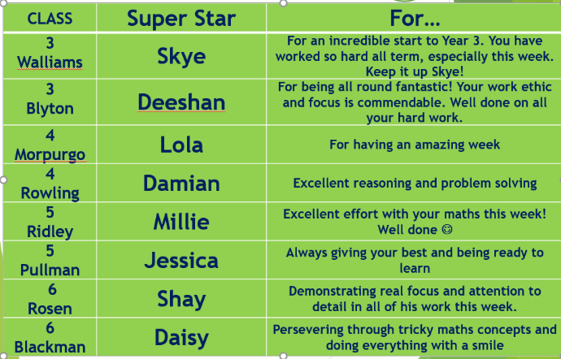

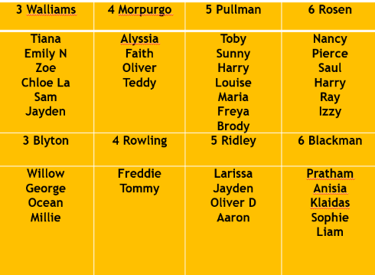

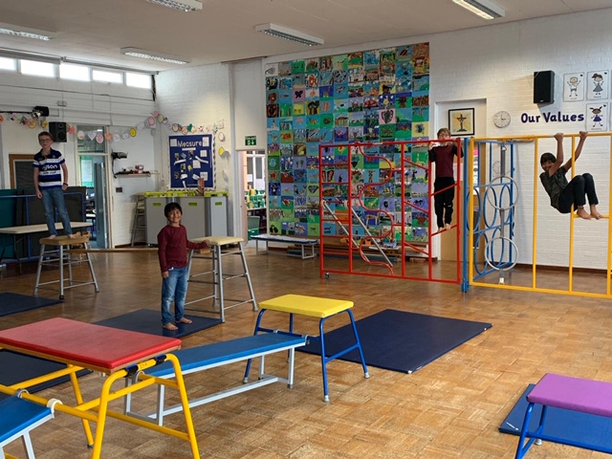

Dates for the Diary
Date | Time | Event | Year Group(s)
October | All month | Black History Celebrations | All
22nd October | 2pm | Deadline for photo return | All
23rd October | 3.10pm | Last day of this half of term | All
26th – 30th October | All week | Half Term | All
Friday 13th November | All day | Children In Need – dress in spots day. £1 donation | All
Friday 13th November | Afternoon | Nasal flu immunisation | All


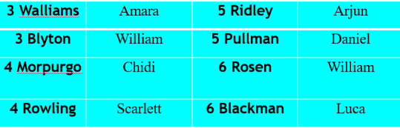

This week’s TT Winners

House Points
Points to date. Next week we will announce the winning house for this
half of term! The winning house will receive an ice cream factory after half term.
1st 583 Kendals

2nd 515 Phillimore
3rd 461 Willow
4th 454 Orchard

Lateness

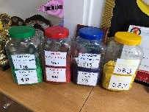

Attendance

3 Walliams | 96% | 5 Ridley | 95%
3 Blyton | 93% | 5 Pullman | 96%
4 Morpurgo | 95% | 6 Rosen | 92%
4 Rowling | 95% | 6 Blackman | 92%

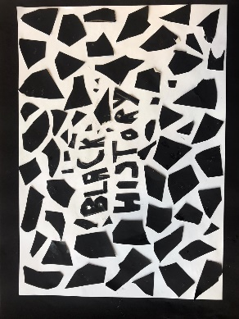
Gallery
.

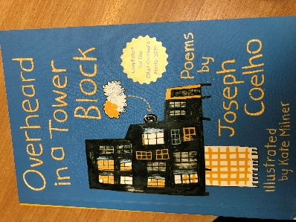
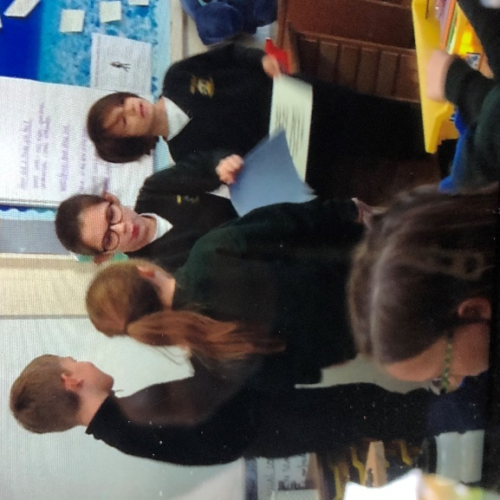
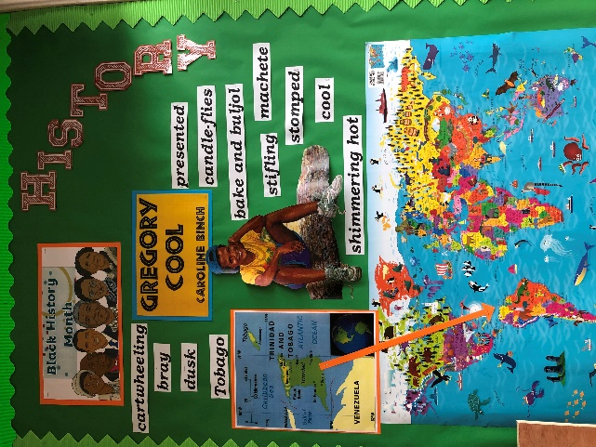

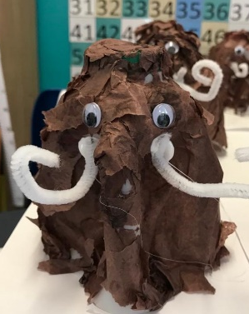
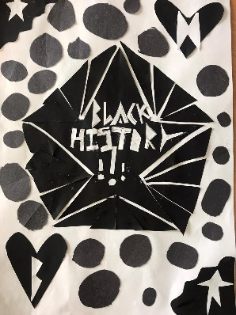
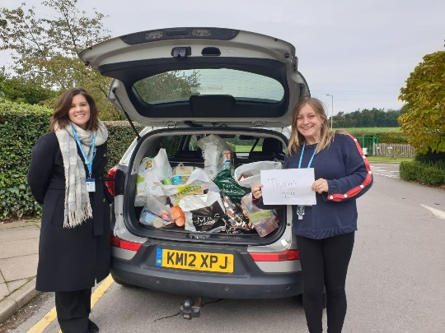
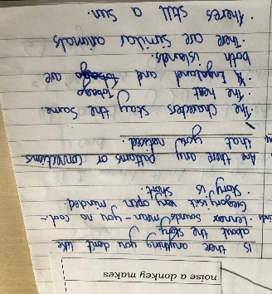
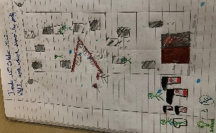



Follow us @FairFieldJrSch
Keep In Touch
Email: admin@fairfield.herts.sch.uk
Tel: 01923 856 341
Fair Field Junior School
Watford Road,
Radlett, Hertfordshire, WD7 8LU

INBOUND MESSAGES from GATEWAY: 01923 750 087

Respect Honesty Perseverance Kindness Forgiveness Inclusion

Our very own Fair Field choir will be singing at 2.50pm. Come and support them before the switching on of the lights at 4.30pm by Sophie Perry.

