FAIR FIELD NEWS
Autumn Term Issue 9
Dear Parents and Carers,

We have had a busy week at Fair Field. Amongst exciting classroom learning, we held a football match against Aldenham School, where our Year 6 team claimed a 10-2 victory in their new kit! We would like to thank the Stevenson family for this kind donation. We are now looking to add the embroidered Fair Field logo and numbers to the back if anybody has any contacts to make this happen! Yesterday the Year 6 children took part in a full day of workshops which explored and challenged the gender stereotypes around some jobs and industry sectors. The day included a hugely enjoyable flower arranging session for the boys using resources generously donated by the Bartholdi family. They also took part in a Q&A session with Mr Yeoman – who has gone from being a fighter pilot to a very domesticated househusband! The girls’ were able to engage with many different women in industry from the Women in Steam initiative. Our Year 6 Eco Warrior & Nature Nurturer leaders have now numbered the bird and bat boxes, which will be going up next week in the woods at Phillimore Recreation Ground. Look out for them! The crews in each bubble will be visiting and observing them over the coming weeks! There are also lots of other exciting activities planned for our different crews across the school too. Lastly, thank to our entire school community for today! We are very proud of how everyone reacted and engaged. It was brilliant to see over 60% of the children on live lessons, with some classes participation as high as 80%.
Next Friday we will be dressing up in spots and asking for a £1 donation for Children In Need.

Take Care and we will resume on Monday!
Mrs Goodwin

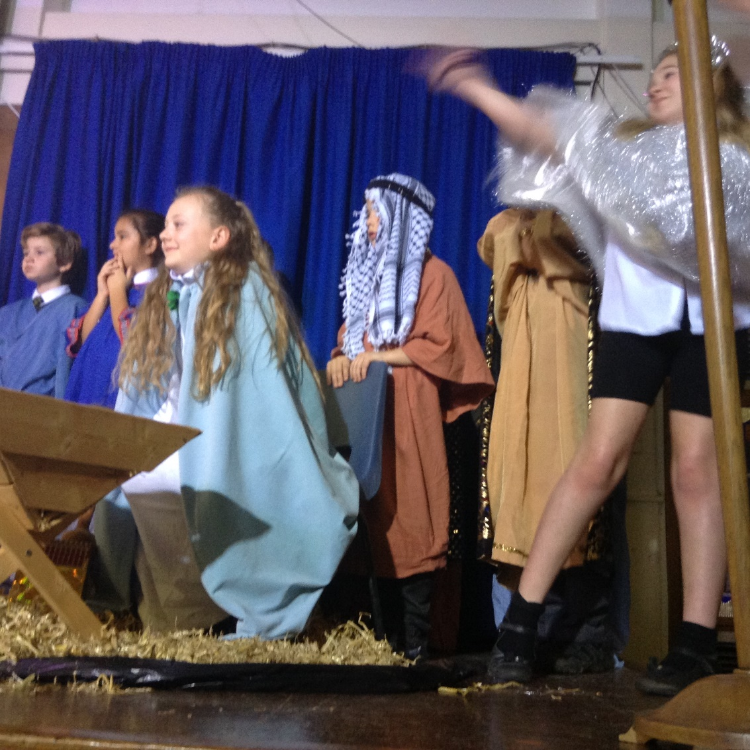

F Factor Superstars ` Diamond Book

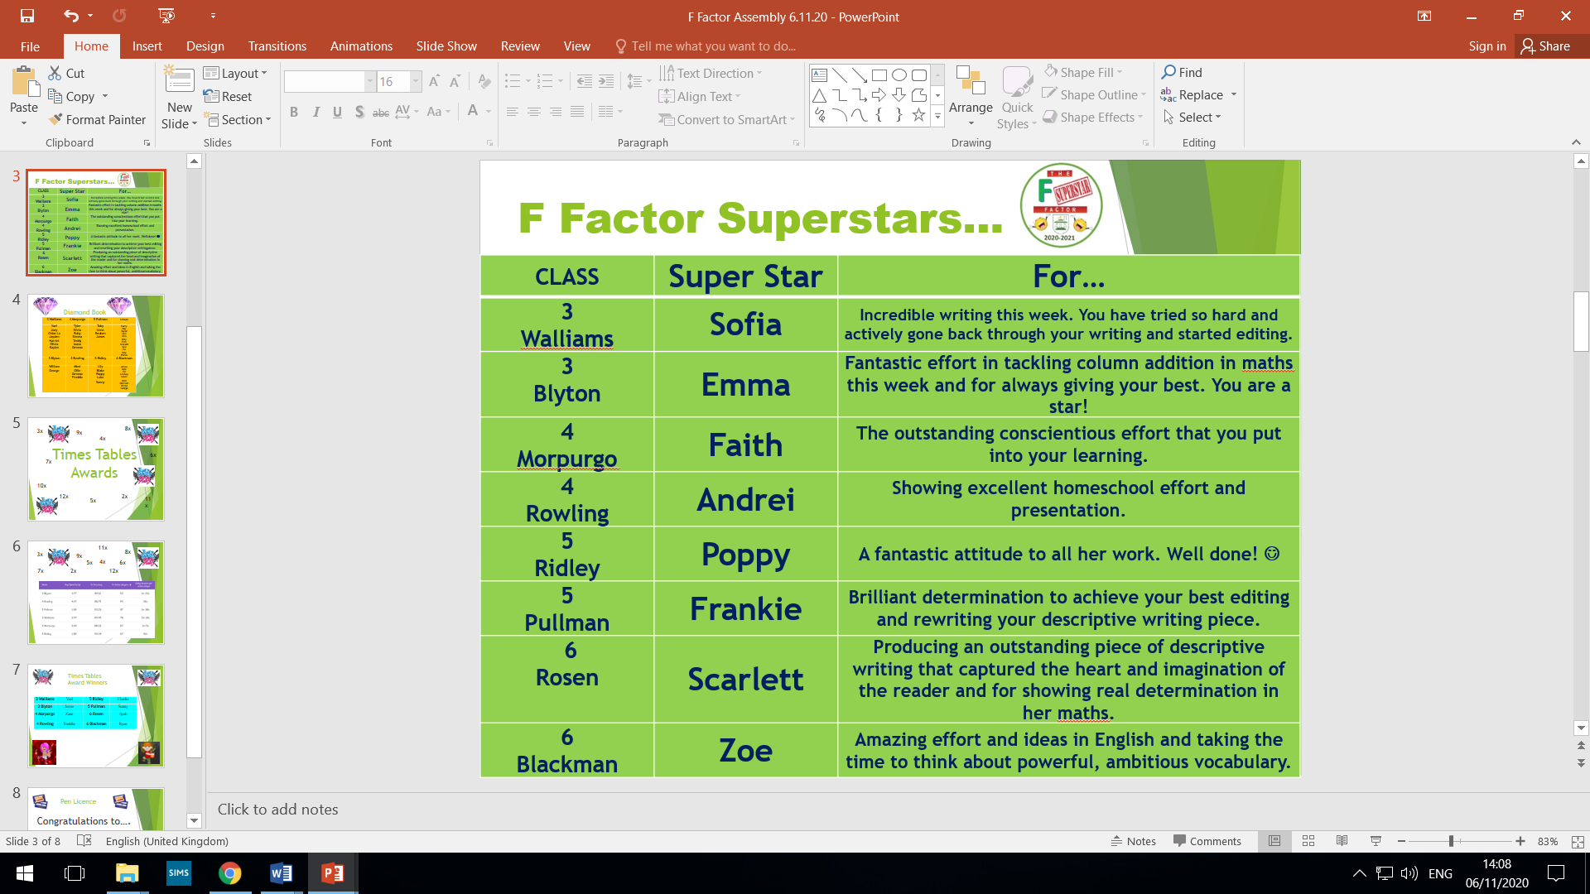

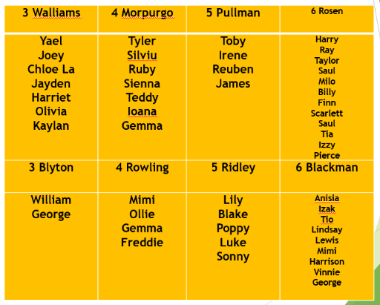


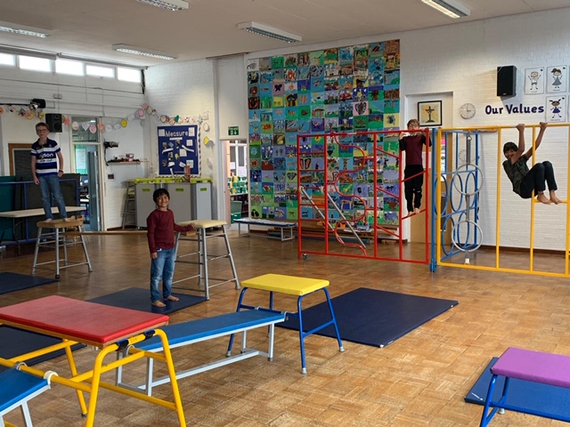

Dates for the Diary
Date | Time | Event | Year Group(s)
Monday 9th November | 11.30am | Diwali assembly – accessorise your uniform with a bright addition | All
Friday 13th November | All day | Children In Need – dress in spots day. £1 donation | All
Friday 13th November | Afternoon | Nasal flu immunisation | All
16th – 20th November | All week | Anti-bullying week | All

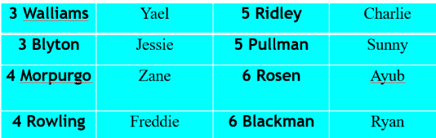


This week’s TT Winners

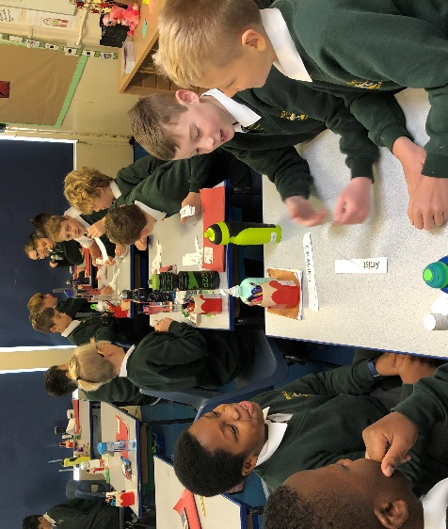
Gallery
.

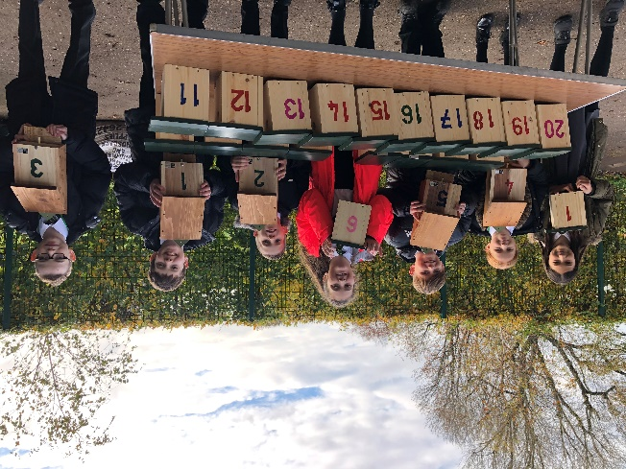
Lateness
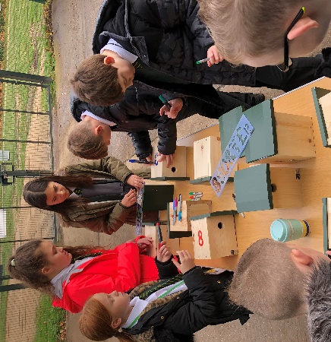

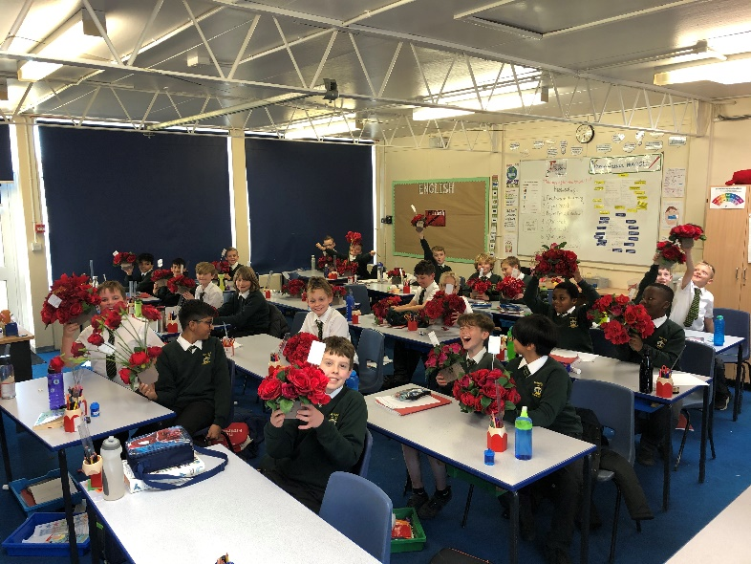
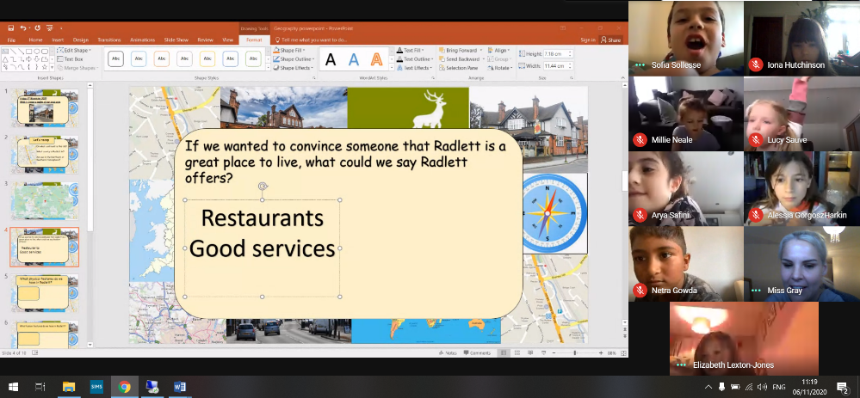


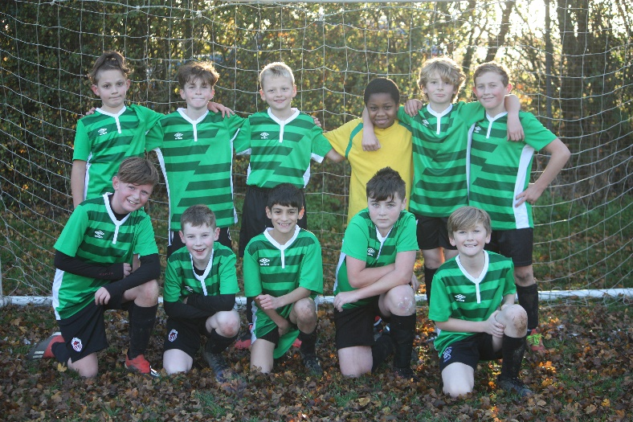

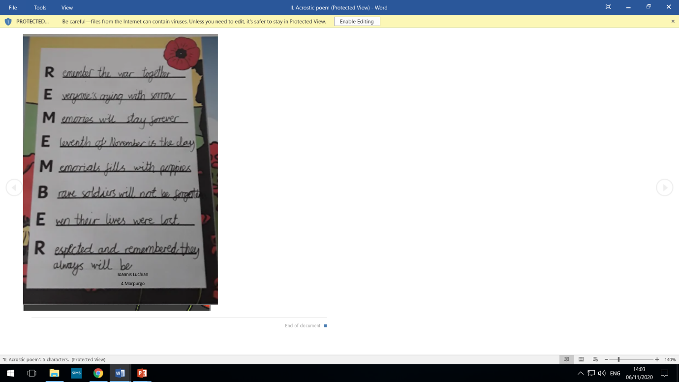
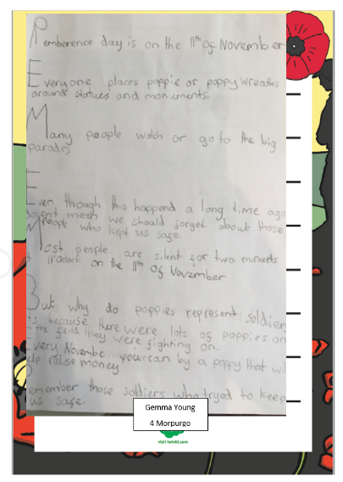



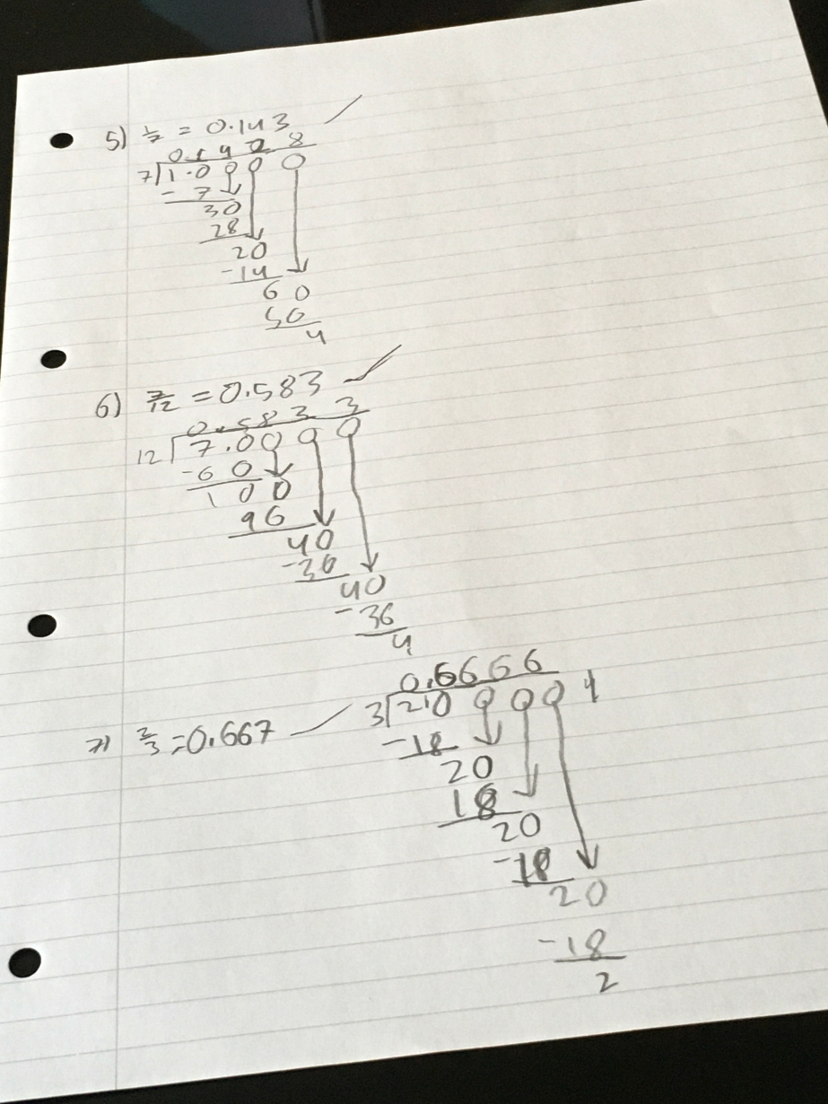
Attendance
Well done! To 5 Pullman!
3 Walliams | 96% | 5 Ridley | 98%
3 Blyton | 96% | 5 Pullman | 100%
4 Morpurgo | 98% | 6 Rosen | 91%
4 Rowling | 98% | 6 Blackman | 95%

Gallery
.

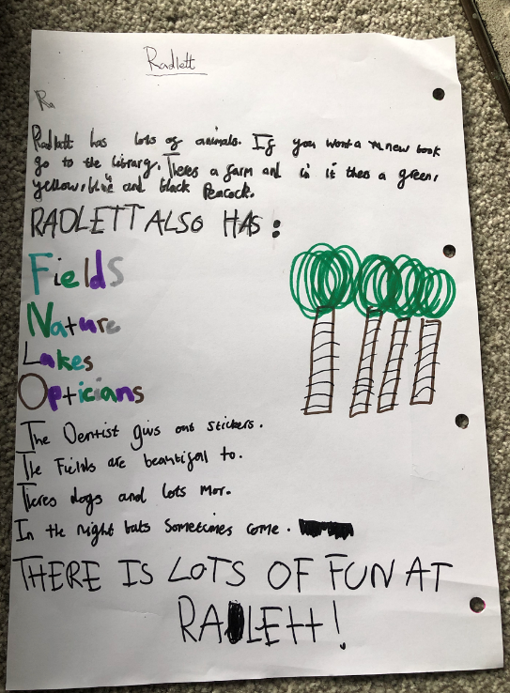
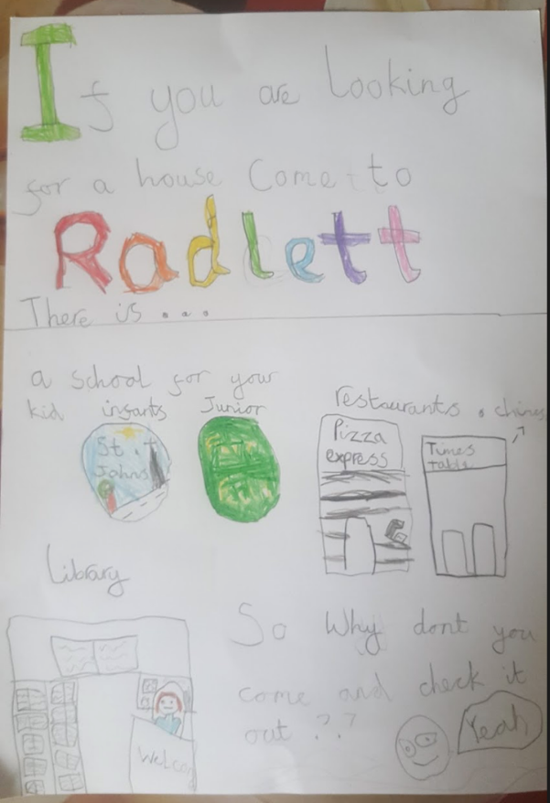

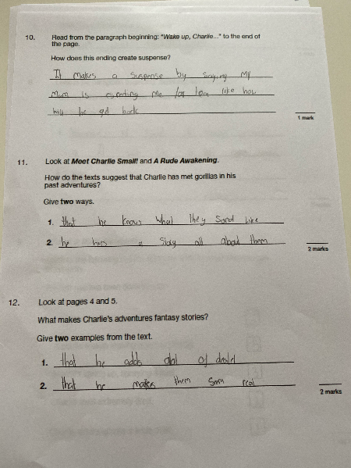

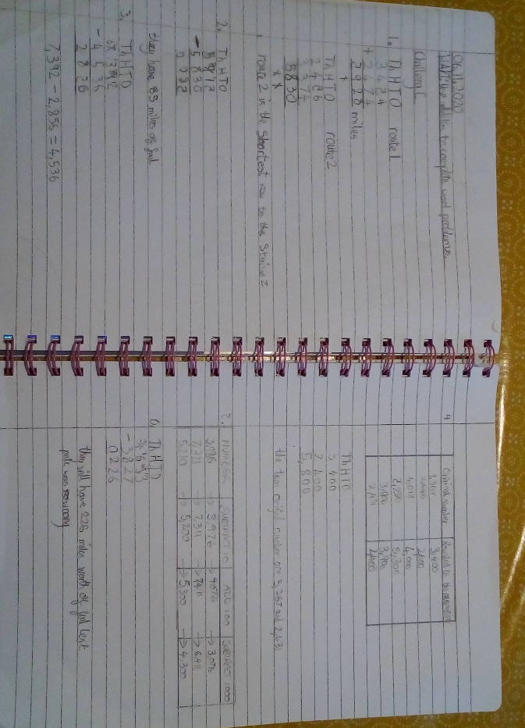

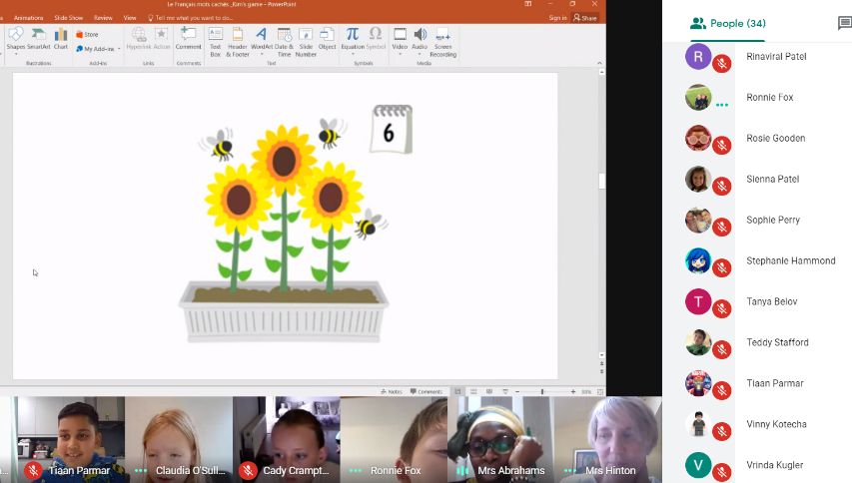

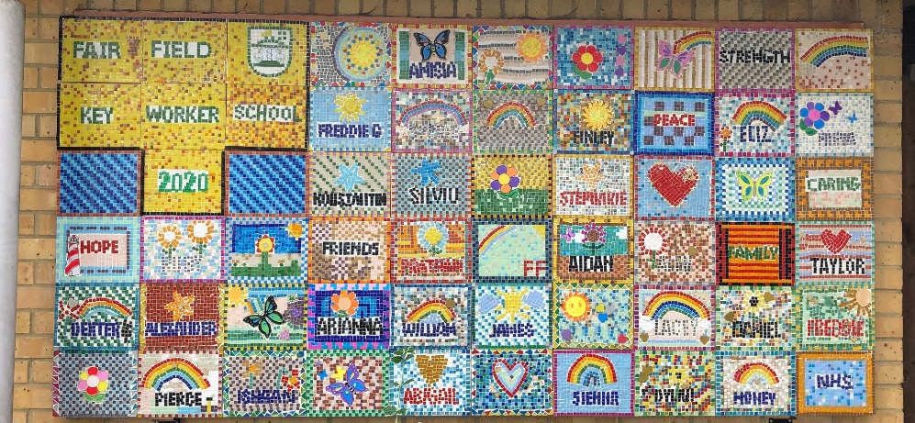

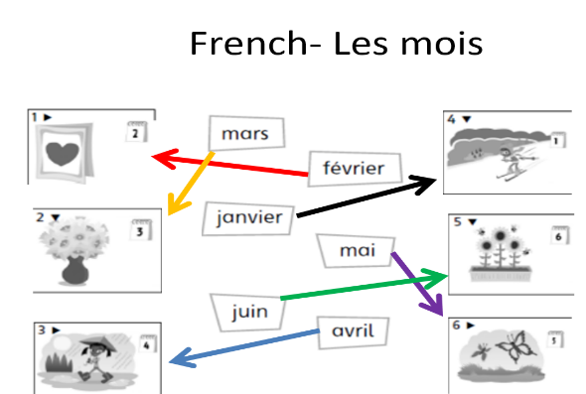



Follow us @FairFieldJrSch
Keep In Touch
Email: admin@fairfield.herts.sch.uk
Tel: 01923 856 341
Fair Field Junior School
Watford Road,
Radlett, Hertfordshire, WD7 8LU
INBOUND MESSAGES from GATEWAY: 01923 750 087

Respect Honesty Perseverance Kindness Forgiveness Inclusion

Our very own Fair Field choir will be singing at 2.50pm. Come and support them before the switching on of the lights at 4.30pm by Sophie Perry.

