PE and Sport Premium Funding
At Fair Field Junior School, we believe PE and Sport plays an important role in making our ethos for 2022-2023 (Do More, Learn More, Be More) a reality for every pupil, with the potential to change young people’s lives for the better. We have welcomed the Government’s announcement on 22nd June, 2022 confirming that schools in England will benefit from £320 million from the PE and Sport Premium during the academic year 2022 -23. This is designed to help children get an active start in life, supporting primary schools to improve the quality of their PE and sport provision so that pupils experience the benefits of regular exercise – from becoming healthier both mentally and physically to improved behaviour and better academic achievement.
The confirmation of the investment into primary schools for PE, sport, activity and play has never been more needed given the potential disruption to children’s activity levels during lockdown. Research from Sport England, shows that the number of children meeting the Chief Medical Officer’s guidelines has dropped from almost 47% to 19%. Over a third of children say they’ve had less chance to be active because schools are shut. This welcomed investment will play an important part in getting children active - which is important not just for their physical health but because being active builds mental resilience and helps children achieve academically.
At Fair Field, we are committed to using this resource in developing high quality PE lessons, alongside greater opportunities for sporting competitions and clubs for all children.
How we are using it at Fair Field Primary School
Our commitment to providing children with high quality competition access was recognised with the School Games Gold Award from the Partnership in 2021, achieved despite lockdown. This has been sustained and we are in the process of going for the Gold again, for continuing to give passionate and talented children the opportunity to participate in competitive sport, but also for the physical activity, mental and physical wellbeing activities and opportunities we have provided each of the children across the school. The Gold Award is the highest of those given out by National School Games and is for a school’s contribution and commitment in providing physical activity opportunities for all. We are extremely proud of our pupils for their dedication to all aspects of physical activity and school sport, whether this be running the daily mile, playing table tennis at lunchtime, competing during sports day or during a football or netball match. A special thanks to our school sport team of 2021/22: Mr Flynn, Mr Byrne, Miss Berg & Mr Rock because this would not be possible without their support.
We promote an inclusive ethos where all pupils enjoy participating in sport; empowering them to become the best they can be. One of the many ways we have used the sports funding at Fair Field has been to update our resources for physical education lessons. Ensuring that the equipment is accessible for all children in the school means that they are able to develop their skills in each area of the curriculum.
Fair Field continues to be part of the Watford & Hersmere Schools Sports Partnership (WHSSP) which provides advice and quality training for teachers and opportunities for pupils to participate in inter-school sports competitions. This funding has enabled us to enter our children into a wide range of sporting competitions throughout the year as well as funding members of the WHSSP staff in training our staff in a variety of areas across physical education, such as MSa and leadership training. We have entered a wide range of sport and dance competitions, progressing to the regional finals.
We will continue to broaden the level of activity within the school through sport clubs and the Daily Mile, which will have a long-lasting impact on the health and fitness of every child in the school.
We are fortunate to have a relationship with Haberdashers' - who loan us the use of their swimming pool and coaches free of charge for a year group a term. In addition, we take the children to the Venue - meaning that children receive 2 terms of school swimming. This has had a clear impact of raising attainment in swimming to meet requirements of the National Curriculum before the end of Key Stage 2, with Fair field reaching over 90%. In 2021, 98% of our Year 6 pupils could swim competently, confidently and proficiently over a distance of at least 25 metres and 98% of our pupils could perform safe self-rescue in different water-based situations.
Cover for our PE Leaders is used to allow him to assess how our new PE and Games Scheme is being delivered and assessed across the school as well as auditing the equipment and ensuring it is kept up to date. His release time allows him to share good practice and identify how the teaching of PE can be improved. We will continue to ensure our children have access to different sporting opportunities including competitions and festivals. To promote the importance of a healthy active lifestyle children will take part in many inter school sport events including sports fancy dress, tournaments, sports days, sports relief days and sports challenges.
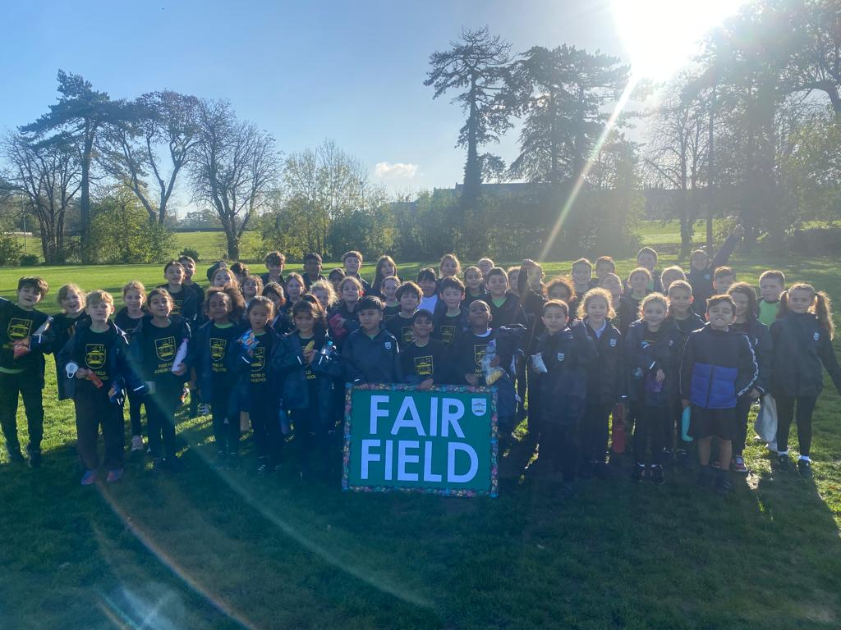
At our school we have developed a plan to ensure this funding is invested to maximise the long term impact of our PE provision for pupils and staff. The impact of these initiatives is monitored through assessment of children’s skills, staff and pupil feedback, uptake of clubs etc
At Fair Field, we have developed a plan to ensure this funding is invested to maximise the long term impact of our PE provision for pupils and staff. The impact of
these initiatives is monitored through assessment of children’s skills, staff and pupil feedback, uptake of clubs etc.
The following factors are taken into account:
- The increase in participation rates in such activities as games, dance, gymnastics, swimming and athletics
- The growth in the range of traditional and alternative sporting activities
- The increase and success in competitive school sports
- How much more inclusive the physical education curriculum has become
- The improvement in partnership work on physical education with other schools and local partners
- Greater awareness amongst pupils about the dangers of obesity, smoking and other such activities that undermine pupils’ health

Sustainability: to build capacity and capability within our school to ensure improvements made now will benefit pupils joining the school in future years, we will extend the resources available within PE lessons and the confidence of class teachers and support staff to ensure that learning within PE and games is consistently improving and that improvements are sustainable. We will continue to broaden the level of activity within the school through termly squads, clubs, and the Daily Mile which will have long lasting impact on the health and fitness of every child in the school. Additionally, Complete PE continues to deliver high quality learning, active learning, thus sustaining wellbeing.
Our connection with WHSSP will continue to develop teacher understanding of fully inclusive PE lessons and through shared resources this connection is beneficial long term. To read more information about sustainability, please click on our Impact reports below.

Review and Reflection on previous spend: considering the 5 key indicators from DfE, what are our development needs for our children now and for the
future?

Key achievements to date: | Areas for further improvement and baseline evidence of need:
- Our commitment to providing children with high quality competition access, physical activities, mental and physical wellbeing activities and involving pupils in leadership opportunities was recognised with being awarded with the School Games National Gold Award (from Watford & Hersmere due to lockdown) in 2021.  - We possess excellent outdoor facilities: a hardtop playground and grass field where outdoor P.E. and sport takes place.  - Children take part in the daily mile, Funky Fridays and play table tennis, football and basketball at lunchtime.  - Prioritising alternative sports to encourage children who many not enjoy traditional school team sports, ie: table tennis, speed stacking  - Informal competitions introduced- inter house  - Our football teams remain hugely successful – unbeaten!  - Our link with WHSSP continues to enhance the opportunities for all children to have excellent first quality teaching due to the WHSSP working alongside staff, attendance on PE training, training MTS/playleaders  - 24 weeks of swimming per year enables us to continue to raise to meet requirements of the National Curriculum by (if not before), the end of KS2.  - Sports day (School Games Day) where all children take part in a competitive and non-competitive events (individual and team) where families were invited to watch. Development of social skills, positive relationships, leadership, teamwork and communication skills, alongside facing new challenges and achievement.  - Provision for the cultural development of our children: willingness to participate in and respond positively to sporting opportunities.  - Children engaged in high quality play/regular activity throughout lunchtime and morning break to increase: mental wellbeing, pupil aerobic activity, team building and communication; balance, co-ordination and core strength; skill, tactic and to encourage pupils to independently design and build.  - Success in recent events include: cross country, hockey  - Sports Leadership training for over 40 Y5 pupils. | - Increased staff CPD opportunities throughout school staff- CPD sessions focusing on a variety of different topics and content, each term to enable teachers continue to develop the delivery of high quality PE lessons (see PE scheme of work).  - To continue to offer whole school Level 1 opportunities (house competitions and festivals): school wide house cup festival and events each term for pupils to participate in their house teams.  - Attend more Level 2 competitions (external- to include CSSP festivals and competitions) across a variety of sports and age groups and to ensure all children are coached before attending – continue to use coaches or buying a minibus.  - Share out, each sporting opportunity between staff and external coaches. Ensure mapped out throughout the year, so each member of staff know when their activity is coming up and can plan for it accordingly. For last minute invites, make an executive decision about participation.  - To ensure PE uniform is always worn and team jackets – children look professional when competing and also for school PE lessons.  - Ensure our PE Scheme of Work (Complete PE) is mapped out from LKS1 & UKS2 to ensure progression of skills across the school. Connect with KS1 and EYFS.  - Encourage healthier packed lunches as part of a drive to improve overall lifestyle choices.  - To continue to increase participation of external school swimming (pre-school and community).  - Research into buying static playground equipment to replace the trim trail.  - To train Pupil Advocate Games Leaders: our Year 6 children trained to run activities at break and lunch time (they have already had leadership training with WHSSP, in Year 5).

Meeting national curriculum requirements for swimming and water safety (summer 2021) | Summer 2023:
What percentage of your current Year 6 cohort swim competently, confidently and proficiently over a distance of at least 25 metres?
What percentage of your current Year 6 cohort use a range of strokes effectively (ie: front crawl (FC), backstroke (BK) and breaststroke (BS)).
What percentage of your current Year 6 cohort perform safe self-rescue in different water-based situations?
Schools can choose to use the Primary PE and Sport Premium to provide additional provision for swimming but this must be for activity over and above the national curriculum requirements. Have you used it in this way?
Meeting national curriculum requirements for swimming and water safety (summer 2021) | Summer 2022:
What percentage of your current Year 6 cohort swim competently, confidently and proficiently over a distance of at least 25 metres? | Class size: 61  Confident: 96% (59/61)  Less Confident: 2% (2/61)
What percentage of your current Year 6 cohort use a range of strokes effectively (ie: front crawl (FC), backstroke (BK) and breaststroke (BS)). | FC: 96%  BK: 96%  BS: 96%
What percentage of your current Year 6 cohort perform safe self-rescue in different water-based situations? | 98%
Schools can choose to use the Primary PE and Sport Premium to provide additional provision for swimming but this must be for activity over and above the national curriculum requirements. Have you used it in this way? | Yes (partially used)

Action Plan and Budget Tracking: Our intended annual spend against the 5 key indicators.
Success criteria and evidence of impact that we intend to measure to evaluate for our children today and for the future.

Academic Year: 2022/23 | Total fund allocated: £19 440  (£16,000 plus £10.00 per pupil) | Date Updated: Expenditure: £16 658
Key indicator 1: The engagement of all pupils in regular physical activity – recommendation that primary school children undertake at least 30 minutes of physical activity a day in school |  |  |  | Percentage of total allocation:
 |  |  |  | %
School focus with clarity on intended impact on pupils: | Actions to achieve: | Funding allocated: | Evidence and impact: | Sustainability and suggested next steps:
- 2 x 1 hour PE Sessions (from GetSet) each week for all children in school  - To support children’s physical and mental well-being, improved levels of concentration as well as physical fitness. | - Children benefit from a progressive scheme of work, written with careful consideration of the aims of the National Curriculum, to ensure a wealth of opportunities to develop physical skills as well as developing the whole child. Further CPD from CSSP to broaden subject knowledge of PE and sport teaching.  - Purchase of essential equipment and resources to enable a wide variety of sports to be taught effectively  - Wake up-shake up, the Daily Mile, play leaders support children’s physical and mental well being, enabling short breaks throughout the day.  - Research into a trim trail | - £1375  - WHSSP £4457  - £2000 for equipment and resources  - £295 for active blasts (iMoves)  *£5000 towards cost | *WHSSP and scheme enables teachers to feel confident in teaching PE- inspiring those who inspire the children is key to successful PE. Increasing CPD opportunities focussing on a variety of areas to continue to develop quality PE lessons.  - Children take part in Daily Mile at least 2x a week, have route to follow on playground to track laps run. | *Enable staff to be able to offer and teach a wide range of sport within PE sessions with improved confidence. To build on year on year.  *PE lead to monitor impact of IMoves sessions and PE/Games lessons across the school – complete staff and pupil voice for IMoves and GetSet.

- All children encouraged to increase their fitness through internal house festivals (Level 1).  - Children engaged in high quality play/regular activity throughout lunchtime break to increase: mental wellbeing, pupil aerobic activity, team building and communication; balance, co-ordination and core strength; skill, tactic and to encourage pupils to independently design and build.  - Provision of before/after school sporting clubs for children. | - Inter-house sporting tournaments/competitions throughout the year, for all children, ie: football, cricket, rounders, cross country, tag rugby, athletics and timetabled in the school diary for frequency and coverage etc.  - Year groups engaged in daily physical activity on the field/playground for approx’ 50 minutes a day.  - Purchase of two basketball nets  - Play time and lunch time staff to have support/training to lead engagement. External training for our new Pupil Advocates (Sports Leaders) and mid-day supervisor training where necessary.  - Wide variety of after school clubs, catering for different sporting interests: gymnastics, dance, multi-sports, rounders, and for children from EYFS – Year 6. | - £600 for internal staffing release (EYFS, KS1,  KS2: termly)  - £800 | - iMoves gives children active breaks in/ between lessons to increase physical activity.  - Termly internal house comps to be organised where all children encouraged to be the best they can be.  - Sports day for EYFS/KS1 and KS2. Impact – development of social skills positive relationship building for life. Demonstration of leadership, teamwork and communication skills.  - Children participate in house teams - promote a termly house competition where the children are encouraged to ‘beat their best’.  - New sports equipment purchased, with impact of increased participation in lessons and improvement of skills, as more children have equipment that is fit for purpose.  - Increased confidence for children of all year groups.

Key indicator 2: The profile of PE and sport being raised across the school as a tool for whole school improvement |  |  |  | Percentage of total allocation:
 |  |  |  | %
School focus with clarity on intended impact on pupils: | Actions to achieve: | Funding allocated: | Evidence and impact: | Sustainability and suggested next steps:
- To encourage pupils to take on leadership roles that support sport and physical activity within The Hayes Primary School (Pupil Advocates).  - To embed physical activity into the school day through active travel to and from school, active break times and active lessons and teaching  - Ensure all children are aware of the importance of a healthy lifestyle, including both diet and regular exercise.  - Pupils, staff and parents are aware of sporting activities and achievements across the school. | - Sports Leader Pupil Advocates- external and internal training for our new leaders and mid-day supervisor training. CSSP/SLT to train.  - All classes to use Imoves to engage children in active breaks in or between lessons to increase regular physical activity  - Introduce a healthy eating week – booked for June 2023. With focus on dangers of obesity, smoking and other such activities that undermine pupils’ health  - Results and photos to be celebrated/displayed/promoted via bulletin and newsletters and via Twitter.  - School participation at external sporting competitions. | *Staff time  *Subscription to IMoves  £295  - £300 for resource and staff to run.  - Sports leader time:  SLT time: | *Autumn term – children interviewed and impact to be noted in early spring term.  - Children take part in regular active blast breaks throughout the day - opportunity to move more during class time.  - Children wear PE kit to school to maximise time spent in PE lessons.  - Children representing the school in at London Schools Games competition.  - Positive relationship building for life. Demonstration of leadership, teamwork and communication skills, alongside facing new challenges. Increase in confidence. | - New PAs receive training in autumn term, with CSSP.  - PE leads to monitor and measure impact use of Imoves through pupil and staff voice questionnaires  - Internal board in lieu of current situation, achievements will be internal, for example: House Competitions, weekly personal challenges.  - To ensure children are prepared to participate in any sporting event (ie: trained to compete in the high jump).

Key indicator 3: Increased confidence, knowledge and skills of all staff in teaching PE and sport |  |  |  | Percentage of total allocation:
 |  |  |  | %
School focus with clarity on intended impact on pupils: | Actions to achieve: | Funding  allocated: | Evidence and impact: | Sustainability and suggested  next steps:
- To provide staff with professional development, mentoring, training and resources to help them ensure confidence and teach PE and sport more effectively to all pupils, embedding physical activity across Fair Field  - Swimming TA is provided with on-going CPD (modelling of teaching by the swimming coach) to enable more confidence in her role to support our swimming teacher to promote excellence in swimming.  - Qualified sports coaches and PE lead (via WHSSP) to work with teachers and mid-day supervisors to enhance or extend current opportunities. | - To use qualified sports coach to work alongside teachers to team teach- enhance or extend current opportunities. Team teaching opportunities.  - PE leads attend training: WHSSP, GetSet4PE, complete PE etc  - Training CPD from Complete PE to support teacher delivering sessions across the school.  - All teachers invited to attend practical after-school CPD sessions at Queens School  - GetSet4PE Scheme of Work is embedded with clear curriculum mapping and progression of skills across all phases. Staff are trained appropriately to ensure quality of teaching.  - TA to support, team teach and qualified swimming coach models teaching. Higher confidence level.  - Staff confident to deliver quality sporting opportunities. Mid-day supervisors to work co- operatively with children during lunchtimes. | - WHSSP  - Twilight session for staff  - £? for cover and training  *£450  - £8000 (35% of annual cost)  - 3x hours a year £197 | - Children taking part in lessons that are confidently delivered by staff  - Teachers confidently delivering lessons with increased confidence and skills  - PE leads to be secure in whole school curriculum overview and 3Is  - Teachers confidently delivering teach active break sessions alongside curriculum subjects (take 10)  - Staff attended CPD session at Trinity School.  - SofW used throughout the school to ensure children given a wealth of opportunities to develop their physical skills as well as developing the whole child.  - Observation of swimming teacher and TA to ensure a safe, supportive environment is promoted.  - WHSSP to run a staff meeting based on areas needed for staff development. Work alongside staff to support and increase confidence in teaching PE. | *Continue to use CSSP to support staff CPD- put in diary throughout the year – tag rugby, hockey, athletics, etc  *PE lead to continue accessing workshops through GETSET, WHSSP.  *Monitor use and impact of Complete PE

Key indicator 4: Broader experience of a range of sports and activities offered to all pupils |  |  |  | Percentage of total allocation:
 |  |  |  | %
School focus with clarity on intended impact on pupils: | Actions to achieve: | Funding  allocated: | Evidence and impact: | Sustainability and suggested  next steps:
- Purchase swimming resources for pre- school and KS1/2 children to support swimming sessions  - Use minibus to travel to future external events run by CSSP (Summer term, if situation changes)  - See Key Indicator 1: support and involve the least active children by providing targeted activities, and running or extending school sports.  - Internal House competitions held termly  - To run a rounders club (summer).  - To run athletics club | *Swimming coach to order equipment to ensure preschool children and our school can take part in swimming sessions, safely.  *Cost of minibus hire (x7) £1120  *Y3 - Y6 to take part in whole school cross country competition, internal event between school houses  *Whole school sports day (see above).  *To learn new skills of throwing and catching, teamwork, knowledge of a new sport and athletic skills – to pick those who can take part in Herts athletics. | *£1000  £160 per journey  PE lead release time  £250 for equipment | *Raising attainment in swimming to meet requirements of the National Curriculum before the end of Key Stage 2  *Use a minibus as transportation to WHSSP sporting events against other schools in a range of activities.  *Children are prepared for Croydon athletics. | *Monitor use of equipment  *At the beginning of the year, highlight across the year, sporting events to attend – booked in advance and to include house competitions.  *Take a teacher survey to see what skill set is within the school, to see if a range of clubs could be run, with a focus of participation from a range of children.  *to ask internally for athletics coach/externally.

Key indicator 5: Increased participation in competitive sport |  |  |  | Percentage of total allocation:
 |  |  |  | %
School focus with clarity on intended impact on pupils: | Actions to achieve: | Funding  allocated: | Evidence and impact: | Sustainability and suggested  next steps:
- Attend more Level 2 competitions across a variety of sports and age groups.  - 7 a-side and 5 a-side football  - Running/sprinting  - Enter annual boys football league and cup, girls football league, netball league and cup competitions.  - Host sports events against local schools if transportation is unavailable.  - Hold whole school house sporting tournaments throughout the year | - Research into hiring/leasing a minibus.  - Increased participation in CSSP festivals and competitions.  - Mark out on the field  Sports day, running: 200m track mark out.  - Cost of minibus/coach hire (x7) | - ??  *£750  *£TBC  *£1120 (approx)  *£160 per journey  *PE lead release time £? | - Participation in competitions – externally: mixed football team competing in league.  - Netball team playing friendly matches to prepare for league competition next year.  - Participation in WHSSP county-wide competitions.  - Informal competitions to be introduced | *Football and netball team to maintain weekly training – need to find a netball coach.  *£? Funding is put aside at the beginning of the year to allow for transportation for events  *Ensure WHSSP, athletic comps are planned for well and that children are trained to compete/play.

