**FAIR FIELD NEWS**

Autumn Term Issue 13

Dear Parents and Carers,

This week we have continued to prepare for our production, the virtual carol concerts and the discos. I am sure you can appreciate the school community is working as hard as they can to make all this happen despite the challenges we face. PTA events provide not only vital fundraising for the school but also great times for the children. It been challenging arranging the discos under the current constraints and we thank the PTA hugely for this. The Year 4 production is looking fantastic and the children are all ready to perform, however recording is proving a little trickier than we had hoped. It is likely that it will not be available to for you to watch until a little later than planned. I am sure you agree, however, it will be worth the wait. We are working hard to continue to provide the same opportunities for the children and find ways to make sure parents can also be a part of these memorable moments in their child’s primary years.

As we are currently still unable to come together as a school due to Covid, we will be recording carol concerts – which will combine whole school and year group only elements. I feel very proud of our staff for going to these lengths to ensure the children don’t miss out on these occasions. Each year group will be coming together in the hall to perform and record their concert. Reverend Fletcher will also be delivering a Christmas message. You will be able to view these concerts via Google Classroom from next week.

Other events this week included more of our Nature Nurturers and Eco Warriors, who braved the rain to take part in our project with Aldenham Parish Council. We hope that over the year, all Fair Field children who are keen can be involved in the project in some way. Please tell your child to speak to their teacher if they want to be included and have not yet had the opportunity. Year 3 have been making Christmas cards for a care home in St Albans this week, which will hopefully go some way to brightening up Christmas this year. To end the week the football team experienced another success against Aldenham, with goals coming from Harrison, George, Shay, Vinnie and Ray.

This week, Year 6 are asking for any donations of unwanted material or old clothes for their D&T project if you are having a clear out! A reminder that the deadline for bringing in gifts and cards is Friday 11th December, in order that they can be given out during the last week of term.

Lastly, we would like to congratulate Mrs & Mr Devlia and big brother Rishaan, on the birth of baby Shayen, born on 7th November weighing a perfect 6lb 12oz.

Wishing you a restful weekend.

Mrs Goodwin and all the Fair Field staff

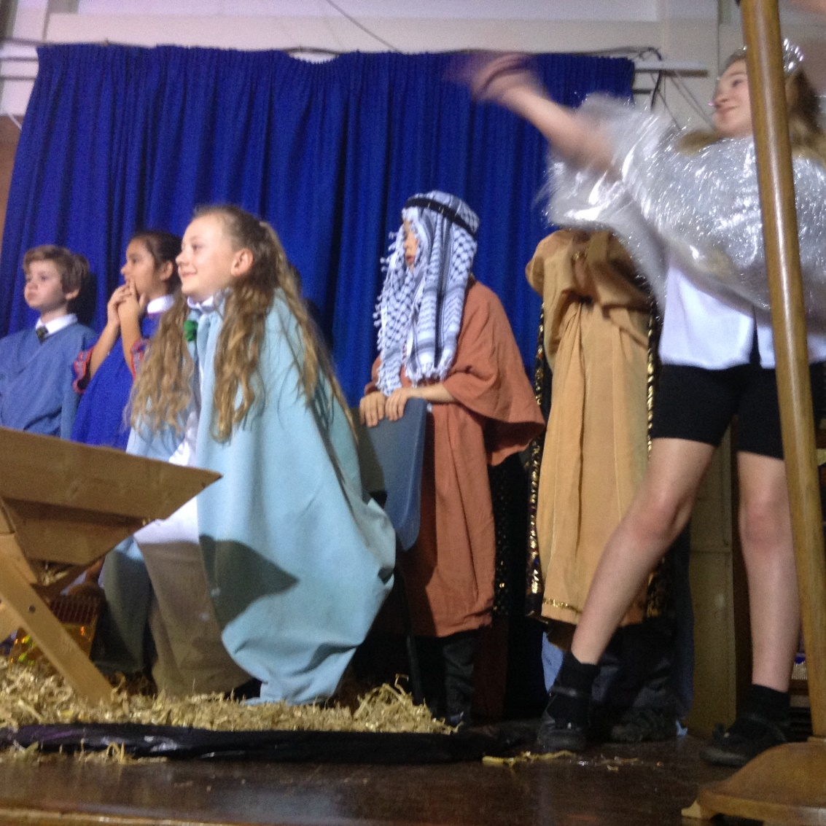

**Dates for the Diary**

|  |  |  |  |
| --- | --- | --- | --- |
| **Date** | **Time** | **Event** | **Year Group(s)** |
| 7th – 10th December | 1.30pm | PTA Discos in uniform | All |
| 11th December | 2.00pm | Reverend Fletcher’s virtual assembly | All |
| 14th December | 1.30pm | Virtual Carol Service | Year 3 |
| 14th December | 2.15pm | Virtual Carol Service | Year 4 |
| 15th December | 1.30pm | Virtual Carol Service | Year 5 |
| 15th December | 2.15pm | Virtual Carol Service | Year 6 |
| 15th December | 2.00pm | Virtual Production | Year 4 |
| 16th December | 12.00pm | Christmas lunch & jumper day | All |
| 16th December | 1.30pm | Virtual pantomime | All |
| 17th December | 1.30pm | Chanukah Celebrations | All |
| 18th December | 1.30pm | Last day of term | All |
| 5th January | 8.50am | First day of Spring Term | All |

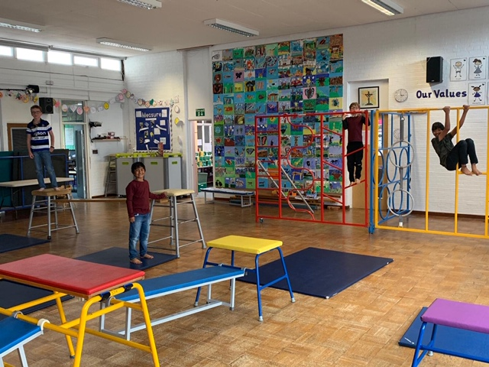

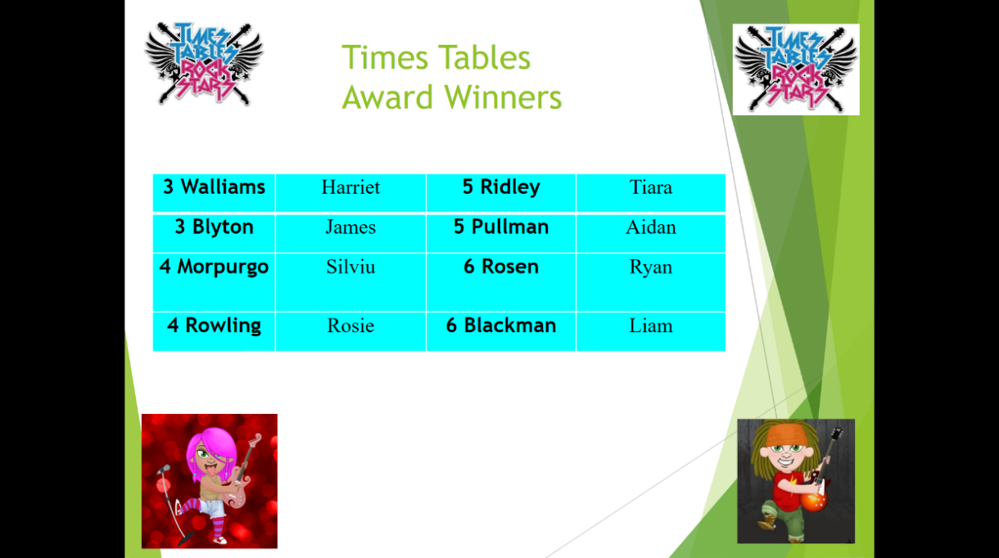



This week’s TT Winners

.

**Diamond Book**

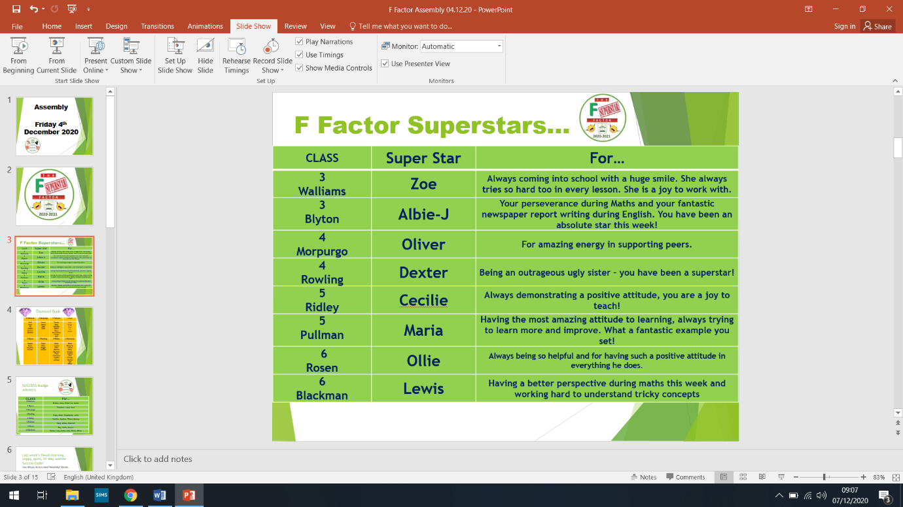

Lateness

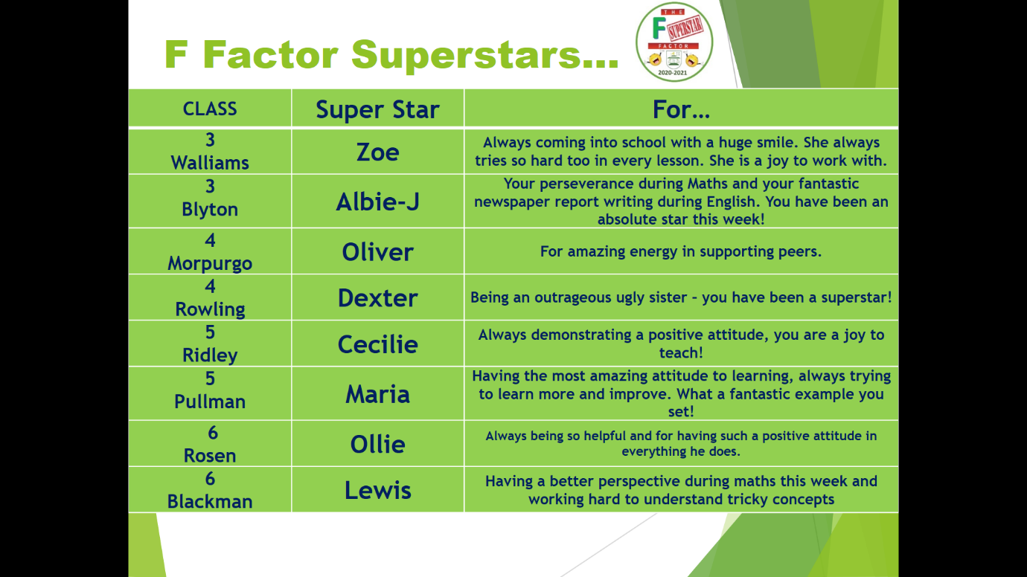



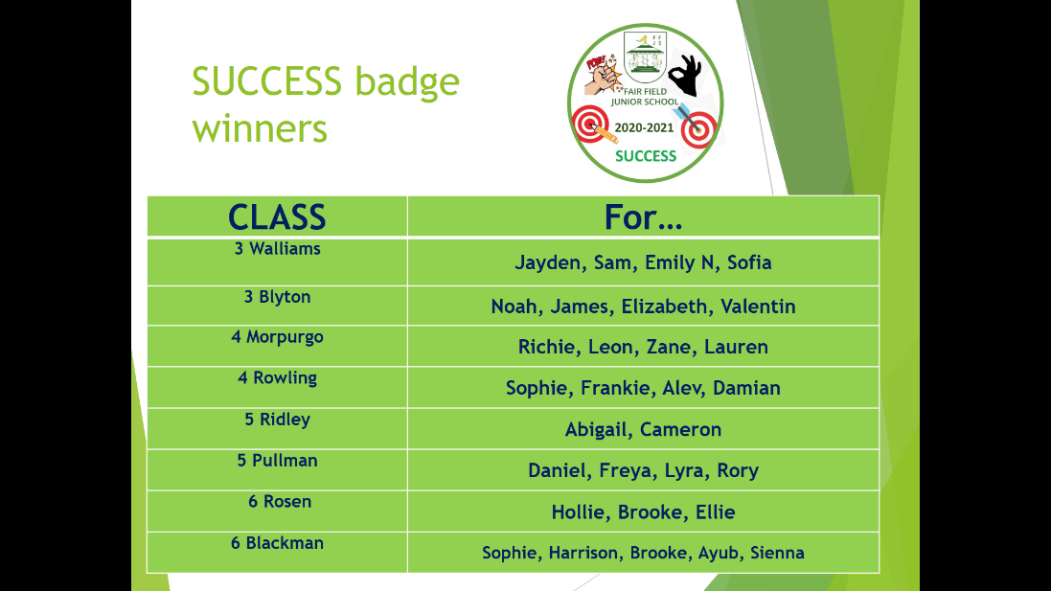

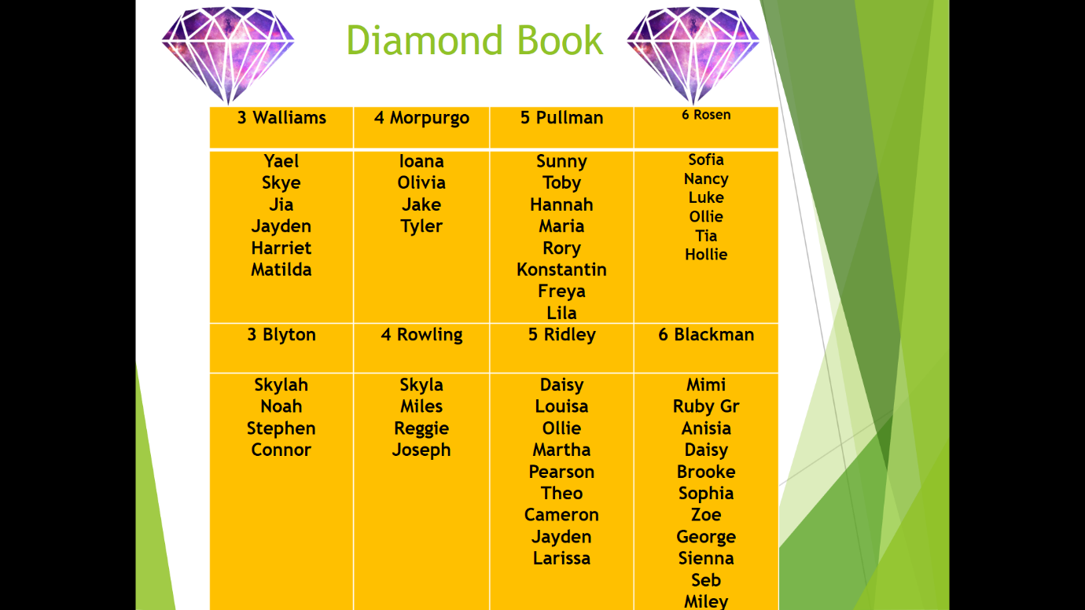

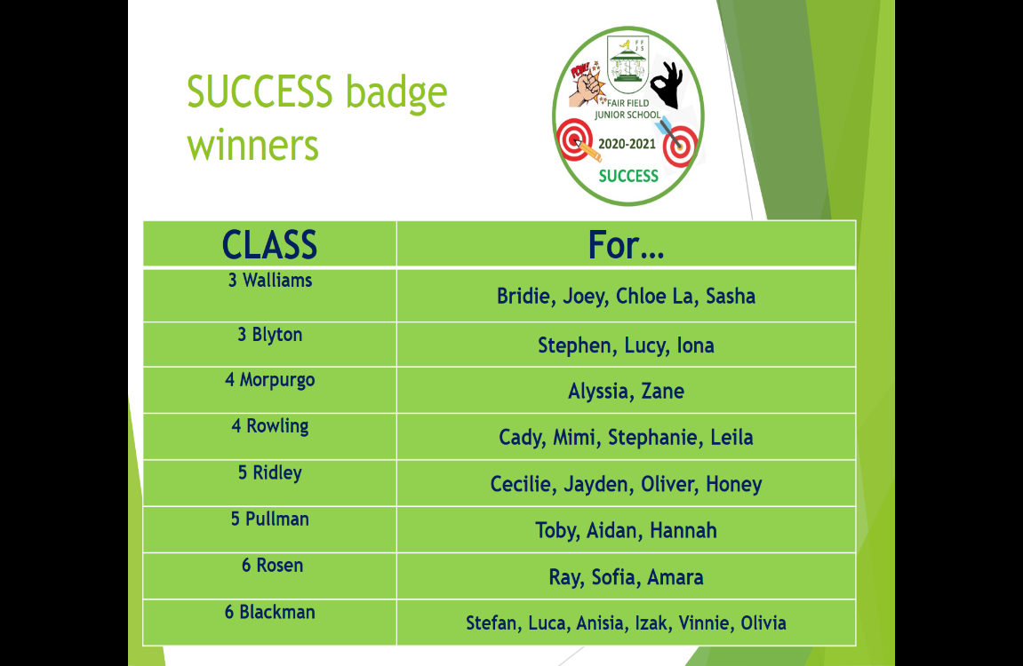

This week’s **SUCCESS** code winners were 5 Pullman, who have won a new basketball for their playground box!

**Attendance**

WOW! Every class has attendance above 97%!

|  |  |  |  |
| --- | --- | --- | --- |
| 3 Walliams | 97% | 5 Ridley | 98% |
| 3 Blyton | 98% | 5 Pullman | 99% |
| 4 Morpurgo | 98% | 6 Rosen | 97% |
| 4 Rowling | 99% | 6 Blackman | 97% |

***Welcome to the world***

***Shayen Devlia!***

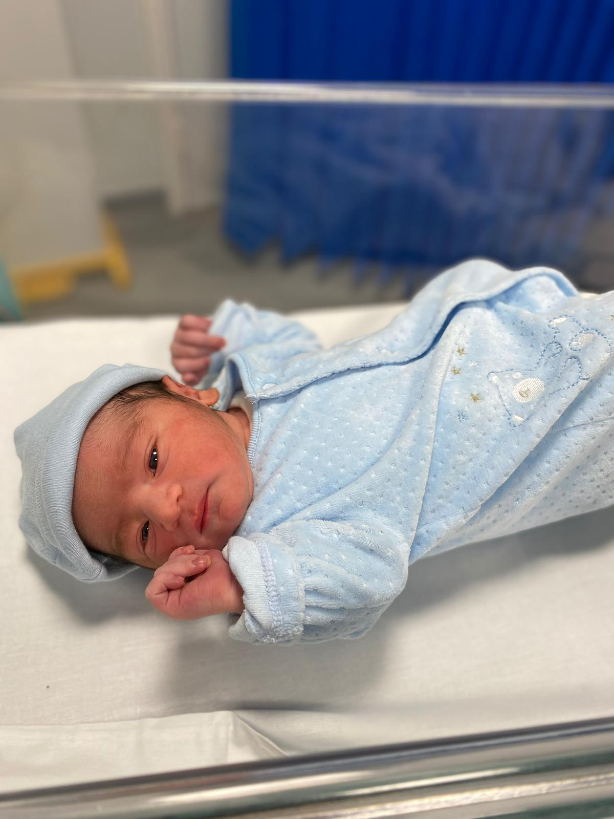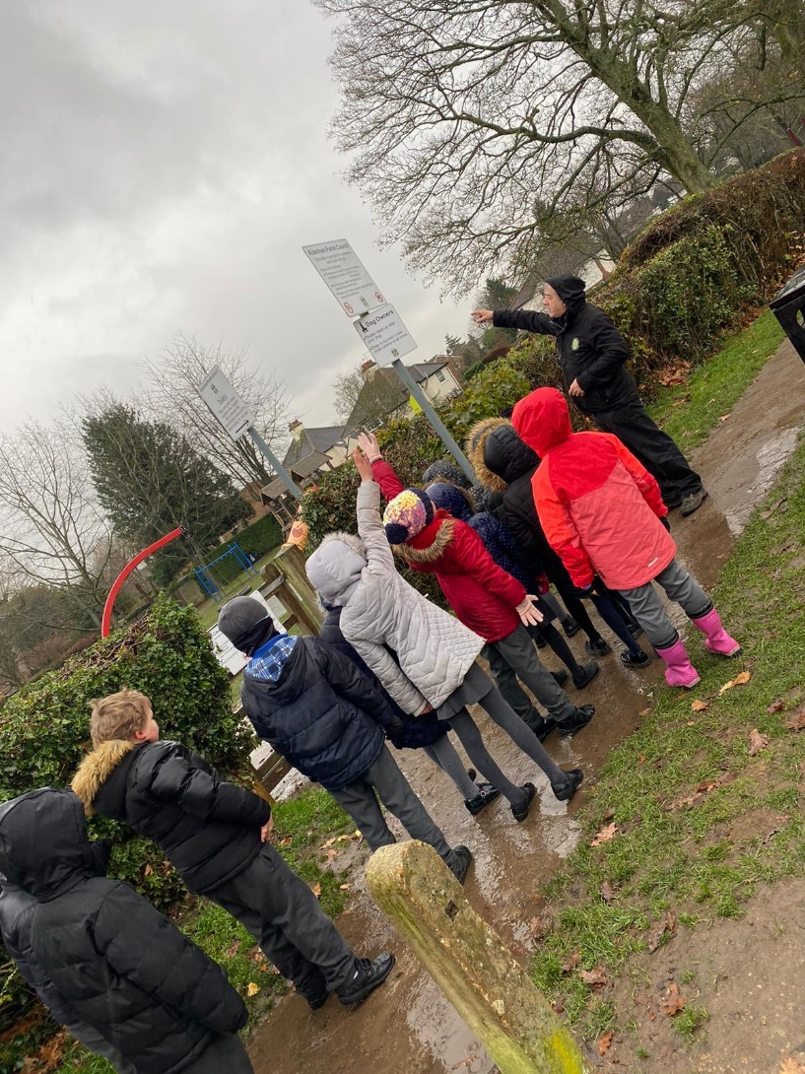

***Year 4 brave the elements at Phillimore Rec!***

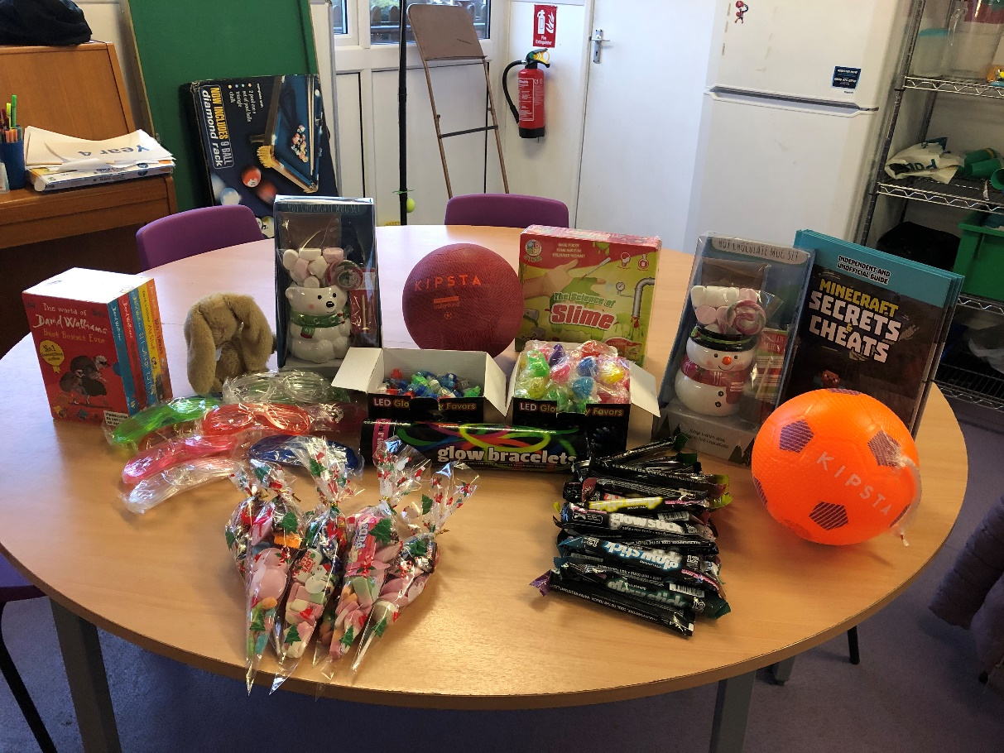

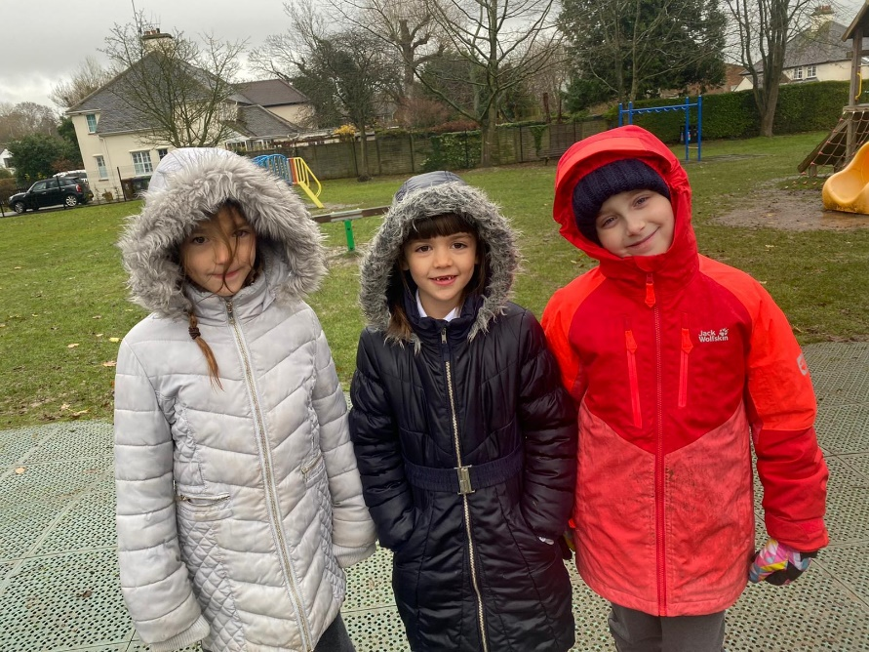

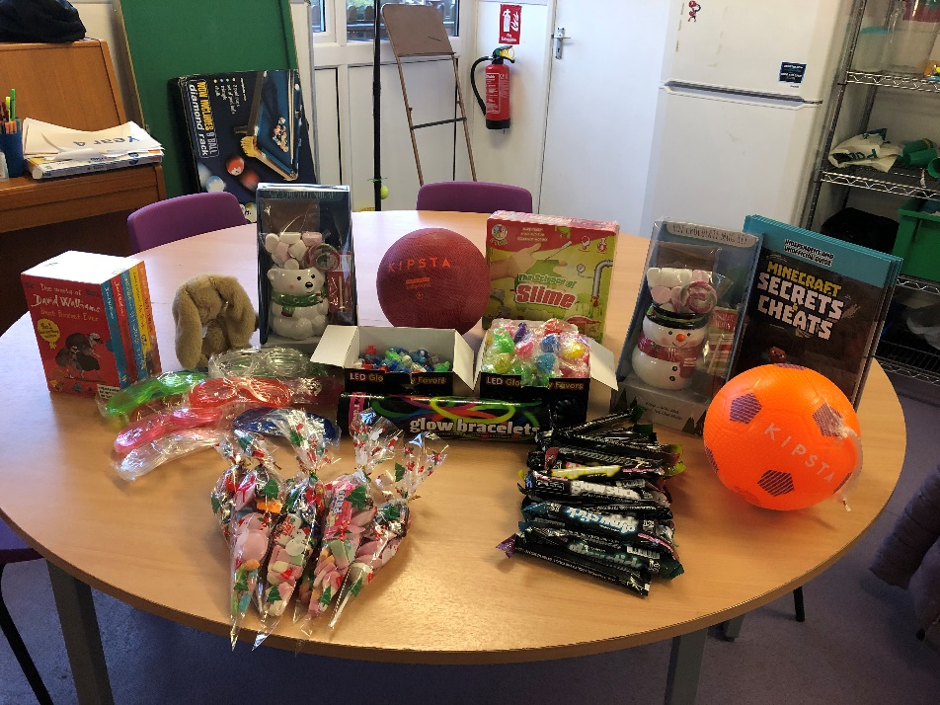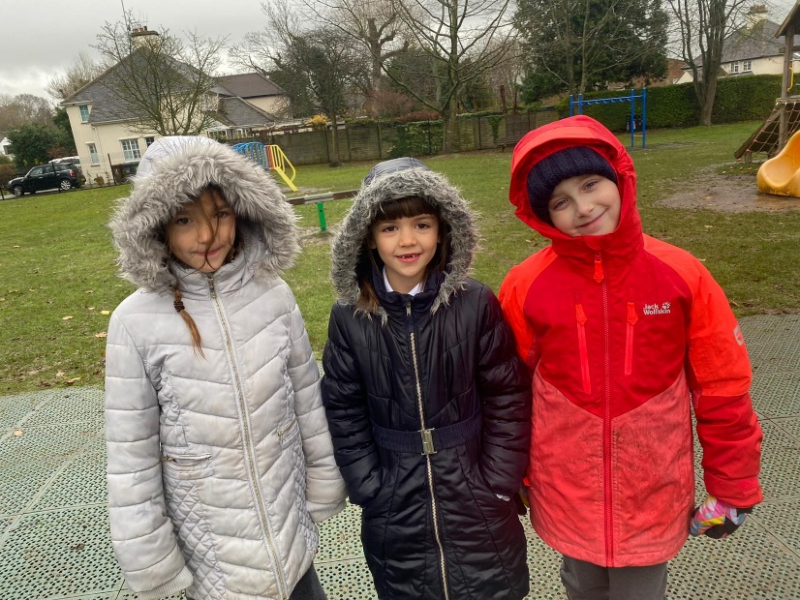

***Some of the treats and prizes ready for the discos!***

Site force have been on a

litter pick this week!

Y5 hugging the oldest tree in the wood!

Follow us!

**Keep In Touch**

Email: [admin@fairfield.herts.sch.uk](mailto:admin@fairfield.herts.sch.uk)

Tel: 01923 856 341

Fair Field Junior School

Watford Road,

Radlett, Hertfordshire, WD7 8LU

INBOUND MESSAGES from GATEWAY: 01923 750 087



@ffjsradlett

@FairFieldJrSch

**Respect Honesty Perseverance Kindness Forgiveness Inclusion**

Our very own Fair Field choir will be singing at 2.50pm. Come and support them before the switching on of the lights at 4.30pm by Sophie Perry.