**FAIR FIELD NEWS**

Autumn Term Issue 8

Dear Parents and Carers,

We’ve made it! Congratulations to everyone for a fabulous first half of the Autumn Term. We would like to thank you for your support and enthusiasm. Your children have excelled in all areas of school life and showed great maturity in adapting to our systems. After half term there will be a reduced window for drop off and collection, which will allow us to increase learning time. More information on this has been sent in a letter earlier today. Today 77% of the children tried our delicious traditional Caribbean cuisine and all the children enjoyed the cultural experience and the shared work on display. New experiences are all part of our ethos at Fair Field and we feel very proud to have hosted this event. Thank you to our hard working kitchen staff. Also this week our Nature Nurturer and Eco Warrior Leaders met with Aldenham Parish Council to draw up exciting plans for a partnership with Open Spaces which begins after the half term. Children from across the school, who are part of these crews, will be involved in many different activities including planting bulbs and monitoring bird boxes at Phillimore Recreation Ground. We wish you a restful half term.

Take Care

Mrs Goodwin

**F Factor Superstars Diamond Book**



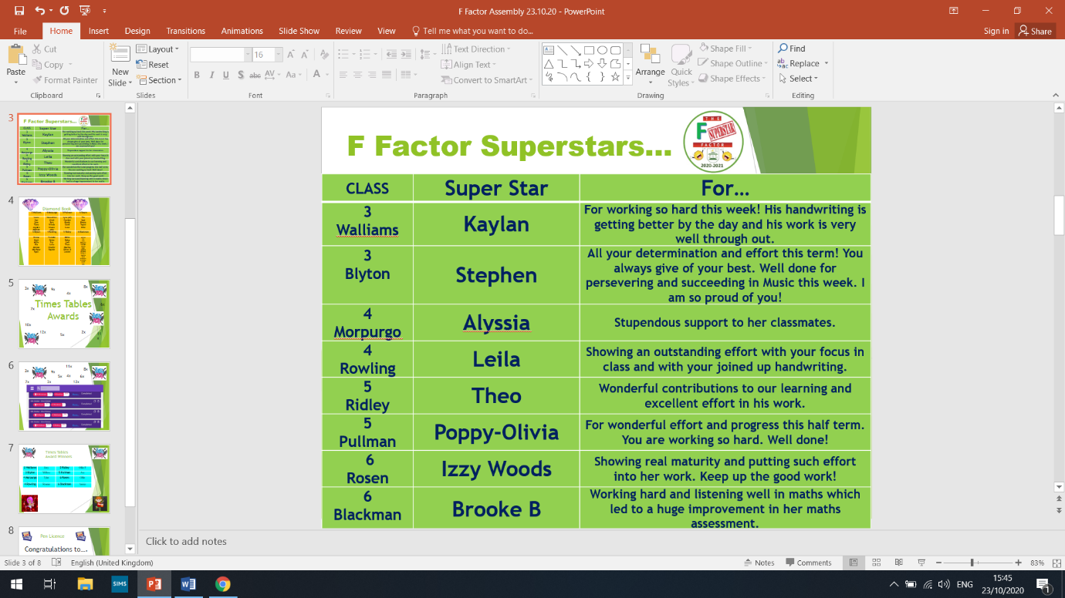

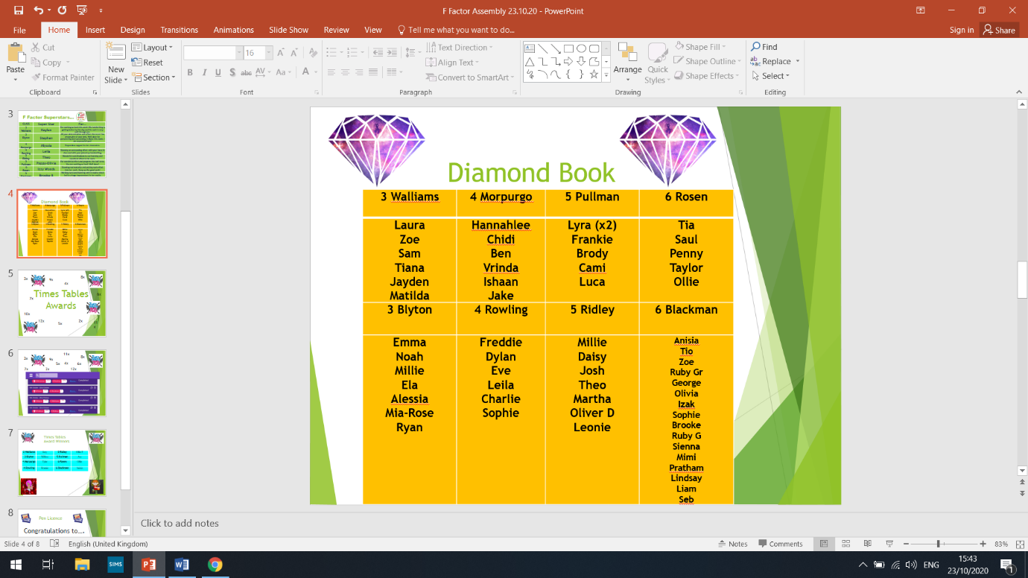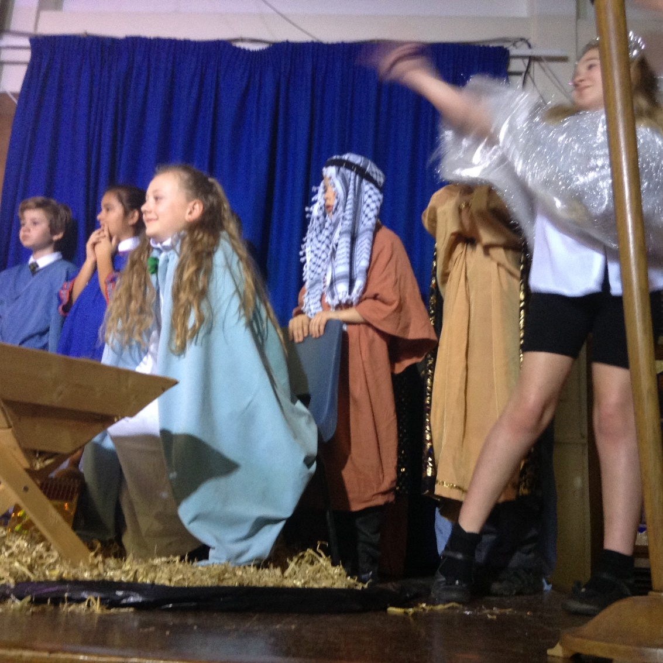





**Dates for the Diary**

|  |  |  |  |
| --- | --- | --- | --- |
| **Date** | **Time** | **Event** | **Year Group(s)** |
| 22nd October | 2pm | Deadline for photo return | All |
| 23rd October | 3.10pm | Last day of this half of term | All |
| 26th – 30th October | All week | Half Term | All |
| Thursday 5th November | All day | virtual workshop – Women In Steam | Y6 girls |
| Monday 9th November | 11.30am | Diwali assembly – accessorise your uniform with a bright | All |
| Friday 13th November | All day | Children In Need – dress in spots day. £1 donation | All |
| Friday 13th November | Afternoon | Nasal flu immunisation | All |
| 16th – 20th November | All week | Anti-bullying week | All |

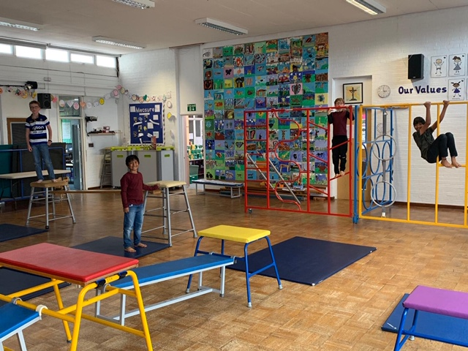

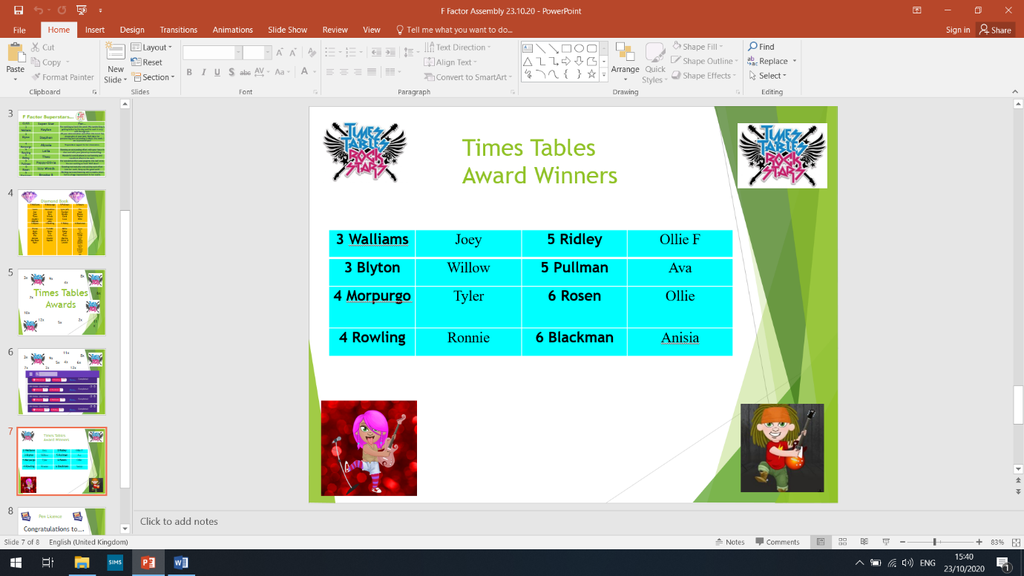



This week’s TT Winners

**House Points**

Congratulations to Kendals who have won the house point prize for this  
 half of term.The winning house will receive an ice cream factory after half term.  
1st 763 Kendals

2nd 728 Phillimore

3rd 635 Willow

4th 634 Orchard

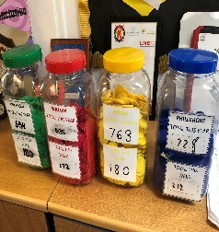

Lateness



**Attendance**

Well done! We have 3 classes at 98%!

|  |  |  |  |
| --- | --- | --- | --- |
| 3 Walliams | 97% | 5 Ridley | 98% |
| 3 Blyton | 98% | 5 Pullman | 98% |
| 4 Morpurgo | 97% | 6 Rosen | 93% |
| 4 Rowling | 97% | 6 Blackman | 91% |

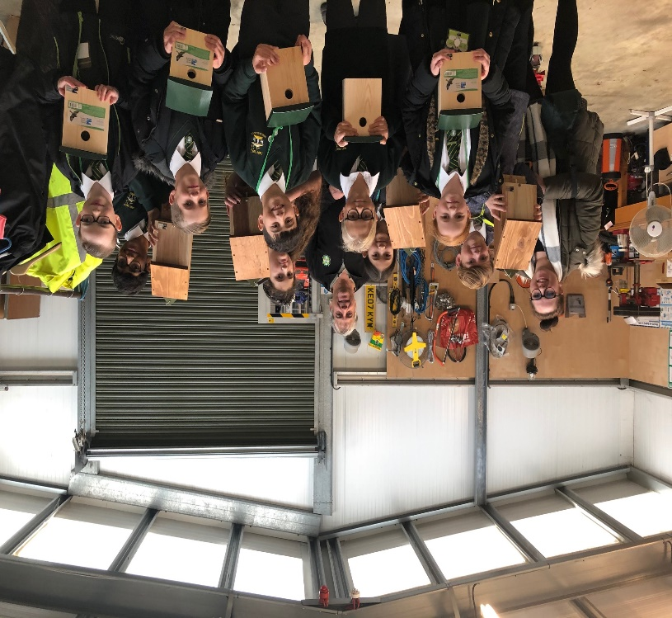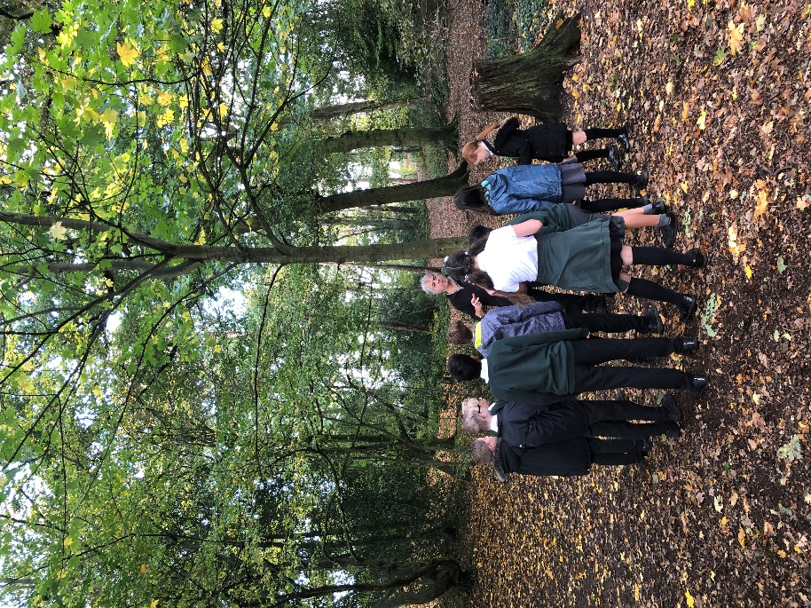

**Gallery**

.

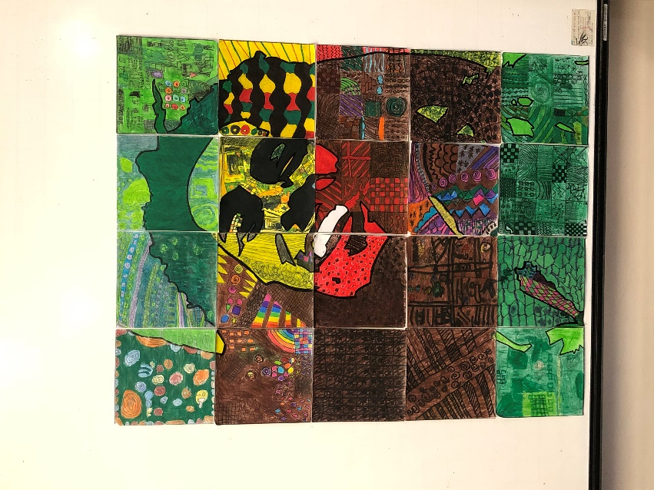

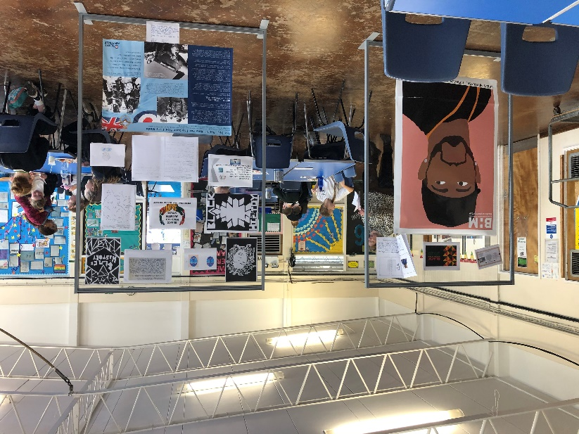

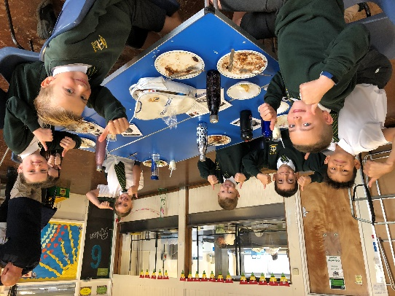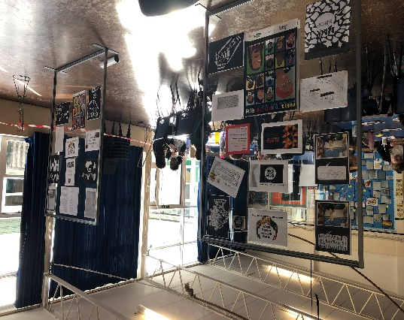





Follow us @FairFieldJrSch

**Keep In Touch**

Email: [admin@fairfield.herts.sch.uk](mailto:admin@fairfield.herts.sch.uk)

Tel: 01923 856 341

Fair Field Junior School

Watford Road,

Radlett, Hertfordshire, WD7 8LU

INBOUND MESSAGES from GATEWAY: 01923 750 087

**Respect Honesty Perseverance Kindness Forgiveness Inclusion**

Our very own Fair Field choir will be singing at 2.50pm. Come and support them before the switching on of the lights at 4.30pm by Sophie Perry.